Ramses

AF_logo_RGB_15x15.tifUser Manual



[1 Introduction 4](#_Toc428866134)

[2 Ramses Portal 4](#_Toc428866135)

[2.1 Introduction 4](#_Toc428866136)

[2.2 General 4](#_Toc428866137)

[3 View/Create/Modify Order App 9](#_Toc428866138)

[3.1 Introduction 9](#_Toc428866139)

[3.2 General 9](#_Toc428866140)

[3.3 Blend Orders 21](#_Toc428866141)

[3.4 Process Orders 39](#_Toc428866142)

[3.5 Transfer Orders 54](#_Toc428866143)

[3.6 Import Order 65](#_Toc428866144)

[3.7 Order Template 67](#_Toc428866145)

[3.8 Duplicate Order 69](#_Toc428866146)

[3.9 Export order Reports 70](#_Toc428866147)

[3.10 Delete Order 70](#_Toc428866148)

[3.11 ERP Adjustment 70](#_Toc428866149)

[4 View/Create Operator Comments App 72](#_Toc428866150)

[4.1 Introduction 72](#_Toc428866151)

[4.2 General 72](#_Toc428866152)

[4.3 Operating Instructions 80](#_Toc428866153)

[4.4 Operator Log 86](#_Toc428866154)

[5 Reports App 90](#_Toc428866155)

[5.1 Introduction 90](#_Toc428866156)

[5.2 General 90](#_Toc428866157)

[5.3 Daily Instruction Reports 92](#_Toc428866158)

[5.4 Shift Reports 95](#_Toc428866159)

[5.5 Handover Reports 97](#_Toc428866160)

[6 PPL Instructions App 98](#_Toc428866161)

[6.1 Introduction 98](#_Toc428866162)

[6.2 General 98](#_Toc428866163)

[6.3 Export to .PDF 99](#_Toc428866164)

[7 Tank Monitoring App 99](#_Toc428866165)

[7.1 Introduction 99](#_Toc428866166)

[7.2 General 99](#_Toc428866167)

[7.3 Tanks 102](#_Toc428866168)

[7.4 Tank Information 103](#_Toc428866169)

[8 Inventory Report App 109](#_Toc428866170)

[8.1 Introduction 109](#_Toc428866171)

[8.2 General 109](#_Toc428866172)

[8.3 Export to .PDF 110](#_Toc428866173)

[9 Lineup 110](#_Toc428866174)

[9.1 Introduction 110](#_Toc428866175)

[9.2 General 110](#_Toc428866176)

[9.3 Add a Lineup 110](#_Toc428866177)

[9.4 Edit a Lineup 113](#_Toc428866178)

[9.5 Delete a Lineup 114](#_Toc428866179)

[10 Asset Profile 114](#_Toc428866180)

[10.1 Introduction 114](#_Toc428866181)

[10.2 General 114](#_Toc428866182)

[10.3 Blender 115](#_Toc428866183)

[10.4 Line 117](#_Toc428866184)

[10.5 Pump 118](#_Toc428866185)

[10.6 Blend Stream 119](#_Toc428866186)

[10.7 Additive Stream 121](#_Toc428866187)

[10.8 Storage 124](#_Toc428866188)

[10.9 Stream 127](#_Toc428866189)

[10.10 Additive Feed/Yield Stream 129](#_Toc428866190)

[10.11 Process Unit 130](#_Toc428866191)

[10.12 Scheduling Area 132](#_Toc428866192)

[10.13 Import 133](#_Toc428866193)

[11 Material Manager 137](#_Toc428866194)

[11.1 Introduction 137](#_Toc428866195)

[11.2 General 137](#_Toc428866196)

[11.3 Material Group 138](#_Toc428866197)

[11.4 Material 139](#_Toc428866198)

[11.5 Add 140](#_Toc428866199)

[11.6 Sport Import 140](#_Toc428866200)

[11.7 Manual Import 140](#_Toc428866201)

[12 User Settings 141](#_Toc428866202)

[12.1 General 141](#_Toc428866203)

[13 Asset Security 142](#_Toc428866204)

[13.1 Introduction 142](#_Toc428866205)

[13.2 General 142](#_Toc428866206)

[13.3 Add/Edit 143](#_Toc428866207)

[13.4 Bulk Add 145](#_Toc428866208)

[13.5 Search 145](#_Toc428866209)

[14 User Specification 146](#_Toc428866210)

[14.1 Introduction 146](#_Toc428866211)

[14.2 General 147](#_Toc428866212)

[14.3 Configuration 149](#_Toc428866213)

[14.4 Indexes Configuration 154](#_Toc428866214)

[14.5 Data 156](#_Toc428866215)

[14.6 Export 158](#_Toc428866216)

[14.7 Important User Specifications 159](#_Toc428866217)

[15 Event Editor – Template Wizard 167](#_Toc428866218)

[15.1 Introduction 167](#_Toc428866219)

[15.2 General 167](#_Toc428866220)

[15.3 Template 168](#_Toc428866221)

[15.4 Settings 169](#_Toc428866222)

[15.5 Actions 181](#_Toc428866223)

[15.6 Security 184](#_Toc428866224)

[16 Process Library 186](#_Toc428866225)

[16.1 Introduction 186](#_Toc428866226)

[16.2 General 186](#_Toc428866227)

[16.3 Summary 187](#_Toc428866228)

[16.4 Schedule 188](#_Toc428866229)

[16.5 Trigger 190](#_Toc428866230)

[16.6 Topic 193](#_Toc428866231)

[16.7 Actions 195](#_Toc428866232)

[16.8 Export 207](#_Toc428866233)

[17 Shift Report – Template Wizard 208](#_Toc428866234)

[17.1 Introduction 208](#_Toc428866235)

[17.2 General 208](#_Toc428866236)

[17.3 Basic Settings 209](#_Toc428866237)

[17.4 Sections 209](#_Toc428866238)

[17.5 Section Configuration 209](#_Toc428866239)

[17.6 Section Tags 209](#_Toc428866240)

[17.7 Import/Export Shift Report Template 210](#_Toc428866241)

[18 Audit Viewer 211](#_Toc428866242)

[18.1 Introduction 211](#_Toc428866243)

[18.2 General 212](#_Toc428866244)

[18.3 Asset Filter 212](#_Toc428866245)

[18.4 Event Filter 212](#_Toc428866246)

[18.5 Audit Trail 213](#_Toc428866247)

[18.6 Integration with Event Editor 213](#_Toc428866248)

[19 Oil Accounting Reports 214](#_Toc428866249)

[19.1 Introduction 214](#_Toc428866250)

[19.2 General 215](#_Toc428866251)

[19.3 Area Report 215](#_Toc428866252)

[19.4 Crude Tank Composition Report 217](#_Toc428866253)

[19.5 Monthly Mass Balance Report 218](#_Toc428866254)

[19.6 Monthly Sales and Receipt by Cargo Report 219](#_Toc428866255)

[19.7 Truck Loading Report 220](#_Toc428866256)

[19.8 Tank Inventory Report 221](#_Toc428866257)

[20 Material Composition 222](#_Toc428866258)

[20.1 Introduction 222](#_Toc428866259)

[20.2 General 222](#_Toc428866260)

[20.3 Crude Disc 223](#_Toc428866261)

Ramses User Manual

# Introduction

This is the user manual for the Ramses system, it describes all you need to know to be able to use the functionalities that the Ramses system supplies.

# Ramses Portal

## Introduction

The Ramses portal is the shell for the entire Ramses solution. It handles all of the navigation between apps and modules.

## General

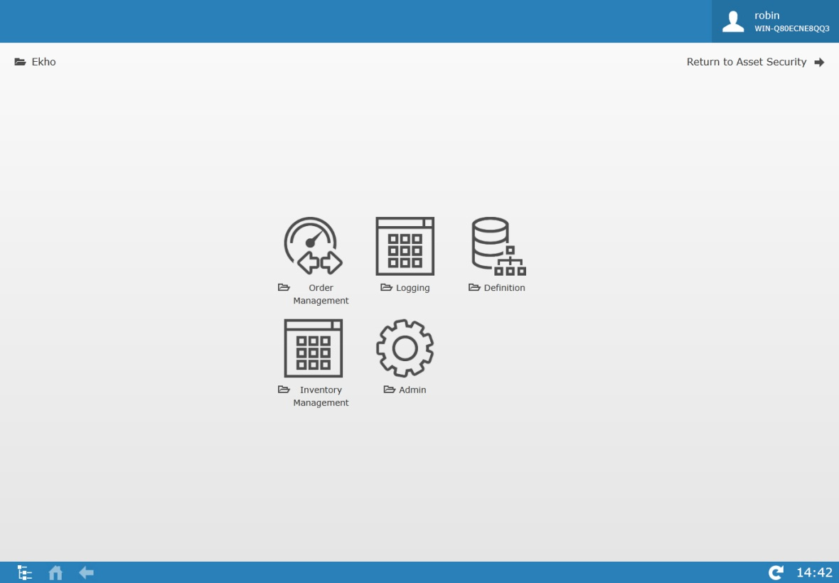

|  |  |
| --- | --- |
| **Icon** | **Description** |
|  | Shows the logged in User, reads from the active directory. |
|  | Displays where you are at in the portal and how you got there. |
|  | Click to return once the back or home button has been used. |
|  | Opens the navigation treeview |
|  | Click to get to the root level of the startpage. |
|  | Click to go back one level. |
|  | If Green, indication that Ekho has established a connection to IP21. |
|  | Click to refresh the system. |
|  | When this icon is visible, it is possible to bring up a manual describing the functionality of the current screen. |
|  | Displays current time. |

### Navigation

When first entering the portal, all of the modules available to you will be shown, by clicking on a module, all of the apps that the chosen module holds will be displayed instead.

### Treeview Navigation

The treeview navigation is especially useful when wanting to navigate away from one app to another without having to go back to the start page.

Clicking  will open up the treeviewer.

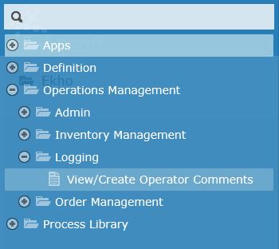

To navigate to an app from here, simply click on the app in the treeview.

The search field can be used to quickly find an app, simply start writing the name of the app and the treeviewer will automatically narrow the list down to only the apps that match your search.

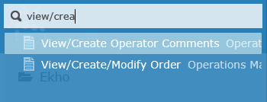

### Modules

There are five modules in Ramses. Note that all of these modules might not be available for all users.

|  |  |
| --- | --- |
| **Icon** | **Description** |
|  | The Order Management module holds the View/Create/Modify Orders app. |
|  | The Logging module holds the View/Create Operator Comments app and Reports app. |
|  | The Inventory Management module holds the Tank Monitoring app and the Crude Composition Tracking App. |
|  | The Admin module holds the Lineup Manager app, Asset Profile app, Material Manager app, User Settings app, Shift Report – Template Wizard app and the Event Editor – Template app. |
|  | The System Management module holds the Asset Security app, Audit Viewer app, Process Library app, KPI Manager app and the User Specification app. |

#### Order Management

There is one app in the Order Management Module.

|  |  |
| --- | --- |
| **Icon** | **Description** |
|  | The View/Create/Modify Order facilitates the creation, editing and viewing of orders (Process, Transfer, Blend and Operating Instructions). This app contains multiple functions such as order import, order templates, order duplication and more. |

#### Logging

There are three apps in the Logging Module, note that all of these apps might not be available for all users.

|  |  |
| --- | --- |
| **Icon** | **Description** |
|  | The view/create operator comments app allows you to view/edit and add operating instructions and logs. |
|  | The reports app allows you to view, publish and sign-off on daily instruction reports, shift reports and handover reports. |
|  | The PPL Instructions App lists all of the “Active” Operating Instructions that are owned by “Planning” as well as any Order Comments that has been categorized with a category configured to be a part of the PPL Instructions App. |

#### Inventory Management

There are four apps in the Inventory Management Module.

|  |  |
| --- | --- |
| **Icon** | **Description** |
|  | The Tank Monitoring app gives you an overview of the status of all the tanks related to your security group. |
|  | The Crude Tank Composition app is a tool where the current tank composition can be viewed for all storage assets that has enabled crude composition tracking. It is also possible in this app to override the crude composition. |
|  | The Inventory Report app lets you view past or present data related to the storage assets and export it as a report. |
|  | The Oil Accounting Reports app contains various reports for Mass Balance, Sales and Receipts, Tank Inventory etc that can be viewed in the system and exported to excel. |

#### Admin

There are six apps in the Admin Module, note that all of these apps might not be available for all users.

|  |  |
| --- | --- |
| **Icon** | **Description** |
|  | The asset profile allows you to view/maintain blenders, lines, pumps, storages and streams. |
|  | The Event Editor – Template Wizard is a tool that allows for the addition, edition and deletion of templates that will be used within the event editor application as pages. This tool contains multiple sections such as basic setting, advanced setting, default values and security. |
|  | The Lineup app allows you to create and maintain lineups in the system used to define the route between source and destination assets. |
|  | The Material Manager lets you manage the materials in the system and gives you functions to view/edit and add materials. |
|  | The Shift Report – Template Wizard app allows you to Import/Export templates of the production data part of the shift reports, per area/subarea. |
|  | The user Settings application allows the users to select the default comment category that should be pre-selected for them whenever they are adding a comment to an event (Order, Log, Instruction) |

#### System Management

There are four apps in the System Management Module, note that all of these apps might not be available for all users.

|  |  |
| --- | --- |
| **Icon** | **Description** |
|  | The Asset Security app lets you manage user groups and asset security for said groups. |
|  | The User Specifications app allows you to configure specifications that can be used when there is a need to store reference information that is not stored by default in the system. |
|  | The Process Library app is a management and communication system that allows you to set up schedule/trigger/topic related jobs that the system will carry out. |
|  | The purpose of the Audit Viewer app is to allow you to see how attributes on events in the system has been modified over time. |

# View/Create/Modify Order App

## Introduction

The View/Create/Modify Order facilitates the creation, editing and viewing of orders (Process, Transfer, Blend and Operating Instructions). This app contains multiple functions such as order import, order templates, order duplication and more.

## General

When first accessing the View/Create/Modify Order app, the page may appear blank. This is because no initial page has been defined.

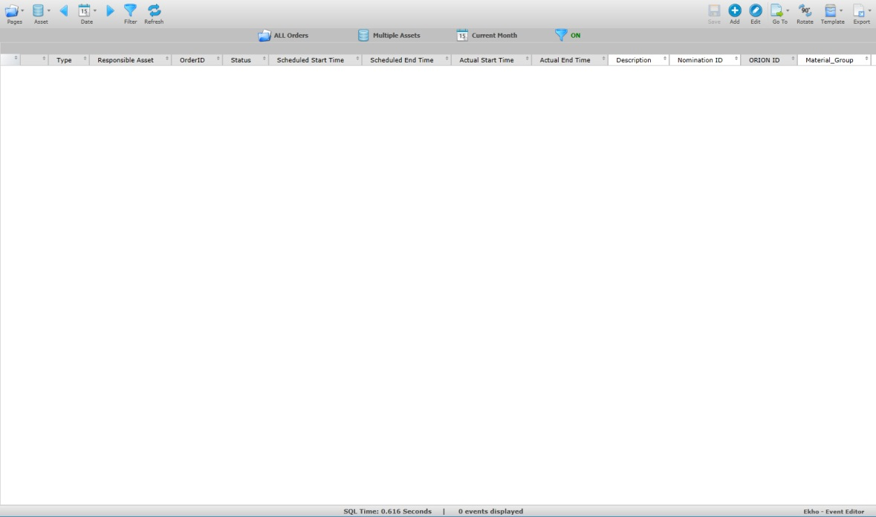

|  |  |
| --- | --- |
| **Icon** | **Description** |
|  | Click to switch between the various pages. |
|  | Click to hide or display the assets pane where the assets can be filtered on. |
|  | Click to select a date for the order search. The arrow on each side allows you to change the date incrementally. |
|  | Click to open the advanced filter. |
|  | Click to refresh the date or to apply new settings. |
|  | Click to save after editing values in the order grid. |
|  | Click to add an order. |
|  | Click to edit selected order. |
|  | Click to switch the event editor grid for a Gantt chart. |
|  | Click to navigate between pre-configured order related pages (e.g. Import Order, Duplicate Order) |
|  | Click to traverse the order view, either by column or by row. |
|  | Click to save your filtered display as a template or to load a template. |
|  | Click to export the order data to either Excel or PDF. |
|  | Clicking this button will bring up a menu with all columns in the event editor grid where you can see what column filters are applied or apply new column filters. |
|  | When the Gantt chart is being viewed, this button can be pressed to bring up an information menu for the selected order. |

The sub header row beneath the toolbar is designed to display the event filtering selections.







|  |  |
| --- | --- |
| **Icon** | **Description** |
| EEPagesNumberIcon.png | Displays the name of the page that is selected. |
| EEAssetsMultiIcon.png | Displays the asset that has been selected, if more than one asset is selected, “Multiple Assets” will be displayed. |
| EELastEventIcon.png | Displays the date selected (relative or specific). |
| EEFilterApplyIcon.png | Displays whether an advanced filter is “ON” or “OFF”. Click the icon to toggle between them if an advanced filter has been set. If no filter option is selected the icon will displayed with “NONE” beside. |

### Pages

Click on 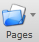 to select an order page.

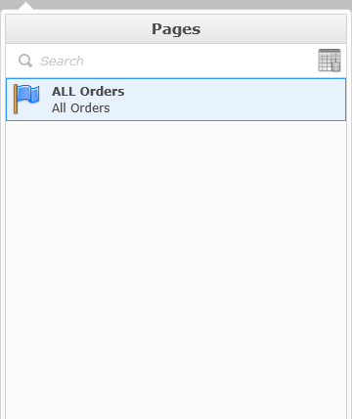

Pages displays a list of all available order pages, a page is an event template created from the “Event Editor – Template Wizard” app. Each page will have a different color flag associated with it to signify a different type of page.

Hover your mouse on the page name and you will see small icons to the right of the name.

Click  to flag the page into your favorites. Your favorites will be displayed on the top of the list. The next time you open the panel and hover your mouse on the name of the page the icon will look like this .

You have the option to set a page as the default page to open when navigating to the view/create/modify orders app.

While hovering your mouse over the page name, a check mark icon appears. By default the check icon  is gray, signifying that the page is not the default, clicking on this icon will change its appearance to  indicating that it is now the default page.

### Assets

Click on 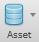 to select the assets you would like to view corresponding orders with.

One or more assets can be selected from the list. The number of assets selected will be shown in parentheses.

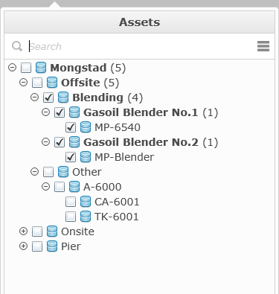

If you know the name of the asset that you are looking for, you can use the search option. Once the keyword that you want to search for is completely typed, hit the enter key, if the name can be found in the asset list it will be highlighted. If you type only a partial name, the list will be open on the first possible match but the name will then be highlighted.

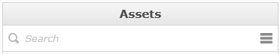

If you need to select or unselect the entire list of items, you can use a quick tool, click on the icon and select the option to select or clear the items.

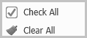

Right click on an Asset in the tree-view to check or un-check all the descendants of the asset.

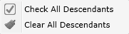

### Date

Click on 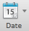 to select/apply a date selection

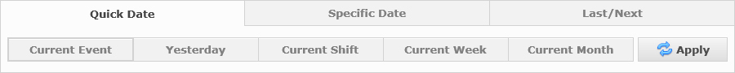

Three date types are available: Quick Date, Specific Date and Last/Next.

#### Quick Date

“Quick Date” has a combination of relative and status based searches that are predefined.



**Current Event**: Displays only open events (events with expected/actual (actual overrides expected) start time that is lesser than now and with no actual end time).

**Yesterday**: Displays yesterday’s open events between 00:00:00 and 23:59:59 (based on the current date), meaning any event whose start time (expected/actual, actual overrides expected) was either before or during the period as long as end time (expected/actual, actual overrides expected) also is during or after that period or not set yet are shown.

**Current Shift**: Displays all events for the current shift, works the same way as Yesterday with respect of timestamps used.

**Current Week**: Displays events between the last Sunday from 00:00:00 to current day, works the same way as Yesterday with respect of timestamps used.

**Current Month**: Displays events between the first day of the month from 00:00:00 to current day, works the same way as Yesterday with respect of timestamps used

#### Specific Date

“Specific Date” allows you to select a specific start date and end date.

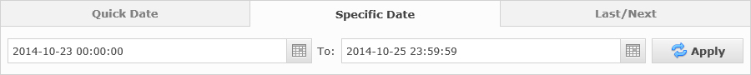

You can change the start time and the end time of the date filter by typing the date and time or by using the calendar and time tool. To use the calendar tool click .

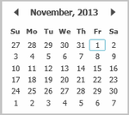

All events whose start time (expected/actual, actual overrides expected) was either before or during the period as long as end time (expected/actual, actual overrides expected) also is during or after that period or not set yet are shown.

#### Last/Next

Last/Next is a relative date option based on pre-defined periods along with user enterable, relative numbers.

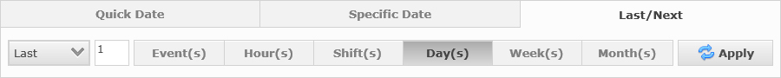

The combobox lets you switch between Last or Next.

Regardless of the “Last” or “Next” number entered or period selected, current day events will always be included in the results.

**Last/Next: Event(s):** Last x Events starting (Expected/Actual start time, actual overrides expected) before “now” or Next x Events starting (Expected/Actual start time, actual overrides expected) after “now”.

**Last/Next: Hour/Shift/Day/Week/Month:** Displays open events between start of chosen duration and end of chosen duration, meaning that any event whose start time (expected/actual, actual overrides expected) was either before or during the period as long as end time (expected/actual, actual overrides expected) also is during or after that period or not set yet are shown.

Click  to apply your date selection. The date selection screen will close and the page will refresh.

### Advanced Filter

Click 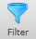 to open the Advanced Filter window.

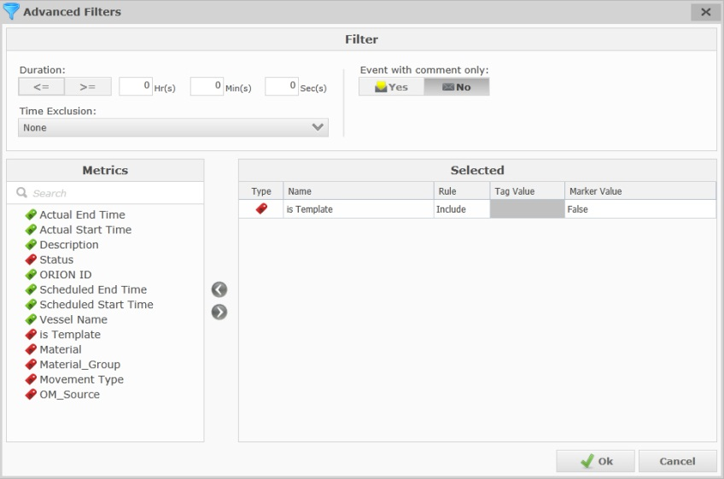

|  |  |  |
| --- | --- | --- |
| Action | Icon | Description |
| Filter duration | EEFilterDuration.png | Filter the duration of the order(s). |
| Time Exclusion | EEFiltersTimeExcl.png | Filter by excluding certain time periods. |
| Event with Comment only | EEFilterCommentExcl.png | Filter by excluding order with or without comment. |

The “Metrics” filter option allows for the filtering of events based on certain metric tags or marker values.

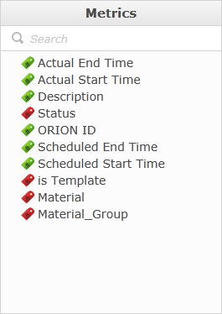

To select (or remove) a metric, you can use the drag and drop method or you can use the arrows  .

Once in the “Selected” list you can apply a rule value to filter for. If the selected item is a marker (status, material group etc) you can enter a marker value. Markers are noticable by their red icon.

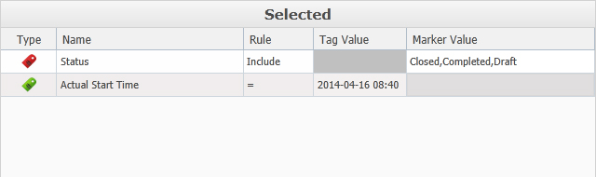

Click to filter selections. Click  or  if you choose not to apply the filter.

### Navigation

Click 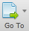 to navigate to custom pages such as “import orders”.

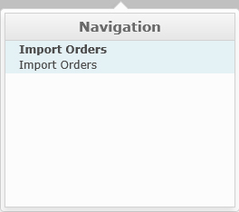

### Rotate

Within the main order grid display, you have the ability to traverse the grid view. By default the grid is displayed in a row based fashion.

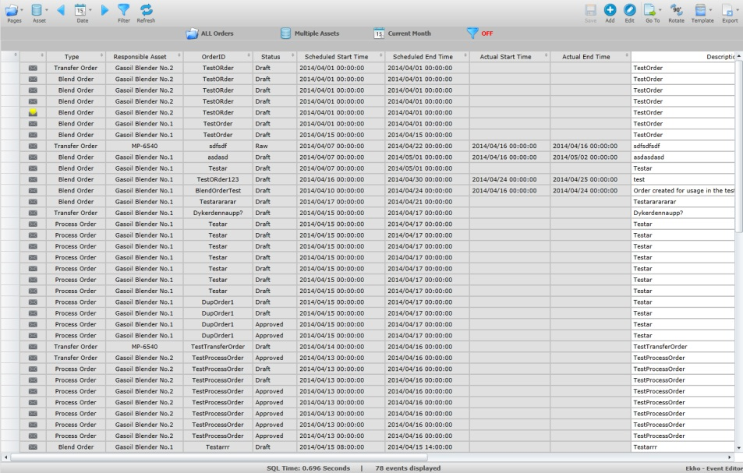

By clicking 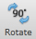 the grid will traverse and display the data in more of a column based fashion.

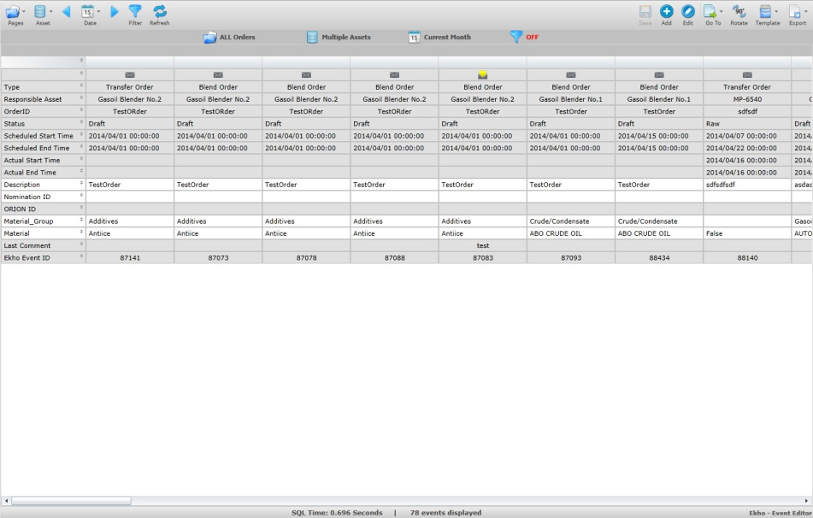

To go back to the default view, just click  again.

### Template

Once you have made all applicable filtering selections (Asset, Period etc.) you can click 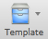 to save a template of your selections. This will allow you to save your selections and use the template for common searches.

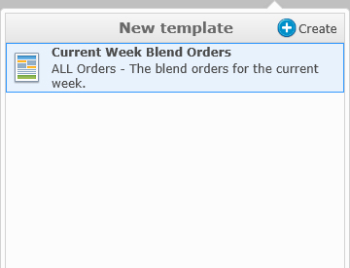

To create a new template click on the create button  and a new section will be displayed.

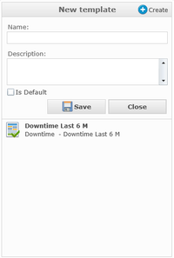

Description is not mandatory but it is recommended to save an associated description to give you more of an idea of what this template is for.

You also have the option to save this template as a default template by checking the “Is Default” box .

To save the template click the save button. 

After saving your template you will see it listed in the “Templates” section.

Templates are ordered in the list by name and type.

A default template is easy to identify by the green check mark in the icon. 

To delete a template, select the template name and click on the delete icon  next to the name.

To edit a template, select the template name and click on the edit icon  next to the name.

Once complete, click  to hide the template panel.

### Export

Click 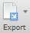 to export the orders in the grid. You will have the ability to export to either XLSX for excel or PDF.

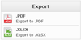

After choosing the file type you will be prompted to select a file location and to enter a name for the file.

Note that the .PDF report takes into account the filtering/grouping and column widths of the event grid.

### Add

Click 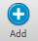 to manually add a new order, you have the option of creating either a Blend, Transfer or Process order.

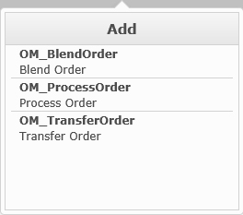

After choosing which type of order you want to create a new window will appear that lets you create the order.

### Edit

With an order selected, click 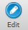 to open the edit form that let’s you alter the order.

Some of the properties on an order are editable straight away in the order grid, noticable by their white cell background. To edit one of these doubleclick in the cell you want to edit.

Note that for this change to take effect you have to click 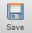.

### Gantt

Pressing the 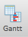 button in the top right corner you will swap the event editor grid for a gantt chart.

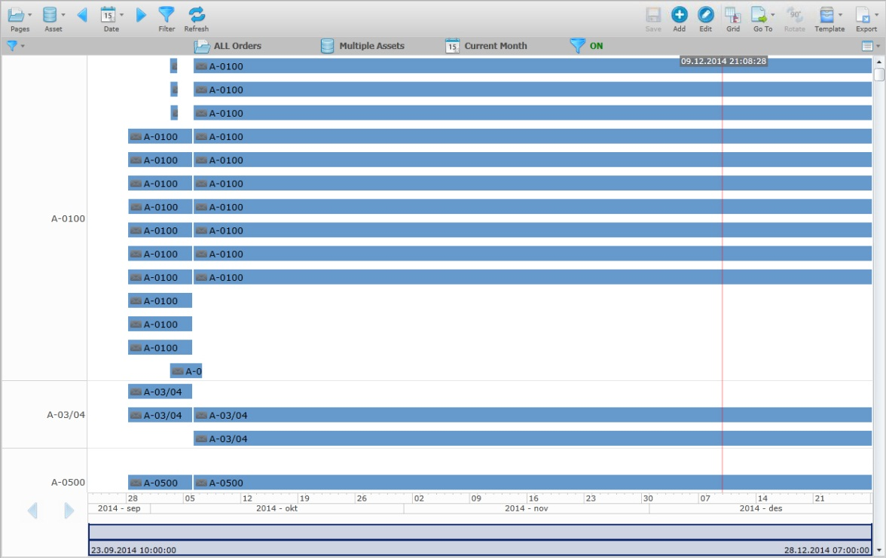

Each of the bars represents an order that uses the asset (configurable, could be something different than asset) that is being displayed.

It is possible to select a bar (order) and press the  button to modify or view the order.

It is possible to zoom in the gantt chart by holding down the mouse cursor and dragging horizontally to cover the area you want to zoom in on.

To zoom out to 100% you can double click on the slider at the bottom.

The slider at the bottom can also be used to select a certain area to zoom in or out for by selecting the point at the very left or right and dragging it inwards or outward.

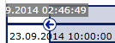

Clicking the  button in the right corner will open a detail window where it is possible to see the attribute values for a selected bar (order).

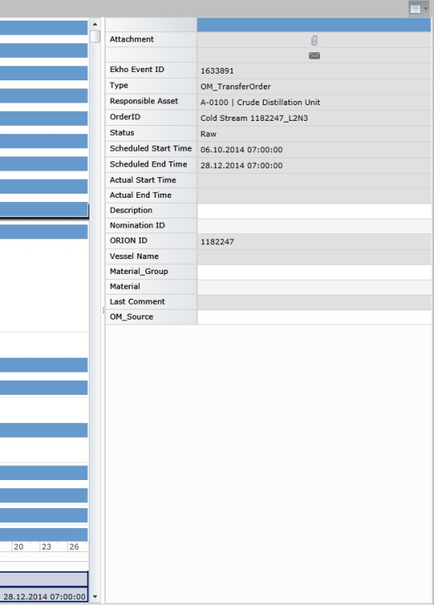

## Blend Orders

The form for creating/editing/viewing a blend order is divided up into four sections; Details, Recipe, Product and Heel.

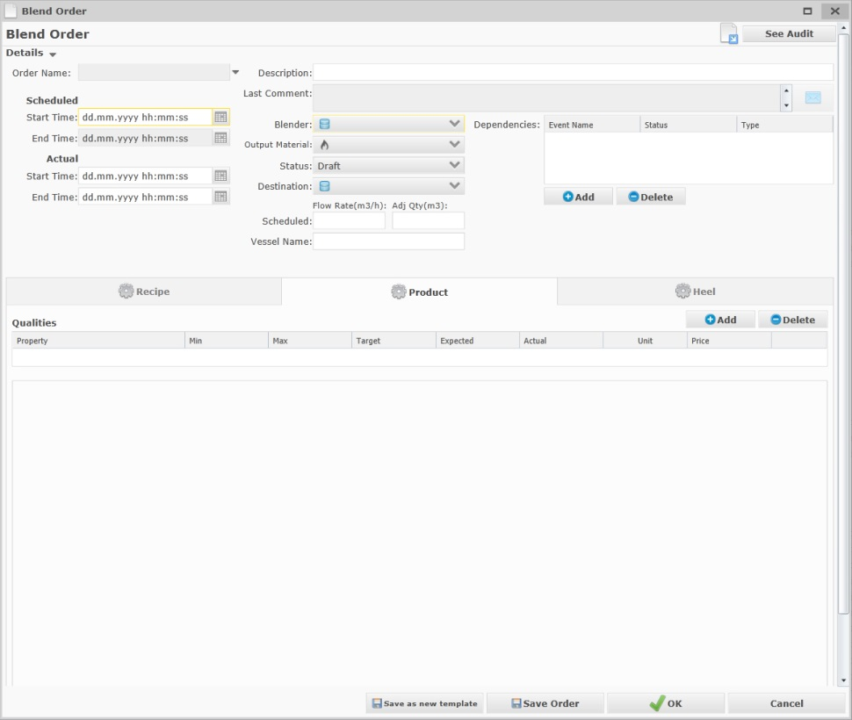

When opening a blend order some fields will not be visible, these are Nomination ID, Orion ID, ERP ID and Ekho ID, to view these fields click next to the Order Name field.

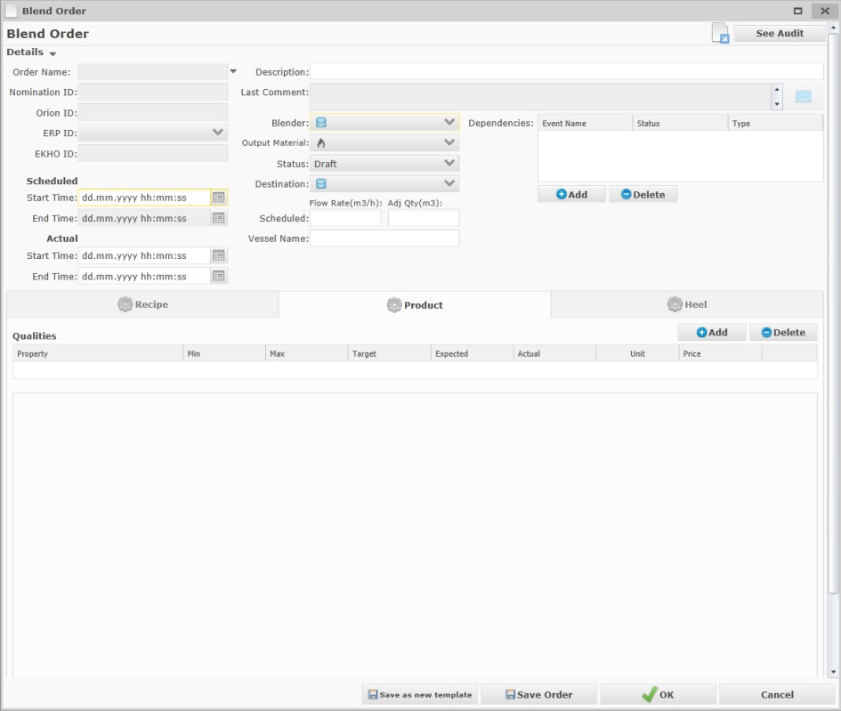

The details header can be collapsed to give more room for the other three sections, recipe, product and heel. Click on to hide the header.

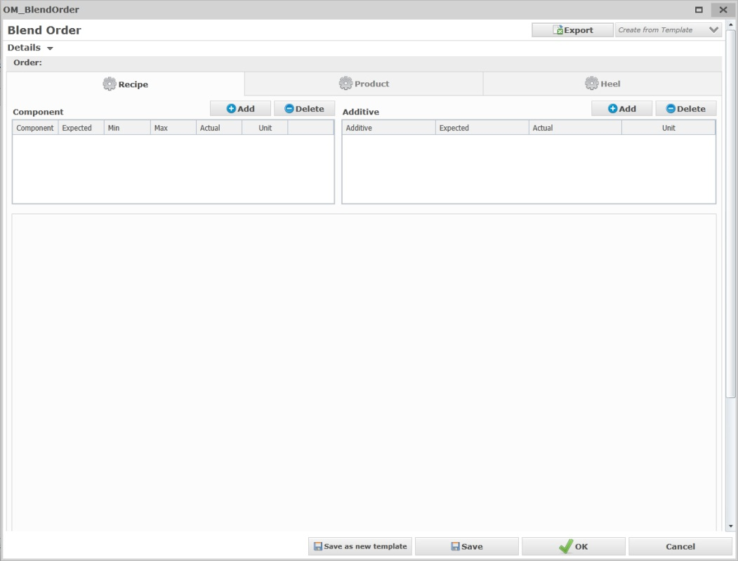

### Details

In order to succesfully create a draft blend order, some of the fields in the details header must be assigned a value, mandatory fields in the header are highlighted with a yellow border.

|  |  |  |
| --- | --- | --- |
| **Detail** | **Description** | **Optional?** |
|  | Assigns an Order Name to the blend order based on key value fields on the order. (Read-Only), will continously be updated if any of the key value fields are updated. | NO |
|  | Assigns a Nomination ID to the blend order if one exists. | YES |
|  | Assigns the corresponding Orion ID if one exists. (Read-Only) | YES |
|  | Assigns the corresponding ERP ID if one exists. Also lets you manually select an existing ERP\_ID from SPORT. | YES |
|  | Automatically assigns an Ekho ID to the blend order. | NO |
|  | Determines the scheduled Start and End time of the order (End Time is read only and automatically calculated by Ekho based on Scheduled start, Flow Rate and Quantity). | NO (Start time) YES (End time for Draft) |
|  | Determines the actual start and end time of the order. | YES (for draft) |
|  | Assigns a description to the order. | YES |
|  | Shows the last comment. | YES |
|  | Assigns the blender to be used in the order. If a Material has been chosen, only blender assets with this material configured as a valid output material are shown. | NO |
|  | Assigns the output material (product) of the blend order.  If a Blender has been chosen, only materials that has been configured as valid output materials for the blender are shown. | YES (for Draft) |
|  | Assigns the status of the blend order, by default this is set to Draft or Raw if the order was imported from sport/orion.  The available statuses a blend order can have through its lifecycle are:  **Raw** (Set on new imported orders)  **Draft** (Default for manually created orders)  **Approved** (Manually set by user to indicate that the scheduled order is approved for execution)  **Ready** (Manually set by user. Only possible to set status to Ready when DCS State = 1 and alla movements are allowed to have status Ready)  **Initialized** (Automatic Status set by Ekho when blend setup is complete and validated)  **Initialized Failed** (Automatic status set by Ekho if blend setup fails)  **Activated** (Automatic status set by Ekho when DCS State = 3 and Ekho has validated all lineups used)  **Suspended** (Automatic status set by Ekho when DCS State = 4 or 6)  **Completed** (Automatic status set by Ekho when DCS State = 5 and )  **Completed – Waiting for Lab** (Automatic status set by Ekho when order is manually closed but Lab samples have not been received by Ekho. Order will automatically be set to Closed when samples are received)  **Closed** (Set by user after order completion when final order figures has been selected)  **Cancelled** (Set by user/ekho to indicate that the order has been abandoned and should not be executed) | NO |
|  | Lets you select the destination asset for the blend order. |  |
|  | Assigns the scheduled Flow Rate and Quantity of the blend. | YES (for Draft) |
|  | Assigns the name of the potential Vessel responsible for import/export. (Only visible for nominated orders) | YES (No for Approved if an ERPID has been supplied) |
|  | Determines if the order is dependant on another order. | YES |

#### Comments



The last comment can always be viewed when opening an existing order. But more than one comment can exist. To view all comments / edit a comment / create a new comment, click 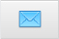

This opens the Comments form with all of the existing comments listed.

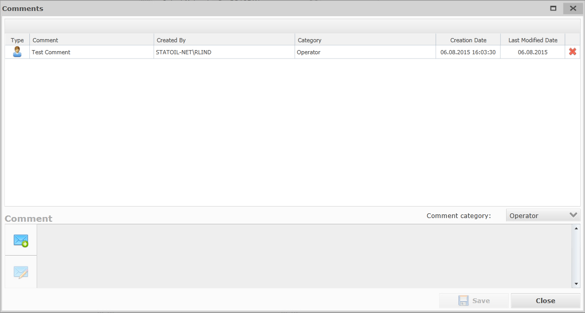

Click 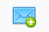 to create a new comment.

The field lets you select a category for the comment.

Click 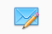with a comment selected in the list to edit the selected comment.

Click  on a comment in the list to remove that comment.

Click  to save your edited or new comment.

Click  to close the Comments form.

#### Dependencies

Orders can be dependant on one or many other orders, to ensure that they are handled in the correct order, warnings would be raised by the system if for example the time between two dependant orders has been reduced or when editing an order that depends on an incomplete order.

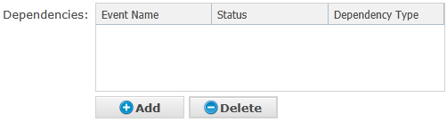

Click  to open the dependencies form which will list all applicable orders in the system (Orders with the following status will not show up in the list: Raw, Completed, Closed, Cancelled).

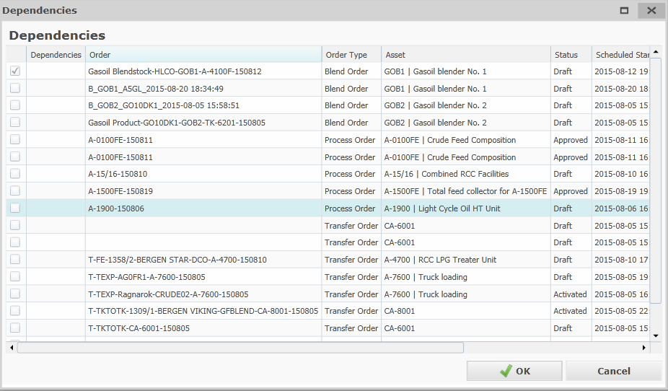

To select the dependant orders, check the respective boxes to the left of the orders in the list. 

You may also select the Dependency type; Before, Concurrent or After (Meaning the dependent order should be carried out either Before, After or at the Same time as the order you are creating/editing) in the Dependencies Column.

Click  to save your changes and close the dependencies form.

Or click  to close the dependencies form without saving.

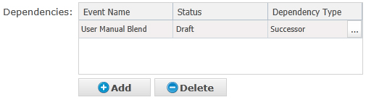

After adding a dependancy, if you didn’t select a Dependency Type when adding the dependency, you may select a type (Before, After, Concurrent) in the list of selected dependencies.

Click  with a dependency selected in the list to delete the dependency.

### Recipe

The recipe section is divided into three smaller sections; Component, Additive and Movements.

By default when viewing/editing/creating a blend order, the recipe tab will not be selected and its contents hidden.

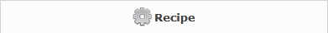

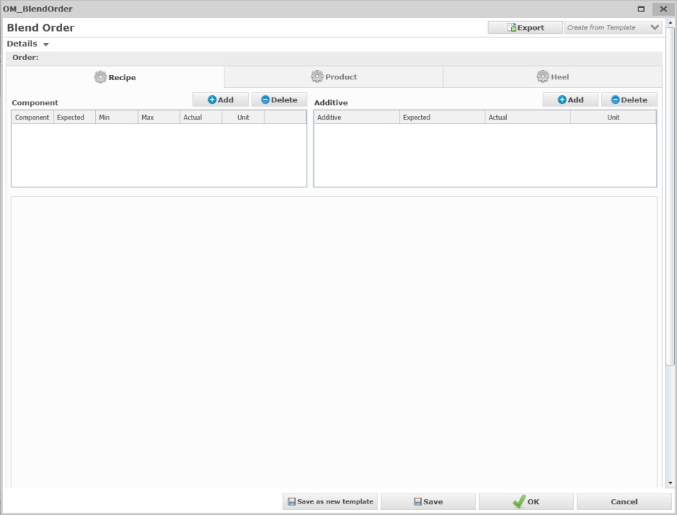

When creating a new blend order, the movements section will not be shown until the blend order has been saved.

#### Component

The component section lets you add new components to your recipe.

In order to successfully create a blend order, at least one component must exist.

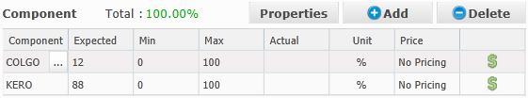

Click  to add a new row in your list of components where you can manually enter values in certain fields, only components that has been configured as potential input components to the blend order material (configurable per Material Group in Material Manager) will be possible to select. To make it easier the system will also display the components which are in service in source tanks that may be used as green and components which are not in service on the source tanks as red.

|  |  |
| --- | --- |
| **Field** | **Description** |
|  | This option lets you select a component from a drop down. |
|  | This field lets you enter the expected fraction.  In order to successfully create a blend order, the sum of all the components expected fraction must be 100% +- 0.5%. |
|  | This field lets you enter the scheduled min fraction (default is 0) |
|  | This field lets you enter the scheduled max fraction (default is 100) |
|  | This field reads the actual fraction from IP21 and is Read-Only. |
|  | This field displays the Unit of Measure for the component fraction values |
|  | Pressing this icon next to a component will open the pricing information dialog, which lets you add price information (Price, UoM, Comment) for the component. |

The total for the Expected fraction is calculated and presented above the component list, the label is colored green when the recipe fraction adds up to 100% +- 0.5% or red if it does not.

To delete a component, select it in the list and click  if a movement has been created for the component, the movement will also be deleted.

To view the component properties (If order was imported from Orion) press .

The component properties dialog opens, showing all of the recipe components and their properties scheduled values.

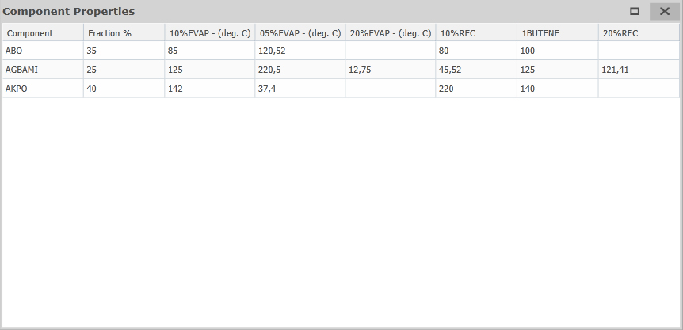

#### Additive

The additive section lets you add new additive components to your recipe.

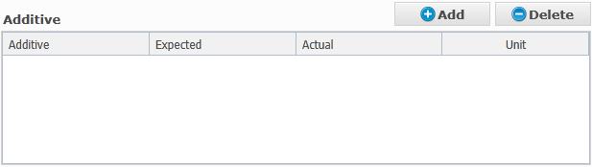

Click  to add a new row in your list of additives where you can manually enter values in certain fields. Only additives that has been configured as potential additives to use with the blend order material (configurable per Material Group in Material Manager) will be possible to select. To make it easier the system will also display the additives which are in service in source tanks that may be used as green and components which are not in service on the source tanks as red.

|  |  |
| --- | --- |
| **Field** | **Description** |
|  | This option lets you select an additive component from a drop down. |
|  | This field lets you enter the expected dosage. |
|  | This field reads the actual dosage from IP21 and is Read-Only. |
|  | This field displays the Unit of Measure for the additive component dosage values. |

### Product

The product section is divided into two smaller sections; specification and movements.

By default when viewing/editing/creating a blend order, the product tab is pre-selected and its contents visible.

To view the contents for the product, click 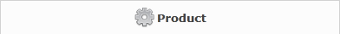.

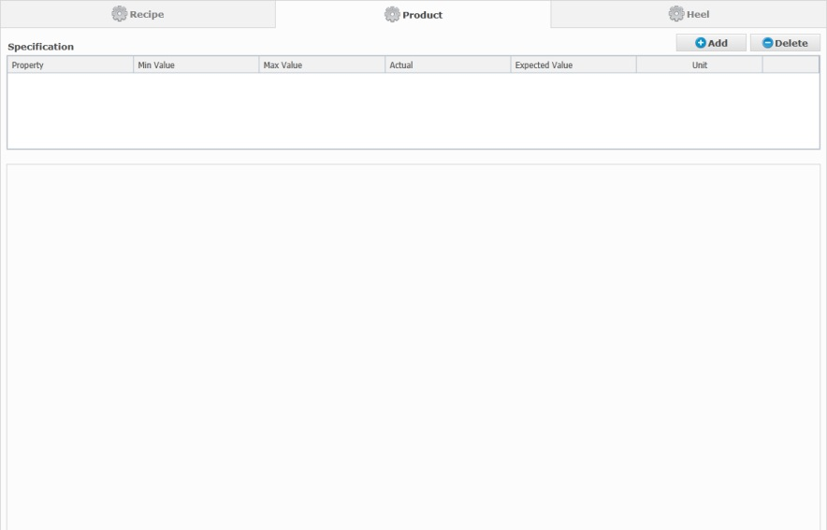

When creating a new blend order, the movements section will not be shown until you save.

#### Specification

The specification section lets you create the product specification of the blend order by adding quality parameters that are to be met in a given blend.

In order to successfully create a blend order, at least one specification property must exist.

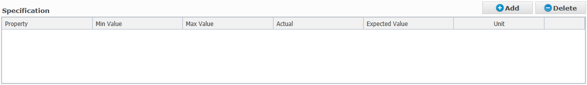

Click  to add a new row in your specification list where you can manually enter values in certain fields.

|  |  |
| --- | --- |
| **Field** | **Description** |
|  | This option lets you select a property from a drop down. List of properties is filtered on propterties that has been configured on the selected blender asset (configurable in Blender Profile). |
|  | This field lets you enter the scheduled max value for the property. |
|  | This field lets you enter the scheduled min value for the property. |
|  | This field is populated from the LIMS Sample and is Read-Only. |
|  | This field lets you enter the expected property value |
|  | This displays the Unit of Measure for the property values (unit of measure for properties is configurable in the “Mapping Quality Property” user specification, for more information about this user specification, see chapter [11.7.3](#_Mapping_Quality_Property)) |
|  | Pressing this icon next to a property will open the pricing information dialog, which lets you add price information (Price, UoM, Comment) for the property. |

To delete a property, select it in the list and click .

### Movements

Blend orders has two sections for movements, one in the recipe tab for input movements and one in the product tab for the output movement(s).

When creating a new blend order, the movement sections will not be visible until you save, this is because the system will automatically create movements based on the information you have supplied in the header and the input components/additives you have added.

A Movement will be automatically created for each component/additive in the recipe section and one movement for the chosen output material will be created in the product section.

#### Movement Grid

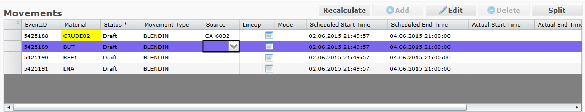

The movement grid lists all of the movements.

For input movements, Source can be edited straight from this grid and for output movements the Destination can be edited straight from this grid.  
  
Lineup can be edited in the grid for both Input and Output movements.  
By pressing the  button next to the lineup field, you may open the lineup chooser which has more information about the available lineups for the source/destination.

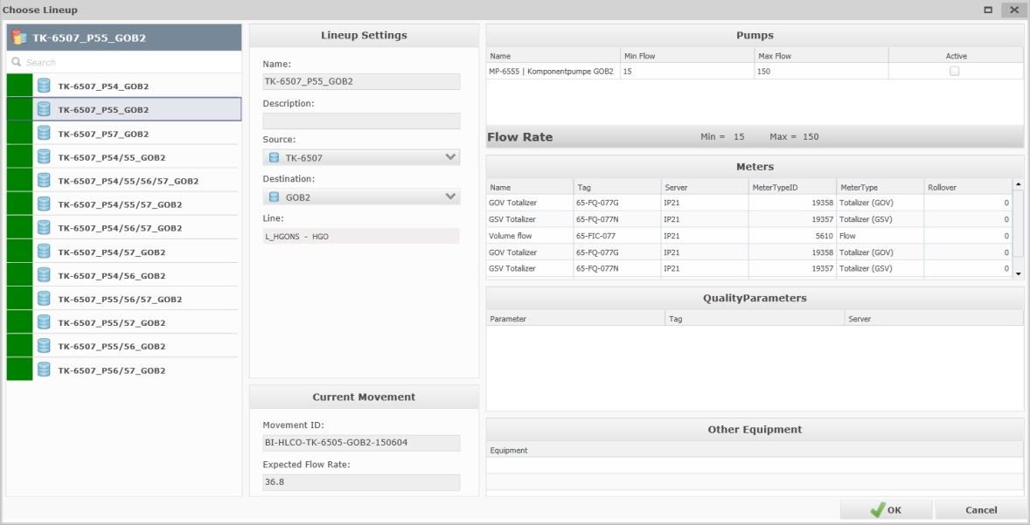

In the “lineup settings” section, the list of lines displays all of the lines configured on the lineup and the Material that was last transported in the respective lines.

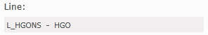

#### Movement Detail

To view / edit the movement details of a movement select it from the list of movements.

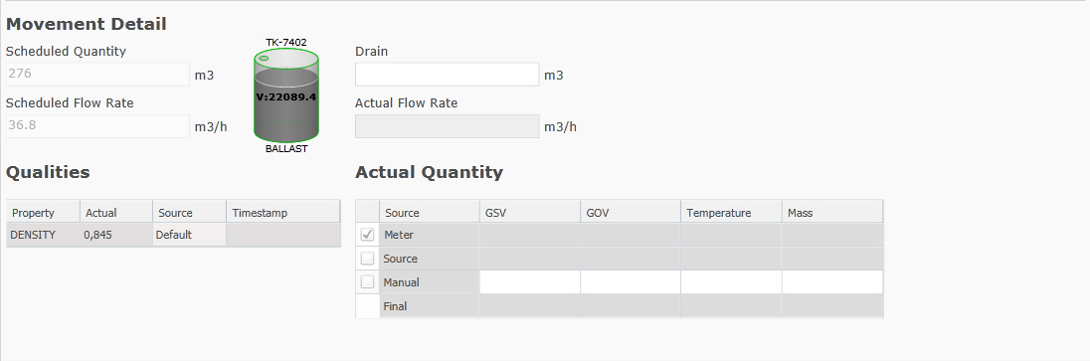

Fields:

|  |  |
| --- | --- |
| **Field** | **Description** |
|  | Read-only.  This field determines the expected quantity of the movement.  For input movements this is calculated by Ekho based on the fraction percentage of the recipe component and the quantity of the order as a whole.  For output movements this is taken from the expected quantity entered in the order header. |
|  | This icon indicates the available volume of the chosen source tank (Only visible for input movements).  If the available volume is greater or equal to the scheduled quantity, a green border is drawn around the tank illustration, else a red border is drawn to indicate that the tank does not have enough volume available to transfer the scheduled amount. |
|  | Read-only. This field determines the expected flow rate of the movement. This is calculated by Ekho based on the expected quantity of the movement and the duration of the movement. |
|  | This field determines any possible drain, any value entered here will be subtracted from the Final GSV (if material is liquid) or Final Mass (if material is solid) |
|  | Read-only.  This field reads and displays the actual flow rate of the movement from IP21. |
|  | In the qualities grid, all of the configured quality parameters on the lineup are displayed.  By pressing in the Source cell for a quality parameter  The Source Selector dialog appears.    Here you may select:  **Meter** (Reads the Tag value from the tag configured for the quality parameter on the lineup)  **Lab** (If Lab Sample has been released to Ekho this is the lab result value for the quality parameter)  **Manual** (Lets you enter a Manual value)  for Density another option is available:  **Default** the Default Density setup for the Material in the Material Manager. |
|  | This grid allows you to select the actual quantity source to use, either;  **Meter** (Default, From the Meter tags configured on the lineup, only available if tags has been configured on the lineup)  **Source** (Calculated volume change on the Source tank from the moment the movement was activated until the latest updated value or the moment the movement was completed, only available for Input movements)  **Destination** (Calculated volume change on the Destination tank from the moment the movement was activated until the latest updated value or the moment the movement was completed, only available for Output movements)  **Manual** (Lets you enter a Manual value to use)    The chosen source will apply to GSV, GOV, Temperature and Mass, it is not possible to read from Meter for GSV and have a manual value for Temperature.  The “Final” row is a summary of the chosen source value and also takes into account any possible drain entered.  If the material is liquid, the Final Mass will be calculated from the Final GSV \* Density. |

#### Edit

To edit a movement select it from the list of movements and click  over the list of movements.

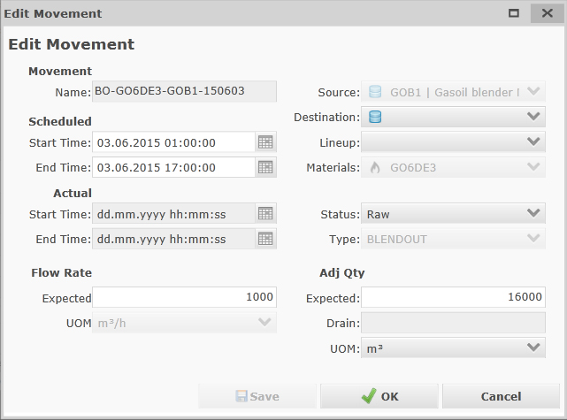

|  |  |
| --- | --- |
| **Field** | **Description** |
|  | Assigns an Movement Name to the blend order based on key value fields on the movement. (Read-Only) , will continously be updated if any of the key value fields are updated. |
|  | This option determines the scheduled start and end time of the movement. Both fields are Read-only and populated by Ekho. |
|  | This option determines the actual start and end time of the movement, actual start time will automatically be set when the movement status becomes Active. Actual end time will automatically be set when the movement status becomes Completed. |
|  | This option determines the source of the movement. (Read-only for output movements) |
|  | This option determines the destination of the movement. (Read-only for input/output movements) |
|  | This option determines the lineup to be used for the movement. If only one lineup exists for the chosen source/destination it is pre-selected automatically. For more information on Lineups see chapter [7](#_Lineup). |
|  | Read-only.  This option determines the material the movement concerns, for output movements this is inherited from the order. As soon as a source tank is chosen for input movements, material will be populated from material in service on the tank (If the material does not match the recipe component a warning will be raised when order is approved and it will not be possible to set status to Ready (Error will be shown)) |
|  | Determines the status of the movement. The available statuses a movement can have through its lifecycle are:  Raw  Draft  Approved  Ready  Initialized  Initialized Failed  Activated  Suspended  Completed  Closed  Cancelled  It is not possible to manually change status on either a BLENDIN movement or BLENDOUT movement, the status will always be inherited from the order status up until the execution phase, at which point the actual tank-meter combinations received from DCS in accordance with the DCS State determines the movement status. |
|  | Determines the type of the movement.  System generated, read-only.  BLENDIN for input movements  BLENDOUT for output movements. |

After modifying a movement, click  to save your changes,  to save and close the edit movement window or  to cancel your changes.

#### Split

An input movement can be split for when a swing tank is needed, creating two movements instead where the first movement ends on the chosen split time and the second movement begins with the new source tank.

To split a movement, select it from the list of movements and click .

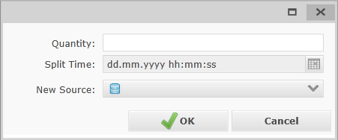

If the movement status is lesser than Active, the Split Time field is read-only and a Quantity may be entered, based on the quantity entered here and the flow rate of the movement, the split time will be calculated automatically by Ekho, the first movement of the two will have an expected quantity that is equal to the quantity entered here.

If the movement status is Active, the Quantity field is read-only and the Split Time (default “now”) should be used to determine at which point in time the movement should be split.

The New Source field allows you to choose the new tank that should be used for the second movement of the two.

To split the movement, click  or  to cancel the split.

#### Delete

If a component only has one associated input movement (meaning the movement has not been split), it is not possible to cancel or delete this movement, instead the component would have to be deleted in order to delete the movement, this is only possible when the movement status is <= “Approved”.

If a component has multiple associated input movements (meaning the movement has been split one or more times) it is possible to cancel and delete movements as long as the movement status is <= “Approved”.

When a split movement is deleted, either the scheduled start or end time of the remaining movement(s) will automatically adjust to fill the duration of the order. This depends on the chronology of the movements.  
  
If the first movement is deleted, the start time of the next movement will be pushed back to the start time of the order. If the last movement is deleted, the end time of the previous movement will be pushed forward to the end time of the order. If a movement in the middle is deleted, the end time of the previous movement will be pushed forward to the start time of the next movement.

#### Movement Segments

When a movement is activated, movement segments are created for the movement.

If the movement is expected to span multiple days, mulitple movement segments are created where each midnight a movement segment ends and a new begins.

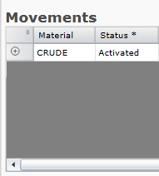

It is possible to to view all of the movement segments in the movements grid by pressing the  button to the far left of the movement row in the grid.

This will expand the movement listing all of the movement segments beneath.

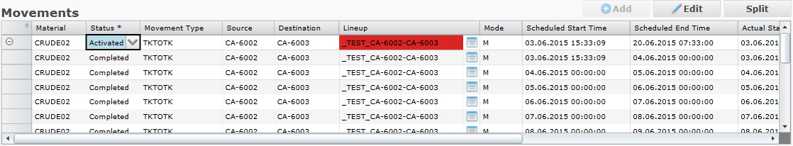

Each movement segment can be selected in the grid and has the same Movement Detail options available as the Movement, where it is possible to select actual quantity source, enter drain, etc.

Some rules are in place to handle this;

* Whenever Manual quantity source is selected for a movement segment, manual is selected for all other movement segments as well.
* If Meter/Source/Destination has already been chosen for a segment before Manual value is selected, the Meter/Source/Destination value is copied to the Manual value field and Manual value is selected, it is still possible to edit the Manual value and all segments may have different manual values.
* When the order is completed, if Meter is selected as source for the movement, meter is selected for all segments.
* When the order is completed, the Final values on the Movement level will be compared to the total values of the segments and any existing delta is assigned to the Final values of the last movement segment.

### Heel

The heel section shows you information surrounding the quality and quantity of the heel.

To view the contents for the heel, click

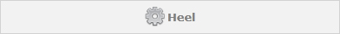  
  
If heel information exists on the order you import from Orion, the property name, scheduled value and unit will be displayed in the list. When the order is set to Ready, Ekho will evaluate the Actual heel qualities and populate the Actual column, if the actual values are different from the scheduled the user will get a warning and have the choice of either accepting the difference and moving to ready or to go back to Approved and view/alter the heel.

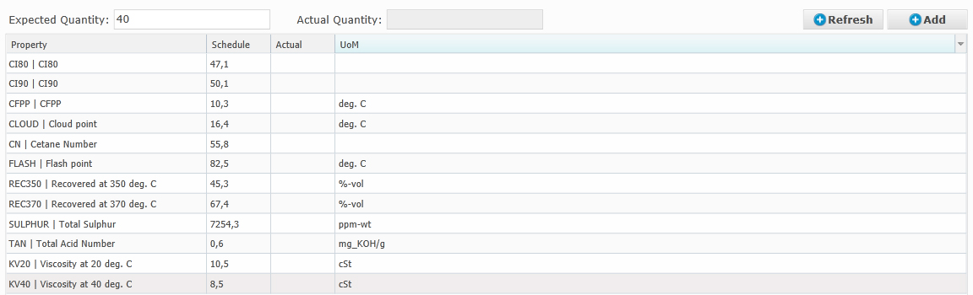

The Expected Heel Quantity field will display the scheduled heel qty value from Orion, it is possible to manually enter a Heel quantity value.



When the order is set to Ready, Ekho will evaluate the Actual heel quantity and populate the Actual Quantity field.



If the actual quantity is different from the scheduled with respect of a 0.5% tolerance with respect of the storage capacity, the user will get a warning and have the choice of either accepting the difference and moving to ready or to go back to Approved and view/alter the heel.

#### Add Manual Heel

It is possible to manually add Heel information to a Blend order. To add heel qualities, press the  button over the Heel grid. A new row is added to the list where you may select a property, scheduled value and actual value if need be.

#### Refresh Heel

It is possible to manually refresh the actual heel quantity/qualities before going to status Ready by pressing the 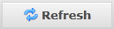 button over the Heel grid.

### Blend Report

Users may choose to export a blend order as either an excel or PDF blend report by pressing in the top right corner of the order dialog and selecting either .PDF or .XLSX from the dropdown.

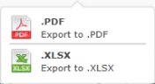

## Process Orders

The form for creating/editing/viewing a process order is divided up into five sections; Details, Streams, Quality, Movements and Operating Parameters.

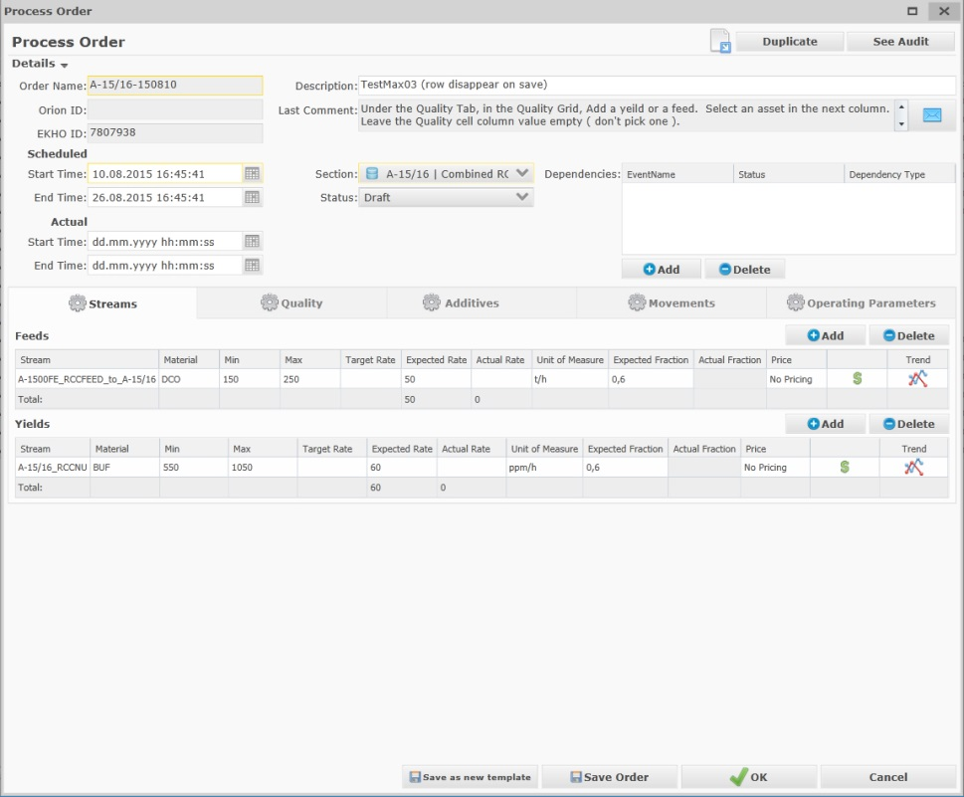

The details header can be collapsed to give more room for the other three sections, streams, movements and operating parameters. Click on to hide the header.

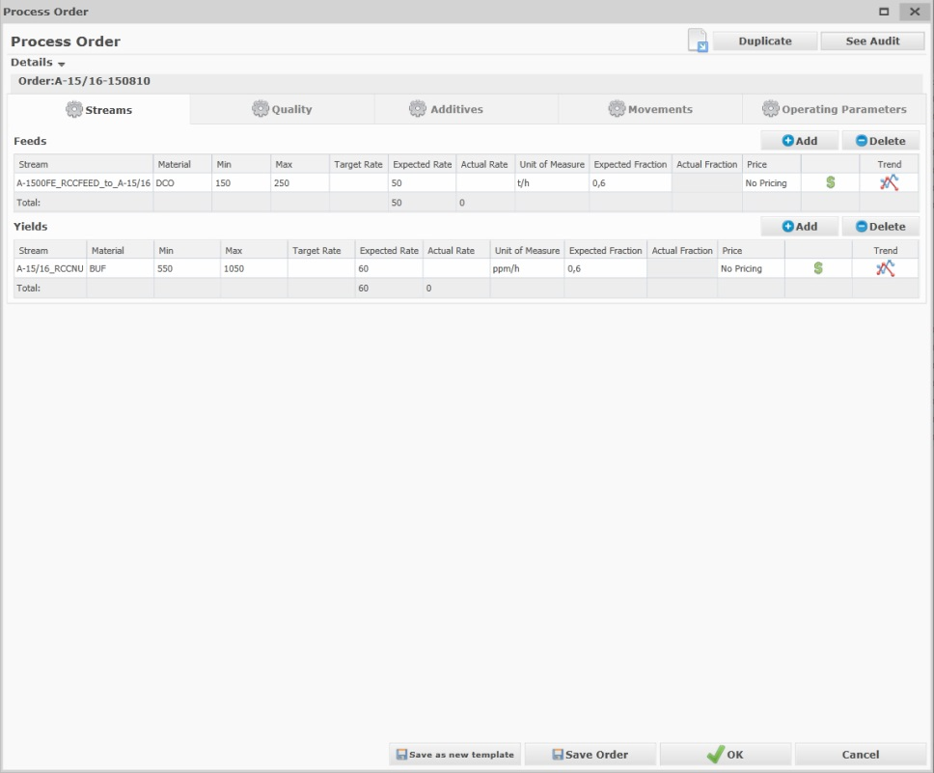

### Details

In order to successfully create a process order, some of the fields in the details header must be assigned a value.

|  |  |  |
| --- | --- | --- |
| **Detail** | **Description** | **Optional?** |
|  | Assigns an Order Name to the blend order based on key value fields on the order. (Read-Only), will continously be updated if any of the key value fields are updated. | NO |
|  | Assigns the corresponding Orion ID if one exists (Read-Only). | YES |
|  | Automatically assigns an Ekho ID to the blend order. | NO |
|  | Determines the scheduled Start and End time of the order. | NO (Start time) YES (End time) |
|  | Determines the actual start and end time of the order. | YES (up to Activated) |
|  | Assigns a description to the order. | YES |
|  | Shows the last comment. | YES |
|  | Defines the section (process unit) the process order corresponds to. | NO |
|  | Assigns the status of the process order, by default this is set to Draft or Raw if the order was imported from Orion.  The available statuses a process order can have through its lifecycle are:   1. Raw (Set on new imported orders) 2. Draft (Default for manually created orders) 3. Approved (Manually set by user to indicate that the scheduled order is approved for execution) 4. Initialized (Manually set by user to initialize the order) 5. Initialized Failed (Automatically set if target values cannot be written to IP21 on initialization) 6. Activated (Automatically set by Ekho if Initialization succeeds) 7. Closed (Automatically set by Ekho when a new process order for the same Process Unit is Initialized, Active order can be manually closed at any time) 8. Cancelled (Set by user to indicate that the order has been abandoned and should not be executed) | NO |
|  | Determines if the order is dependent on another order. | YES |

For information on how to handle comments, see chapter: [3.3.1.1](#_Comments)

For information on how to handle dependencies, see chapter: [3.3.1.2](#_Dependencies)

### Streams

The stream section is divided into two smaller sections, Feeds and Yields.

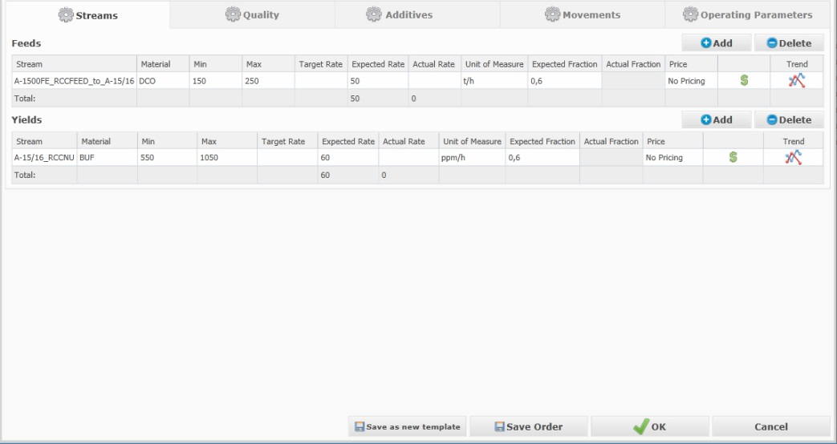

The stream tab will automatically be selected when editing or creating a new process order.

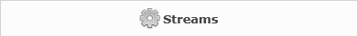

#### Feeds

If the Process unit has configured feed stream(s), at least one feed stream must be added to the order.

Click  to add a new row for feed streams where you can manually input certain fields.

|  |  |
| --- | --- |
| **Field** | **Description** |
|  | This option lets you select which feed stream to use from a dropdown. Only Feed streams that are children of the selected process unit are visible in the selection list. |
|  | This option lets you select a material (a default material can be configured per stream in the Stream Profile, for more information about stream profiles see chapter [8.8.5](#_Stream_Profiles)). |
|  | This field lets you input a min rate for the feed stream. |
|  | This field lets you input a max rate for the feed stream. |
|  | If the expected rate = min or max it becomes the Target Rate (Read-only) |
|  | This option lets you input an Expected rate for the feed stream. |
|  | This field reads the actual rate on the feed stream from IP21 and is read only. |
|  | Displays the UoM |
|  | This option lets you input an Expected fraction for the feed stream |
|  | This option reads the actual fraction from IP21 and is read only. |
|  | Pressing this icon next to a feed stream will open the pricing information dialog, which lets you add price information (Price, UoM, Comment) for the feed stream. |

A total row is present in the Feed list, which displays the total Expected/Target Rate and the total Actual rate.



To delete a feed stream, select it in the list and click .

#### Yields

If the Process unit has configured yield stream(s), at least one yield stream must be added to the order.

Click  to add a new row for yield streams where you can manually input certain fields.

|  |  |
| --- | --- |
| **Field** | **Description** |
|  | This option lets you select which stream to use from a dropdown. Only Yield streams that are children of the selected process unit are visible in the selection list. |
|  | This option lets you select a material (a default material can be configured per stream in the Stream Profile, for more information about stream profiles see chapter [8.8.5](#_Stream_Profiles)). |
|  | This field lets you input a min rate for the yield stream. |
|  | This field lets you input a max rate for the yield stream. |
|  | If the expected rate = min or max it becomes the Target Rate (Read-only) |
|  | This option lets you input an Expected rate for the yield stream. |
|  | This field reads the actual rate on the yield stream from IP21 and is read only. |
|  | This option lets you select which Unit to measure the flow rates with. |
|  | This option lets you input an Expected fraction for the yield stream |
|  | This option reads the actual fraction from IP21 and is read only. |
|  | Pressing this icon next to a yield stream will open the pricing information dialog, which lets you add price information (Price, UoM, Comment) for the yield stream. |

A total row is present in the Yield list, which displays the total Expected/Target Rate and the total Actual rate.



To delete a yield stream, select it in the list and click .

### Quality

When editing or creating a new process order, the Quality tab is not selected and it’s contents hidden. To access the qualities, click

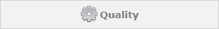

The quality section allows you to add quality properties that should be met on the feed/yield streams.

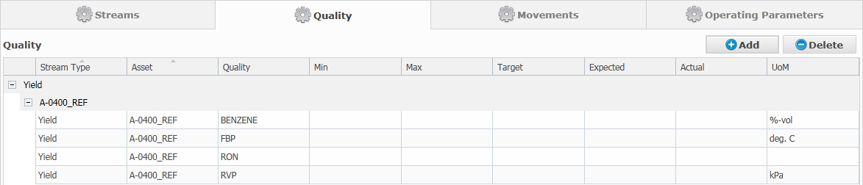

#### Add Quality

To add a new quality property press the  button.

A new row is added to the grid.

|  |  |
| --- | --- |
| **Field** | **Description** |
| Stream Type | Determines if the property is for a feed or yield stream. |
| Asset | Determines which stream the property is for. |
| Quality | Determines the quality property. |
| Min | Determines the Min value for the quality property. |
| Max | Determines the Max value for the quality property. |
| Target | If Expected value = Min or Max (with respect of configured tolerance) expected value becomes the Target value. |
| Expected | Determines the Expected value for the quality property. |
| Actual | Reads the Actual value from IP21 and is read-only |
| UoM | Displays the unit of measure for the quality property. (Unit of measure for quality properties is configurable in the “Mapping Quality Property” unit specification, for more information about this user specification, see chapter: [11.7.3](#_Mapping_Quality_Property)). |

The list of properties will be grouped on Stream Type and Asset.

#### Delete Quality

To delete a quality property, select the entry you want to remove and press the  button.

### Additives

When editing or creating a new process order, the Additives tab is not selected and it’s contents hidden. To access the additive streams, click

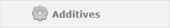

The additives section allows you to add additive feed/yield streams to the process unit order.

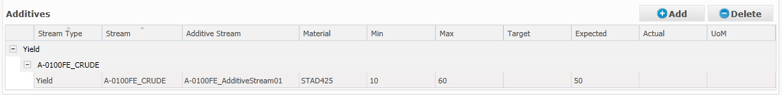

#### Add Additive Stream

To add a new additive feed/yield stream press the  button.

A new row is added to the grid.

|  |  |
| --- | --- |
| **Field** | **Description** |
| Stream Type | Determines if the additive stream is for a feed or yield stream. |
| Stream | Determines which stream the additive stream is a child of. |
| Material | Determines the additive material, a default material can be configured in the Additive Feed/Yield Stream Profile. |
| Min | Determines the Min dosage for the additive stream. |
| Max | Determines the Max dosage for the additive stream. |
| Target | If Expected value = Min or Max (with respect of tolerance) expected value becomes the Target value. |
| Expected | Determines the Expected dosage for the additive stream. |
| Actual | Reads the Actual dosage from IP21 and is read-only |
| UoM | Displays the unit of measure. |

#### Delete Additive Stream

To delete an additive stream, select the entry you want to remove and press the  button.

### Movements

When editing or creating a new process order, the Movements tab is not selected and it’s contents hidden. To access the movements, click

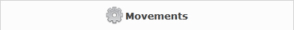

When creating a new process order, the movements tab will be empty, this is because you must save your process order before you can add movements.

All RUNDOWN and FEED movements existing in ekho associated to the process unit and timeframe of the process order will automatically be shown in the list of movements.

#### Movement Grid

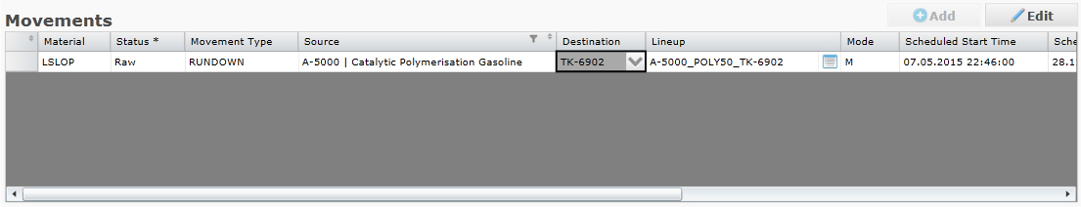

The movement grid lists all of the movements.

For FEED movements, Source can be edited straight from this grid and for RUNDOWN movements the Destination can be edited straight from this grid.  
  
Lineup can also be edited straight from this grid.  
By pressing the  button next to the lineup field, you may open the lineup chooser which has more information about the available lineups for the source/destination.



In the “lineup settings” section, the list of lines displays all of the lines configured on the lineup and the Material that was last transported in the respective lines.



#### Movement Detail

To view / edit the movement details of a movement select it from the list of movements.



Fields:

|  |  |
| --- | --- |
| **Field** | **Description** |
|  | This field determines the expected quantity of the movement. |
|  | This icon indicates the available volume of the chosen source tank (Only visible if source is a tank).  If the available volume is greater or equal to the scheduled quantity, a green border is drawn around the tank illustration, else a red border is drawn to indicate that the tank does not have enough volume available to transfer the scheduled amount. |
|  | This field determines the expected flow rate of the movement. |
|  | This field determines any possible drain, any value entered here will be subtracted from the Final GSV (if material is liquid) or Final Mass (if material is solid) |
|  | Read-only.  This field reads and displays the actual flow rate of the movement from IP21. |
|  | In the qualities grid, all of the configured quality parameters on the lineup are displayed.  By pressing in the Source cell for a quality parameter  The Source Selector dialog appears.    Here you may select:  **Meter** (Reads the Tag value from the tag configured for the quality parameter on the lineup)  **Lab** (If Lab Sample has been released to Ekho this is the lab result value for the quality parameter)  **Manual** (Lets you enter a Manual value)  for Density another option is available:  **Default** the Default Density setup for the Material in the Material Manager. |
|  | This grid allows you to select the actual quantity source to use, either;  **Meter** (Default, From the Meter tags configured on the lineup, only available if tags has been configured on the lineup)  **Source** (Calculated volume change on the Source tank from the moment the movement was activated until the latest updated value or the moment the movement was completed, only available if source is a tank)  **Destination** (Calculated volume change on the Destination tank from the moment the movement was activated until the latest updated value or the moment the movement was completed, only available is destination is a tank)  **Manual** (Lets you enter a Manual value to use)    The chosen source will apply to GSV, GOV, Temperature and Mass, it is not possible to read from Meter for GSV and have a manual value for Temperature.  The “Final” row is a summary of the chosen source value and also takes into account any possible drain entered.  If the material is liquid, the Final Mass will be calculated from the Final GSV \* Density. |

#### Add

To add a new movement, click  over the list of movements.

Process Unit movements are defined as transfer orders with Transfer Type FEED or RUNDOWN, for more information on transfer orders see chapter: [3.5](#_Transfer_Orders)

When importing an order from Orion, Ekho will check for each stream available on the order if it is associated with a lineup in Ekho, if it is, a cold stream transfer order (FEED or RUNDOWN) will be automatically created.  
  
The “Mapping Lineup” user specification is used for this purpose, for more information about this user specification, see chapter: [11.7.6](#_Mapping_Lineup)

#### Edit

To edit a movement, select it in the movement list and click  over the list of movements.

The Edit Transfer Order dialog will appear.

### Operating Parameters

The Operating Parameters section lets you view any operating parameters for the process unit that are active within the duration of the process order that are to be targeted and followed.

When editing or creating a new process order, the Operating Parameters tab is not selected and it’s contents hidden. To access the operating parameters, click 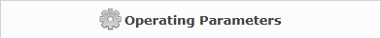.

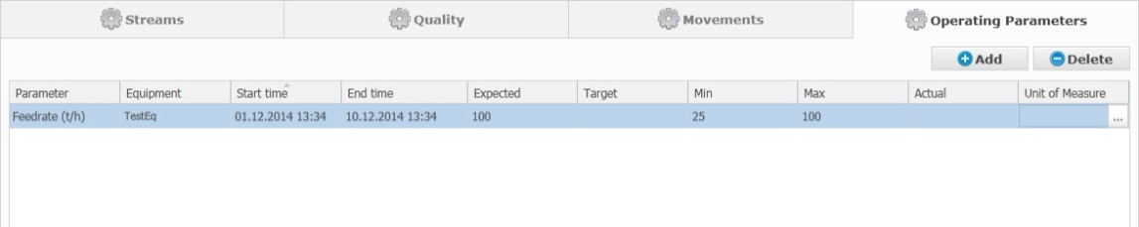

The operating parameters are read-only from the order dialog, to add or maintain operating parameters the Operating Parameters page is available.

#### Operating Parameters Page

To view or add operating parameters in the system, click the  button and select the Operating Parameters option from the dropdown.

**Add Operating Parameter**

Click  to add a new operating parameter.

An Add/Edit Operating Parameter popup dialog appears where you may choose a parameter.

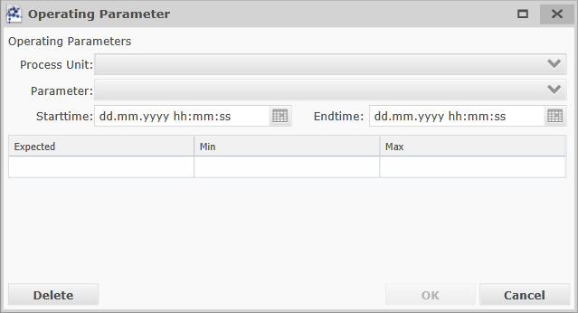

|  |  |
| --- | --- |
| **Field** | **Description** |
|  | Lets you select the process unit the operating parameter is for. |
|  | Lets you select a parameter – equipment combination that has been configured for the process unit in the “Process Unit Profile” for more information about the process unit profile, see chapter: [8.8](#_Process_Unit) |
|  | Lets you select when the parameter should be valid from (if the time frame coincides with any process order for the same unit, the parameter will automatically be part of that order). |
|  | Lets you select when the parameter should be valid until (if the time frame conicides with any process order for the same unit, the parameter will automatically be part of that order). |
|  | Determines the expected value of the parameter. |
|  | Determines the min limit on the parameter. |
|  | Determines the max limit on the parameter. |

To add the parameter, press the  button or  to cancel the operation.

After pressing “OK” the operating parameter will be added.

If the newly added operating parameters start time is within the duration for another of the same operating parameter – equipment – process unit combination. The old operating parameters end time will automatically be set to the start time of the new parameter.

**Edit Operating Parameter**

To edit an operating parameter, select the parameter you want to edit in the event editor grid and press the  button. If the start time of the operating parameter is greater than “now” you are allowed to edit the Start/End time, Expected, Min and Max values. Otherwise the entire operating parameter will be read-only.

**Delete Operating Parameter**

To remove an operating parameter, press the  from within the Add/Edit Operating Paramater dialog. Note that it is only possible to delete operating parameters whose start time is greater than “now”.

### Trend Charts

It is possible to view a trend chart of the min/max/expected/target/actual values for both stream rates, properties and operating parameters. The trend chart plots from the actual start of the process unit order to either “now” if the order is active or until the actual end time of the process unit order if it is closed.

To view the trend chart, press the 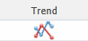 button in the trend column for the stream / property / operating parameter you want to see.

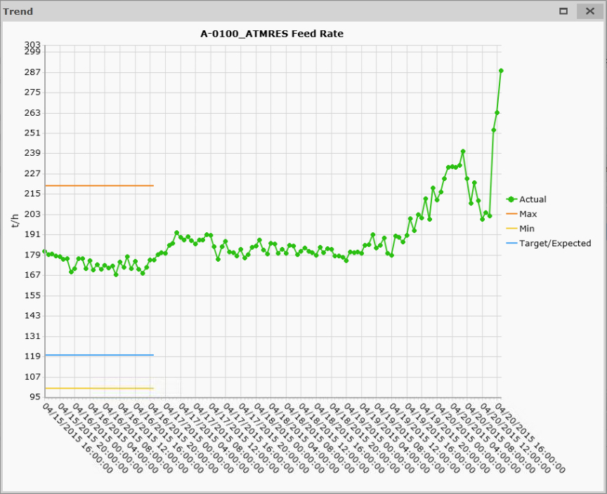

The Actual, Max, Min, Target/Expected labels can be clicked to toggle on or off their plot line.

### Compare Process Orders

From a draft/approved process order, if an activated process order exists for the same process unit, it is possible to compare the scheduled values for the two orders by pressing the  button.

The Compare dialog is opened.

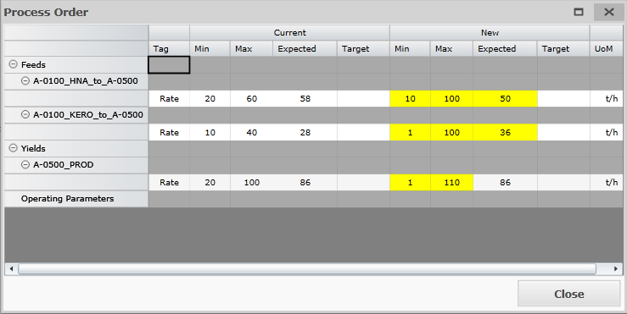

The compare dialog lists all of the Feed/yield stream rates, qualities and additives as well as the operating parameters; Min, Max, Expected and Target values, for both the Current Active order and the new scheduled order. If any of the scheduled values in the new order differs from the current Active order, the value will be highlighted with a yellow background.

### Process Order Report

Users may choose to export a process order as either an excel or PDF process order report by pressing in the top right corner of the order dialog and selecting either .PDF or .XLSX from the dropdown.



## Transfer Orders

The form for creating/editing/viewing a transfer order is divided into two sections, Details and Movements.

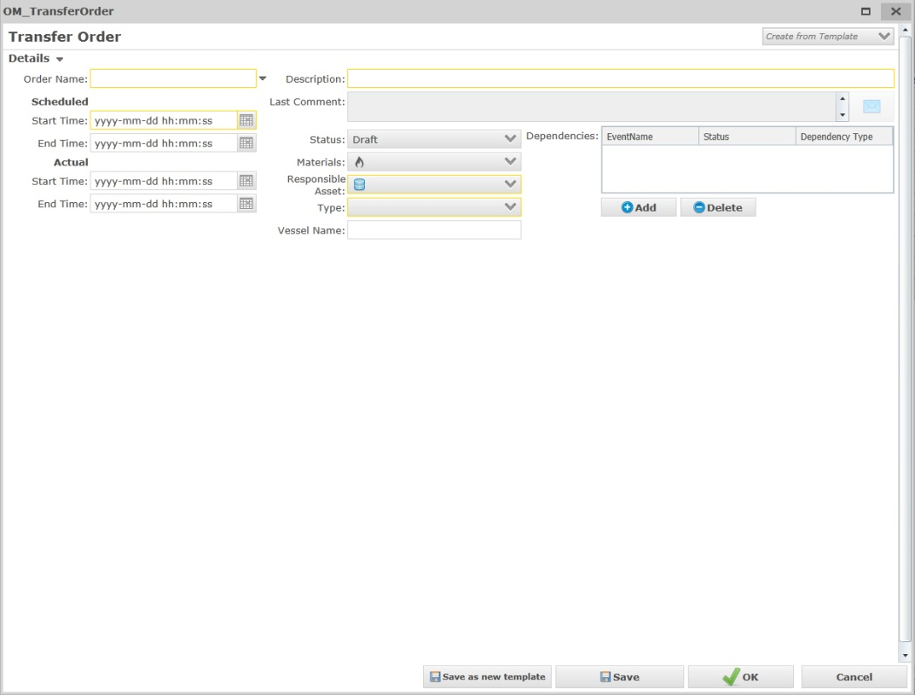

When opening a transfer order some fields will not be visible, these are Nomination ID, Orion ID, ERP ID and Ekho ID, to view these fields click next to the Order Name field.

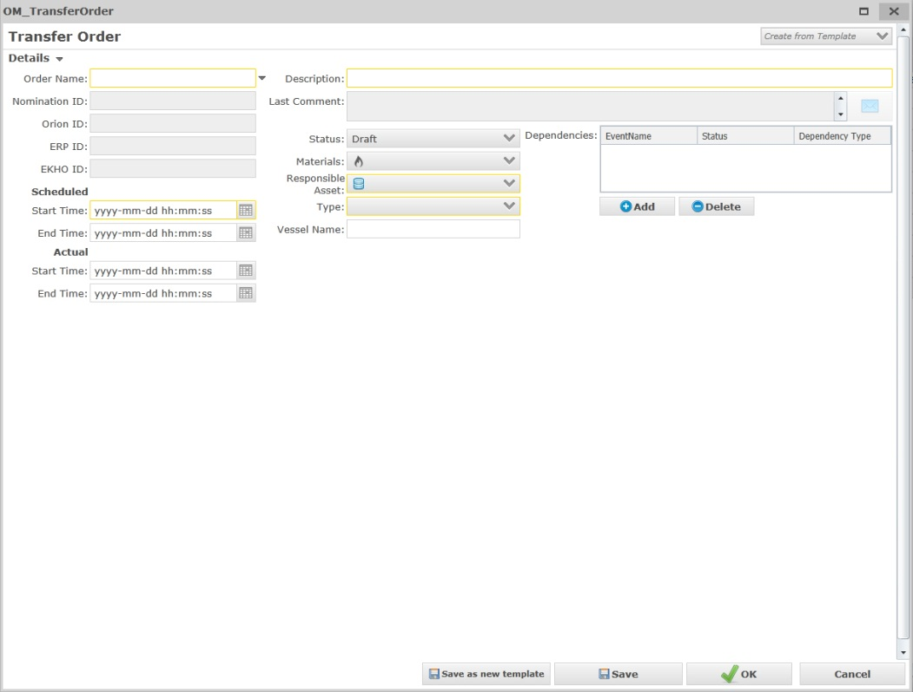

The details header can be collapsed to give more room for the movements section. Click on to hide the header.

### Details

In order to successfully create a draft transfer order, some of the fields in the details header must be assigned a value.

|  |  |  |
| --- | --- | --- |
| **Detail** | **Description** | **Optional?** |
|  | Assigns an Order Name to the blend order based on key value fields on the order. (Read-Only), will continously be updated if any of the key value fields are updated. | NO |
|  | Assigns a Nomination ID to the transfer if one exists (Read-Only). | YES |
|  | Assigns the corresponding Orion ID if one exists (Read-Only). | YES |
|  | Assigns the corresponding ERP ID if one exists. Also lets you manually select an existing ERP\_ID from SPORT.  For certain Transfer Types an ERP\_ID must be supplied before the order can be approved. The types are:  PUMPBACK  CRTRANS  IMPORT  EXPORT | YES |
|  | Automatically assigns an Ekho ID to the transfer order. | NO |
|  | Determines the scheduled Start and End time of the order. End Time is read-only and calculated by Ekho using the scheduled start, flow rate of the movement(s) and total scheduled quantity) | NO (Start time) YES (End time for Raw/Draft) |
|  | Determines the actual start and end time of the order. Automatically set by Ekho when order is activated/completed. | YES (up until activated) |
|  | Assigns a description to the order. | YES |
|  | Shows the last comment. | YES |
|  | The status on the Transfer Order level is read-only and inherited from its movement(s).  The available statuses a movement can have through its lifecycle are:  **Pre-Execution**   1. Raw (Set on new imported orders) 2. Draft (Default for manually created orders) 3. Approved (At least one movement is approved but no movement has a higher status) 4. Ready (At least one movement is Ready but no movement has a higher status) 5. Initialized (At least one movement is initialized but no movement has a higher status) 6. Initialized Failed (Initialization failed for a movement and no other movement has a higher status than Initialized)   **Execution**   1. Activated (At least one movement is Activated)   **Post-Execution**   1. Completed (all movements are in a post-execution state and at least one has status Completed) 2. Closed (All movements has status Closed)   **Other**   1. Suspended (All movements are suspended or one movement is in “Pre-execution” state and one is in “Post-Execution” state. 2. Cancelled (All movements are cancelled) | NO |
|  | Determines the material that will be transferred. | YES (for Raw/Draft) |
|  | Determines the asset responsible for the transfer (depending on the Type, the label for this control may change, this is configured in the “OrderType ResponsibleAsset” user specification, for more information about this user specification see chapter: [11.7.7](#_OrderType_ResponsibleAsset)). | NO |
|  | Determines which type of transfer it is. Depending on the Type, the Responsible asset will be automatically set (this is configured in the “OrderType ResponsibleAsset” user specification, for more information about this user specification see chapter: [11.7.7](#_OrderType_ResponsibleAsset) )  Available choices are:  **TKTOTK** (Used for tank to tank transfers)  **CRTRANS** (Used for Crude Transfers)  **FEED** (Used for cold stream transfers from feeder tanks)  **RUNDOWN** (Used for cold stream transfers to rundown tanks)  **PIPEIMP** (Used for pipeline imports)  **PUMPBACK** (Used for pumping back from ship to a tank for nominated orders)  **IMPORT** (Used for nominated import transfers to the refinery)  **EXPORT** (Used for nominated export transfers from the refinery) **TRUCKEXP** (Used for Truck Loading orders, Ekho will look for Active TRUCKEXP orders in Ekho which information from SPORT applies to based on material and import the quantity information from SPORT to a new movement segment on the TRUCKEXP order in Ekho.)  **TRUCKIMP**  **OWNCONSUMPTION** (Used for tracking fuel and flare consumptions) | NO |
|  | Assigns the name of the potential Vessel used for import/export. | YES (No for Approved if an ERPID has been supplied) |
|  | Determines if the order is dependent on another order. | YES |

For information on how to handle comments, see chapter: [3.3.1.1](#_Comments)

For information on how to handle dependencies, see chapter: [3.3.1.2](#_Dependencies)

### Movements

When creating a new transfer order, the movement section will not be visible until you save. When the order is saved for the first time, one movement will be created automatically based on the order information.

#### Movement Grid

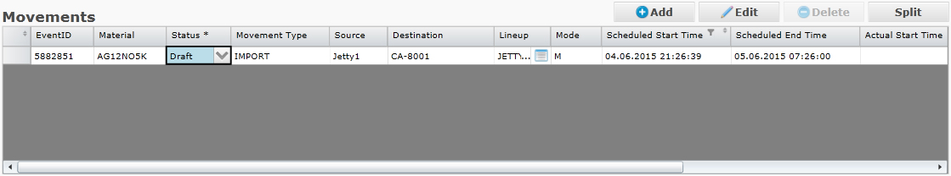

The movement grid lists all of the movements.

Source or Destination can be edited straight from this grid depending on which of the two is the Responsible Asset (Responsible Asset cannot be edited from here).  
  
Lineup and Status can also be edited straight from this grid.

The Mode column indicates whether the movements lifecycle will be handled; Manual (M) or if Ekho - DCS state tags has been configured on the chosen lineup; Automatic (A)

By pressing the  button next to the lineup field, you may open the lineup chooser which has more information about the available lineups for the source/destination.



In the “lineup settings” section, the list of lines displays all of the lines configured on the lineup and the Material that was last transported in the respective lines.



#### Movement Detail

To view / edit the movement details of a movement select it from the list of movements.



Fields:

|  |  |
| --- | --- |
| **Field** | **Description** |
|  | This field determines the expected quantity of the movement. (Required to be able to Approve order) |
|  | This icon indicates the available volume of the chosen source tank (Only visible for if source is a tank).  If the available volume is greater or equal to the scheduled quantity, a green border is drawn around the tank illustration, else a red border is drawn to indicate that the tank does not have enough volume available to transfer the scheduled amount. |
|  | This field determines the expected flow rate of the movement. (Required to be able to Approve order) |
|  | This field determines any possible drain, any value entered here will be subtracted from the Final GSV (if material is liquid) or Final Mass (if material is solid) |
|  | Read-only.  This field reads and displays the actual flow rate of the movement from IP21. |
|  | In the qualities grid, all of the configured quality parameters on the lineup are displayed.  By pressing in the Source cell for a quality parameter  The Source Selector dialog appears.    Here you may select:  **Meter** (Reads the Tag value from the tag configured for the quality parameter on the lineup)  **Lab** (If Lab Sample has been released to Ekho this is the lab result value for the quality parameter)  **Manual** (Lets you enter a Manual value)  for Density another option is available:  **Default** the Default Density setup for the Material in the Material Manager. |
|  | This grid allows you to select the actual quantity source to use, either;  **Meter** (Default, From the Meter tags configured on the lineup, only available if tags has been configured on the lineup)  **Source** (Calculated volume change on the Source tank from the moment the movement was activated until the latest updated value or the moment the movement was completed, only available if source is a tank)  **Destination** (Calculated volume change on the Destination tank from the moment the movement was activated until the latest updated value or the moment the movement was completed, only available is destination is a tank)  **Manual** (Lets you enter a Manual value to use)    The chosen source will apply to GSV, GOV, Temperature and Mass, it is not possible to read from Meter for GSV and have a manual value for Temperature.  The “Final” row is a summary of the chosen source value and also takes into account any possible drain entered.  If the material is liquid, the Final Mass will be calculated from the Final GSV \* Density. |

#### Add

To add a new movement, click  over the list of movements.

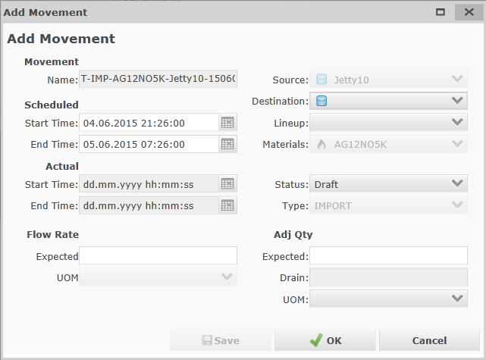

|  |  |
| --- | --- |
| **Field** | **Description** |
|  | Assigns an Movement Name to the blend order based on key value fields on the movement. (Read-Only) , will continously be updated if any of the key value fields are updated. |
|  | This option determines the scheduled start and end time of the movement. End time is read only and calculated by Ekho from expected quantity and flow rate. |
|  | This option determines the actual start and end time of the movement, actual start time will automatically be set when the movement status becomes Active. Actual end time will automatically be set when the movement status becomes Completed. |
|  | This option determines the source of the movement. (Read-only depending on Responsible Asset) |
|  | This option determines the destination of the movement. (Read-only depending on Responsible Asset) |
|  | This option determines the lineup to be used for the movement. If only one lineup exists for the chosen source/destination it is pre-selected automatically. A lineup is required in order to set Movement to Ready. For more information on Lineups see chapter [10](#_Lineup). |
|  | Read-Only.  This option determines the material the movement concerns, initially this is inherited from the order. If a source tank is selected, the material will be inherited from the material in service on the tank and a warning will appear if the material is different from the order material. |
|  | This option determines the status of the movement. The available statuses a movement can have through its lifecycle are:  Raw (Set on new imported orders)  Draft (Default for manually created orders)  Approved  Ready  Initialized  Initialized Failed  Activated  Suspended  Completed  Closed  Cancelled |
|  | This option determines the type of the movement and is inherited from the order. Read-only. |

After filling in the required fields on a new movement, click  to save your changes,  to save and close the add movement window or  to cancel your changes.

#### Edit

To edit a movement select it from the list of movements and click  over the list of movements.



After modifying a movement, click  to save your changes,  to save and close the edit movement window or  to cancel your changes.

#### Split

A movement can be split for when a swing tank is needed, creating two movements instead where the first movement ends on the chosen split time and the second movement begins with the new source or destination (depending on responsible asset) tank.

To split a movement, select it from the list of movements and click .

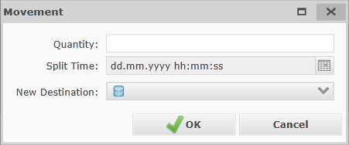

If the movement status is lesser than Active, the Split Time field is read-only and a Quantity may be entered, based on the quantity entered here and the flow rate of the movement, the split time will be calculated automatically by Ekho, the first movement of the two will have an expected quantity that is equal to the quantity entered here.

If the movement status is Active, the Quantity field is read-only and the Split Time (default “now”) should be used to determine at which point in time the movement should be split.

The New Source/Destination field allows you to choose the new tank that should be used for the second movement of the two as either source or destination depending on Reponsible Asset (If Responsible Asset is Source then a new Destination can be chosen and vice versa).

To split the movement, click  or  to cancel the split.

#### Movement Segments

When a movement is activated, movement segments are created for the movement.

If the movement is expected to span multiple days, mulitple movement segments are created where each midnight a movement segment ends and a new begins.



It is possible to to view all of the movement segments in the movements grid by pressing the  button to the far left of the movement row in the grid.

This will expand the movement listing all of the movement segments beneath.



Each movement segment can be selected in the grid and has the same Movement Detail options available as the Movement, where it is possible to select actual quantity source, enter drain, etc.

Some rules are in place to handle this;

* Whenever Manual quantity source is selected for a movement segment, manual is selected for all other movement segments as well.
* If Meter/Source/Destination has already been chosen for a segment before Manual value is selected, the Meter/Source/Destination value is copied to the Manual value field and Manual value is selected, it is still possible to edit the Manual value and all segments may have different manual values.
* When the order is completed, if Meter is selected as source for the movement, meter is selected for all segments.
* When the order is completed, the Final values on the Movement level will be compared to the total values of the segments and any existing delta is assigned to the Final values of the last movement segment.

### Transfer Report

Users may choose to export a transfer order as either an excel or PDF transfer report by pressing in the top right corner of the order dialog and selecting either .PDF or .XLSX from the dropdown.



## Import Order

Orders can be imported from Orion and Sport into the Ramses system.

Click  and choose Import Orders to open the Import Order form.

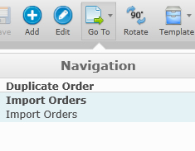

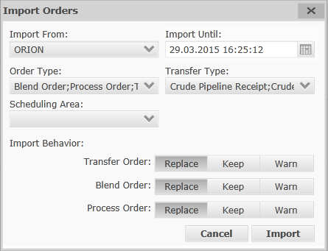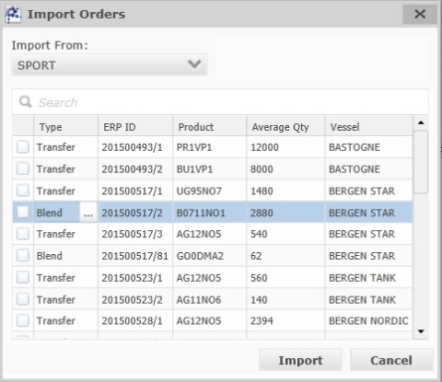

|  |  |
| --- | --- |
| Field | Description |
|  | Determines which source to import orders from, either Orion or Sport |
|  | Determines the day to import orders until from “now”. (Only available when importing from Orion) |
|  | Lets you choose which Nominated parcels to import from SPORT. (Only available when importing from Sport)  Based on the “Material Rules” user specification, the orders imported may be transfer or blend orders, but if need be the user may override which type of order to create in Ekho by choosing a different order type in the “Type” column. For more information about the Material Rules user specification see chapter: 11.7.5 |
|  | Assigns the order type(s) to import, Transfer, Blend or Process order. All order types can be imported at the same time. (Only available when importing from Orion) |
|  | Only available for Transfer orders, this assigns the transfer type(s) to import. (Only available when importing from Orion) |
|  | Determines the scheduling area to import associated orders for. (Only available for Orion) (The scheduling areas can be configured in the “Scheduling Area Profile”, for more information about the scheduling area profile, see chapter: [8.9](#_Scheduling_Area)) |
|  | If this option is checked, all existing orders in Ekho with status Raw/Draft that matches the selected import criteria (import until, order type, transfer type, scheduling area) will be deleted before the Orion orders are imported, if process orders are replaced, any associated FEED/RUNDOWN transfers in the state of Raw/Draft will also be deleted regardless of if Transfer Orders should be replaced or not. (Only available when importing from Orion) |
|  | If this option is checked, Ekho will keep all of the orders that has already been imported at some point, only importing new orders.  (Only available when importing from Orion) |
|  | Warns for each duplicate order and asks how to handle each order one by one.    If the order already exists in Ekho, you will have the options to Replace or Keep the order.  If the order does not already exist in Ekho, you will have the option to Add or Ignore the order.  (Only available when importing from Orion) |

Click  to start importing orders based on your choices. Based on the configuration in the Material Rules user spec, flush orders may be generated when importing. For more information about the Material Rules user specification see chapter: 11.7.5

When the import job is complete, the system will validate the outcome, a dialog showing all orders that Ekho tried to import will be listed with either a Success, Warning or Error flag. If the order was flagged with warning, it was imported but some information could not be imported, mostly due to missing/wrong name mapping between Ekho and Orion. If the order is flagged with an Error, it could not be imported since key information to build the event in Ekho could not be imported, may also be due to missing or wrong name mapping. Ekho will try to explain why it could not import certain information.

Click  to close the Import Orders form.

## Order Template

Order templates allow you to save most of the information on an order as a reusable template.

Only certain users will have the option to create or edit order templates. This is configurable in the “Template Creation Security” user spec. For more information about this User Spec see chapter: 11.7.8

Click  when viewing an order in the order form to save the order as a template.

You will be prompted to give the template a name.

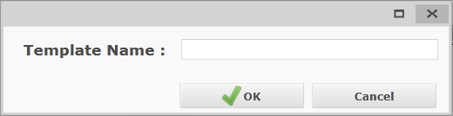

Click  when adding a new order to create the order from a template.

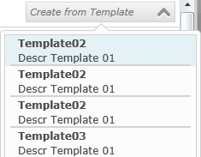

Or you may edit the Order Template and create an Order from the Edit Order Template dialog by pressing the “Save Order” button.

### Edit Order Template

To see all of the order templates in the event grid, first open the advanced filter.

In the selected metrics part of the advanced filter, the “is Template” metric should already be selected.

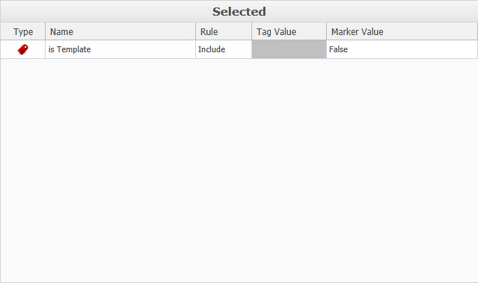

Set the Marker Value to True to only see the order templates, or true and false to see both orders and order templates at the same time.

To edit an order template, select the template in the event grid and press .

The edit order window will appear, allowing you to modify the information on the template.

To save your modification press .

To save your modification as a new Template, press .

To cancel your order template modification press .

### Delete Order Template

Order templates can be deleted by a scheduler by first setting the status of the order template to Cancelled. 

To delete a cancelled order template, select the order template in the event grid and press , then press  in the bottom of the Edit order window.

## Duplicate Order

The system allows for order duplication.

Click  with an order selected in the grid and choose Duplicate Order.

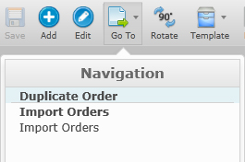

The system will prompt you for a new order description for the duplicate.

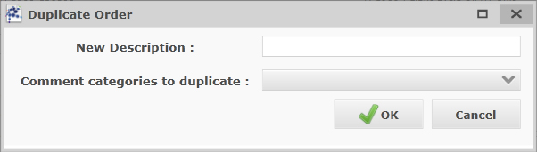

It is also possible to select comment categories, any comments from the original order with the selected categories will be added to the duplicate order, these comments will be “owned” by the user that duplicated.

Click  to save your duplication and close the duplicate order form.

Or click  to close the duplicate order form without saving.

## Export order Reports

It is possible to export multiple orders as one .pdf report by pressing the  button and selecting the 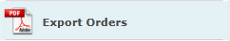 option.

This will open the Export Orders dialog where you may check the orders you would like to export as a report

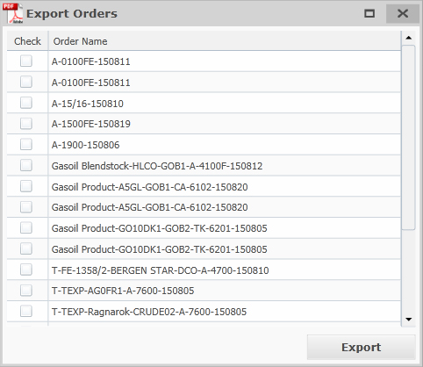

To export the selected orders press the  button.

## Delete Order

Orders can be deleted by a scheduler by first setting the status of the order to Cancelled.   
To delete a cancelled order, select the order in the list and press , then press  in the bottom of the Edit order window.

## ERP Adjustment

The ERP Adjustment page contains all of the Open or Released ERP Adjustment events, an ERP adjustment event is created automatically by Ekho whenever the first order with the ERP\_ID is approved in Ekho, any new orders that exists or are created at a later date with the same ERP\_ID will be automatically added to the ERP Adjustment event.

### Edit ERP Adjustment

To view or edit an ERP Adjustment event, select it in the event editor grid and press .

The “Edit ERP Adjustment” dialog appears.

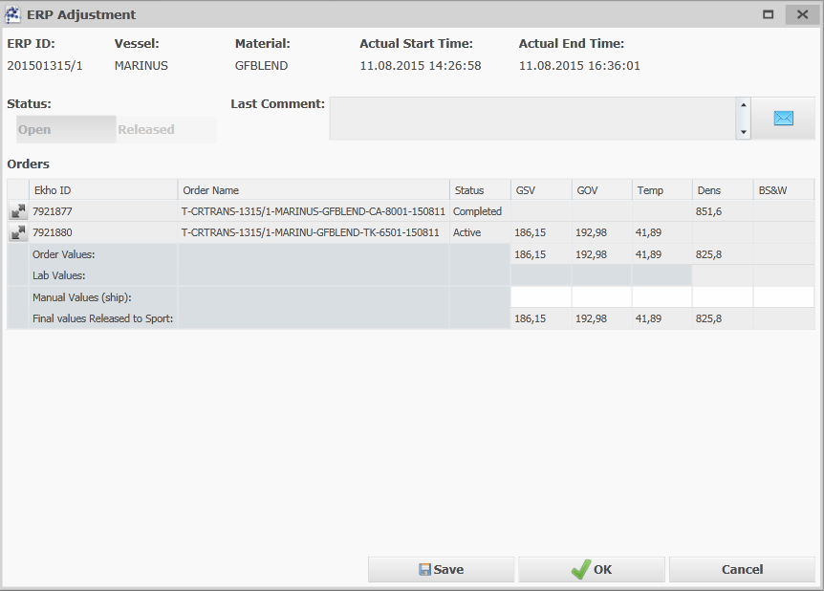

### Header information

The header of the dialog contains the following information:

* ERP ID
* Vessel Name
* Material
* Actual Start Time (of first order that shares ERP\_ID)
* Actual End Time (of last order that shares ERP\_ID)

### Status

The status of the ERP Adjustment Event can be either Open or Released, it is not possible to set an ERP Adjustment event to Released (button is disabled) unless all of the orders sharing the ERP\_ID has status “Closed” or “Completed – Waiting for Lab” (then button becomes enabled). When status is set to Released and the ERP adjustment event is saved, the Final ERP values will be released to SPORT/Oil Accounting.

After Releasing the ERP Adjustment Event, it is possible to re-open the ERP Adjustment Event, make changes and Release it again.

### Orders

The Orders grid lists all of the orders that share the ERP\_ID.



The following fields are visible (but read-only) for the orders:

* Ekho ID
* Order Name
* Status
* GSV
* GOV
* Temp (Temperature)
* Dens (Density)
* BS&W

Beneath the list of orders, a set of rows are shown.

* Order Values (The total of the order values, pumpback quantities are subtracted.)
* Lab Values (Lab values from LIMS for Density and BS&W)
* Manual Values (ship), (Allows you to override the Order/Lab values with a manual value to use as final ERP values)
* Final Values Released to Sport (These values will be released to SPORT/Oil Accounting)

For the Final Values row this is how Ekho chooses which value that is the Final value for each column:

* Final GSV = Manual if exists else Total Order value
* Final GOV = Manual if exists else Total Order value
* Final Temp = Manual if exists else Total Order value
* Final Dens = Manual if exists else Lab value if exists else Total Order value
* Final BS&W = Manual if exists else Lab value if exists else Total Order value.

If manual values are entered for GSV/GOV and/or Density the User will have to enter a comment before being able to Release the ERP Adjustment Event.

# View/Create Operator Comments App

## Introduction

The view/create operator comments app allows you to view/edit and add operating instructions and logs.

## General

When first accessing the View/Create/Operator Comments app, the page may appear blank. This is because no initial page has been defined.

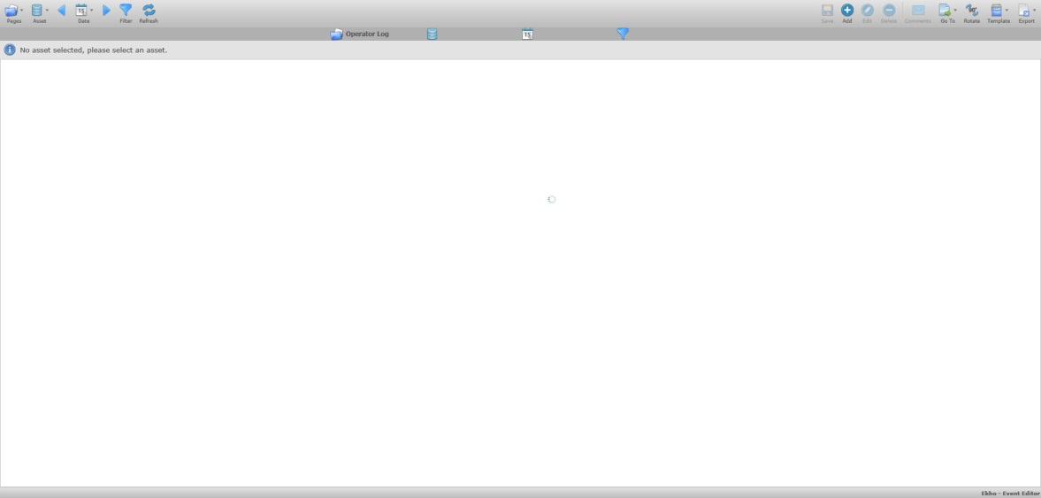

|  |  |
| --- | --- |
| **Icon** | **Description** |
|  | Click to switch between the various pages. |
|  | Click to hide or display the assets pane where the assets can be filtered on. |
|  | Click to select a date for the order search. The arrow on each side allows you to change the date incrementally. |
|  | Click to open the advanced filter. |
|  | Click to refresh the date or to apply new settings. |
|  | Click to save after editing values in the grid. |
|  | Click to add an operating instruction or operator log depending on active page. |
|  | Click to edit selected operating instruction or operator log depending on active page. |
|  | Click to delete selected operating instruction or operator log depending on active page. |
|  | Click to traverse the view, either by column or by row. |
|  | Click to save your filtered display as a template or to load a template. |
|  | Click to export the data to either Excel or PDF. |
|  | Clicking this button will bring up a menu with all columns in the event editor grid where you can see what column filters are applied or apply new column filters. |

The sub header row beneath the toolbar is designed to display the event filtering selections.







|  |  |
| --- | --- |
| **Icon** | **Description** |
| EEPagesNumberIcon.png | Displays the name of the page that is selected. |
| EEAssetsMultiIcon.png | Displays the asset that has been selected, if more than one asset is selected, “Multiple Assets” will be displayed. |
| EELastEventIcon.png | Displays the date selected (relative or specific). |
| EEFilterApplyIcon.png | Displays whether an advanced filter is “ON” or “OFF”. Click the icon to toggle between them if an advanced filter has been set. If no filter option is selected the icon will displayed with “NONE” beside. |

### Pages

Click on  to select a page.

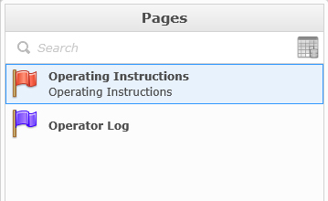

Pages displays a list of all available pages for the view/create operator comments app, a page is an event template created from the “Event Editor – Template Wizard” app. Each page will have a different color flag associated with it to signify a different type of page.

Hover your mouse on the page name and you will see small icons to the right of the name.

Click  to flag the page into your favorites. Your favorites will be displayed on the top of the list. The next time you open the panel and hover your mouse on the name of the page the icon will look like this .

You have the option to set a page as the default page to open when navigating to the view/create operator comments app.

While hovering your mouse over the page name, a check mark icon appears. By default the check icon  is gray, signifying that the page is not the default, clicking on this icon will change it’s appearance to  indicating that it is now the default page.

### Assets

Click on  to select the assets you would like to view corresponding orders with.

One or more assets can be selected from the list. The number of assets selected will be shown in parentheses.



If you know the name of the asset that you are looking for, you can use the search option. Once the keyword that you want to search for is completely typed, hit the enter key, if the name can be found in the asset list it will be highlighted. If you type only a partial name, the list will be open on the first possible match but the name will then be highlighted.



If you need to select or unselect the entire list of items, you can use a quick tool, click on the icon and select the option to select or clear the items.



Right click on an Asset in the tree-view to check or un-check all the descendants of the asset.



### Date

Click on  to select/apply a date selection



Three date types are available: Quick Date, Specific Date and Last/Next.

#### Quick Date

“Quick Date” has a combination of relative and status based searches that are predefined.



**Current Event**: Displays only open events (events with no end time), using this option will not work for operator logs and instructions since the functionality requires events who could have an end time but which is not yet known, operator logs for example can never have an end time, using this filter will display zero events.

**Yesterday**: Displays yesterday’s events between 00:00:00 and 23:59:59 (based on the current date), for operator logs this means that Effective time is during that duration, for Operating Instructions it means Start Time is during that duration.

**Current Shift**: Displays all events for the current shift, works the same way as Yesterday with respect of timestamps used.

**Current Week**: Displays events between the last Sunday from 00:00:00 to current day, works the same way as Yesterday with respect of timestamps used.

**Current Month**: Displays events between the first day of the month from 00:00:00 to current day, works the same way as Yesterday with respect of timestamps used.

#### Specific Date

“Specific Date” allows you to select a specific start date and end date.



You can change the start time and the end time of the date filter by typing the date and time or by using the calendar and time tool. To use the calendar tool click .



For operator logs, all events where Effective time is during the chosen duration will be shown.  
For operating instructions, all events where Start Time is during the chosen duration will be shown.

#### Last/Next

Last/Next is a relative date option based on pre-defined periods along with user enterable, relative numbers.



The combobox lets you switch between Last or Next.

Regardless of the “Last” or “Next” number entered or period selected, current day events will always be included in the results.

**Last/Next: Event(s):** Last x Events starting (Effective Time for Operator logs, Start Time for operating instructions) before “now” or Next x Events starting (Effective Time for Operator logs, Start Time for operating instructions) after “now”.

**Last/Next: Hour/Shift/Day/Week/Month:** Displays events starting between start of chosen duration and end of chosen duration, meaning that any operating instructions whose start time is during the period or for operator logs all events whose effective time is during the period will be shown.

Click  to apply your date selection. The date selection screen will close and the page will refresh.

### Advanced Filter

Click  to open the Advanced Filter window.



|  |  |  |
| --- | --- | --- |
| Action | Icon | Description |
| Filter duration | EEFilterDuration.png | Filter the duration of the order(s). |
| Time Exclusion | EEFiltersTimeExcl.png | Filter by excluding certain time periods. |
| Event with Comment only | EEFilterCommentExcl.png | Filter by excluding order with or without comment. |

The “Metrics” filter option allows for the filtering of events based on certain metric tags or marker values.



To select (or remove) a metric, you can use the drag and drop method or you can use the arrows  .

Once in the “Selected” list you can apply a rule value to filter for. If the selected item is a marker (status, material group etc) you can enter a marker value. Markers are noticable by their red icon.



Click to filter selections. Click  or  if you choose not to apply the filter.

### Template

Once you have made all applicable filtering selections (Asset, Period etc.) you can click  to save a template of your selections. This will allow you to save your selections and use the template for common searches.

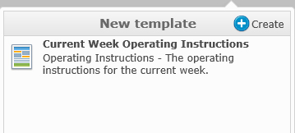

To create a new template click on the create button  and a new section will be displayed.



Description is not mandatory but it is recommended to save an associated description to give you more of an idea of what this template is for.

You also have the option to save this template as a default template by checking the “Is Default” box .

To save the template click the save button. 

After saving your template you will see it listed in the “Templates” section.

Templates are ordered in the list by name and type.

A default template is easy to identify by the green check mark in the icon. 

To delete a template, select the template name and click on the delete icon  next to the name.

To edit a template, select the template name and click on the edit icon  next to the name.

Once complete, click  to hide the template panel.

### Export

Click  to export the orders in the grid. You will have the ability to export to either XLSX for excel or PDF.



After choosing the file type you will be prompted to select a file location and to enter a name for the file.

Note that the .PDF report takes into account the filtering/grouping and column widths of the event grid.

### Add

Click  to manually add a new operating instruction or operator log depending on the active page.

A new window will appear where you can enter the required information.

### Edit

With an operating instruction or operator log selected, click  to open the edit form that lets you alter it.

Some of the properties on an operating instruction/operator log are editable straight away in the event editor grid, noticeable by their white cell background. To edit one of these doubleclick in the cell you want to edit.

Note that for this change to take effect you have to click .

### Delete

With an operating instruction or operator selected, click 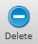 to delete the instruction/log.

## Operating Instructions

To view the operating instructions in the system, click  and select the Operating Instruction page.



### Add Operating Instruction

To add a new operating instruction, click .

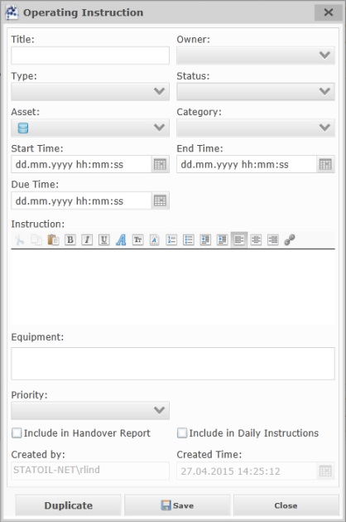

|  |  |
| --- | --- |
| **Field** | **Description** |
|  | This field assigns a short title to the operating instruction. |
|  | This option determines the owner of the operating instruction, available options are:    Lab  Planning  Process  Offsite  (Note that this markergroup is configurable and might differ between KLB and MO) |
|  | This option determines the type of operating instruction, available options are:  Service Order (used to communicate tasks to be executed by operation).  Daily Instruction Header (used for general subarea/section headers in the daily instruction reports).  Daily Instruction Item (used for subarea/section instructions in the daily instruction reports)  Standing Instruction Header (used for general subarea/section header information for instructions that rarely changes)  Standing Instruction Item (used for subarea/section instructions that rarely changes) |
|  | This option determines the status of the operating instruction, the status list will be filtered depending on the chosen instruction Type.  Available options for Daily/Standing Instruction Headers/Items are:  Draft (will not show up in any reports)  Approved (the operating instruction is approved and will show up in flagged reports)  Active (the operating instruction is active and will show up in flagged reports)  Closed (the operating instruction has been completed/closed and will not show up in any new reports)  For Service Orders available options are:  Draft (will not show up in any reports)  Active (the service order is active and will show up in flagged reports)  Approved (the service order is approved and will show up in flagged reports)  Prepare for Maintenance (will show up in flagged reports)  Out of service (will show up in flagged reports)  Prepare for Operation (will show up in flagged reports)  Under Observation (will show up in flagged reports)  Closed (the operating instruction has been completed/closed and will not show up in any new reports) |
|  | This option determines the subarea/section asset the instruction belongs to. |
|  | This option determines the category of the operating instruction, available options are:  Lab  Operation  Chemicals  Routine  Environmental  Turnover  (Note that this markergroup is configurable and might differ between KLB and MO) |
|  | Determines the Start Time of the instruction. |
|  | Determines the Due Time of the instruction. (only available for Service Orders) |
|  | Determines the End Time of the instruction. (Optional) (only available for daily/standing instruction headers/items) |
|  | This field determines the actual instruction. |
|  | This field lets you manually enter an equipment to associate the instruction with. |
|  | This option determines the criticality of the operating instruction, available options are:  Low Medium  High  Critical  (Note that this markergroup is configurable and might differ between KLB and MO) |
|  | This flag tells the system if the operating instruction should be used in handover reports. (Only available for Service Orders) |
|  | This flag tells the system if the operating instruction should be used in daily instruction reports. If the type of the instruction is either Daily Instruction Item or Daily Instruction Header, this flag will be automatically checked. |
|  | This will be automatically filled by the system when an operating instruction is saved. |
|  | This will be automatically filled by the system when an operating instruction is saved. |

### Edit Operating Instruction

To Edit an operating instruction, select the instruction in the event editor grid and press the  button.

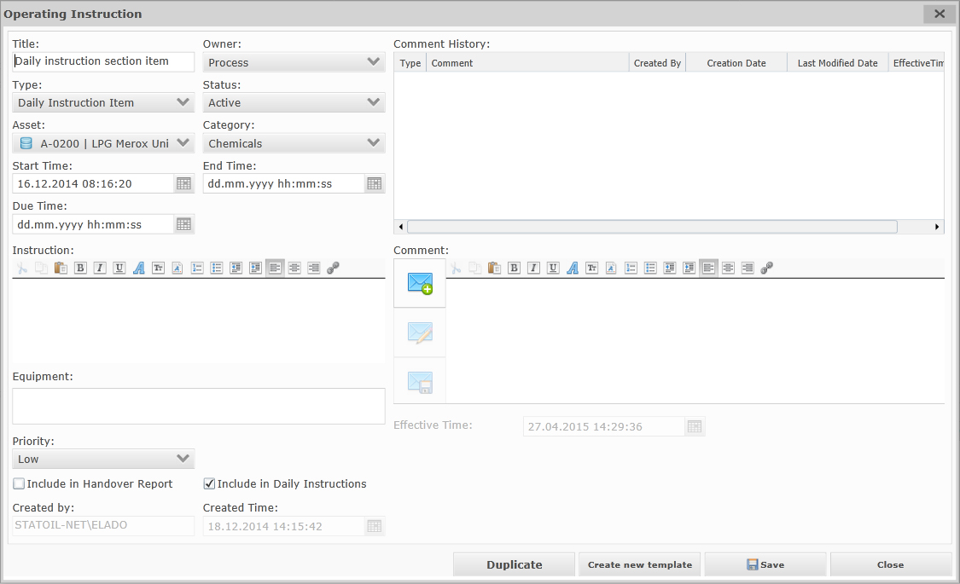

Comments can be added to the operating instruction by pressing the  button.

Whenever a new comment is added to the operating instruction, an operator log will be automatically created, if the comment is edited, the operator log will be automatically edited as well.

The effective date of the log will be the effective time of the comment.

The Asset for the log will be the same Asset as for the operating instruction.

The Category for the operator log will be the Type of the operating instruction.

The description of the operator log will be a combination of the Title and the actual comment on the operating instruction.

After any modification / addition, click  to save your changes or  to close the window without saving.

### Instruction Template

Instruction templates allow you to save most of the information on an operating instruction as a reusable template. Only certain users will have the option to create or edit Instruction templates. This is configurable in the “Template Creation Security” user spec. For more information about this User Spec see chapter: 11.7.8

Click  when editing/viewing an instruction to save the instruction as a template.

You will be prompted to give the template a name.



Click  when adding a new instruction to create the log from a template.



Or you may edit the Instruction Template and create an Instruction from the Edit Instruction Template dialog by pressing the “Save Instruction” button.

#### Edit Instruction Template

To see all of the instruction templates in the event grid, first open the advanced filter.

In the selected metrics part of the advanced filter, the “is Template” metric should already be selected.



Set the Marker Value to True to only see the log templates, or true and false to see both instructions and instruction templates at the same time.

To edit an instruction template, select the template in the event grid and press .

The edit log window will appear, allowing you to modify the information on the template.

To save your modification press .

To save your modification as a new Template, press .

To cancel your instruction template modification press .

#### Delete Instruction Template

Instruction templates can be deleted by selecting the template in the event grid and pressing the delete button in the top right toolbar .

### Duplicate Instruction

The system allows for duplicating operating instructions.

Click  with an order selected in the grid and choose Duplicate Order.



A duplicate of the selected instruction will appear in a dialog.

Click Save to save your duplication and close the duplicate instruction dialog.

Or click  to close the duplicate instruction dialog without saving.

## Operator Log

To view the operator logs in the system, click  and select the Operator Log page.

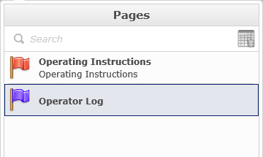

To add a new operator log, click .

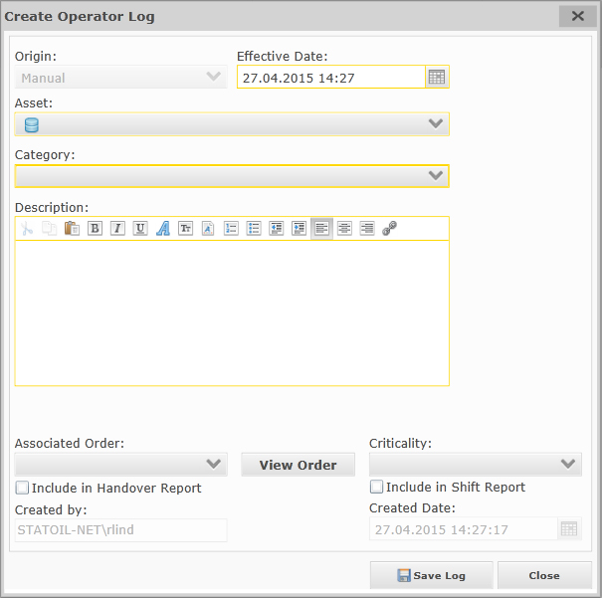

|  |  |
| --- | --- |
| **Field** | **Description** |
|  | This field is automatically set to either “User” if the log was manually created or the Event Type (Process Order, Blend Order, Operating Instruction.. etc) of the event that caused the log to be automatically created. |
|  | This field lets you assign an effective date to the log. Default is “now”. |
|  | This option determines the asset the operator log is associated with. |
|  | This option determines the category of the operator log, available options are:  Standby  Misc  Operations  Environmental  Environmental Deviations  Routine  (Note that this markergroup is configurable and might differ between KLB and MO) |
|  | This field is used for the actual log message |
|  | This option lets you assign an associated order to the operator log, the list of available associated orders to choose from will be filtered on the chosen asset for the operator log. |
|  | When an associated order has been assigned, this button can be pushed to open a read-only window with the order. |
|  | This option determines the criticality of the operator log, available options are:  Low Medium  High  Critical  (Note that this markergroup is configurable and might differ between KLB and MO) |
|  | This flag tells the system if the operator log should be used in handover reports. |
|  | This flag tells the system if the operator log should be used in shift reports. |
|  | This will be automatically filled by the system when an operator log is saved. |
|  | This will be automatically filled by the system when an operator log is saved. |

After any modification / addition, click  to save your changes or  to close the window without saving.

### Log Template

Log templates allow you to save most of the information on a log as a reusable template.

Only certain users will have the option to create or edit log templates. This is configurable in the “Template Creation Security” user spec. For more information about this User Spec see chapter: 11.7.8

Click  when editing/viewing a log to save the log as a template.

You will be prompted to give the template a name.



Click  when adding a new log to create the log from a template.



Or you may edit the Instruction Template and create a log from the Edit Log Template dialog by pressing the  button.

#### Edit Log Template

To see all of the log templates in the event grid, first open the advanced filter.

In the selected metrics part of the advanced filter, the “is Template” metric should already be selected.



Set the Marker Value to True to only see the log templates, or true and false to see both logs and log templates at the same time.

To edit a log template, select the template in the event grid and press .

The edit log window will appear, allowing you to modify the information on the template.

To save your modification press .

To save your modification as a new Template, press .

To cancel your log template modification press .

#### Delete Log Template

log templates can be deleted by selecting the template in the event grid and pressing the delete button in the top right toolbar .

### Duplicate Logs

The system allows for duplicating operator logs.

Click  with an order selected in the grid and choose Duplicate Order.



A duplicate of the selected log will appear in a dialog.

Click Save to save your duplication and close the duplicate log dialog.

Or click  to close the duplicate log dialog without saving.

# Reports App

## Introduction

The Reports App lets you handle most reports in the system, namely: Daily Instruction Report, Shift Report, Handover Report and Storage Inventory Report. For most of these reports, functionality includes publishing and signing off on the reports.

## General

### Pages

Click on  to select a page.

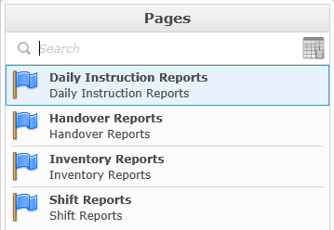

Pages displays a list of all available pages for the Reports app, a page is an event template created from the “Event Editor – Template Wizard” app. Each page could have a different color flag associated with it to signify a different type of page.

Hover your mouse on the page name and you will see small icons to the right of the name.

Click  to flag the page into your favorites. Your favorites will be displayed on the top of the list. The next time you open the panel and hover your mouse on the name of the page the icon will look like this .

You have the option to set a page as the default page to open when navigating to the view/create operator comments app.

While hovering your mouse over the page name, a check mark icon appears. By default the check icon  is gray, signifying that the page is not the default, clicking on this icon will change it’s appearance to  indicating that it is now the default page.

### Assets

Click on  to select the asset you would like to view the reports for.

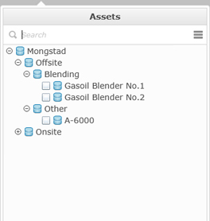

If you know the name of the asset that you are looking for, you can use the search option. Once the keyword that you want to search for is completely typed, hit the enter key, if the name can be found in the asset list it will be highlighted. If you type only a partial name, the list will be open on the first possible match but the name will then be highlighted.



## Daily Instruction Reports

### Introduction

The daily instruction report page lets you filter out daily instruction reports which consists of a set of operating instructions with a certain status for a given time period. Depending on your role you may also have the option to publish or sign-off on published daily instruction reports.

### Daily Instruction Reports Page

To view published and signed-off daily instruction reports, click  and select the Daily Instructions Reports Page.

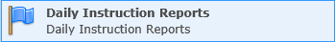

All published and signed-off daily instruction reports matching your asset and date filtering will appear in the grid.

To open a .pdf version of a report, double-click the .pdf icon 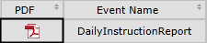 in the cell for the daily instruction report you want to open.

### Publish

To publish daily instruction reports, click  and select the “Daily Instruction Report” item.

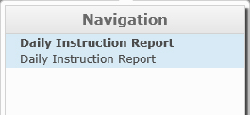

The “Publish Daily Instruction Report” window appears.

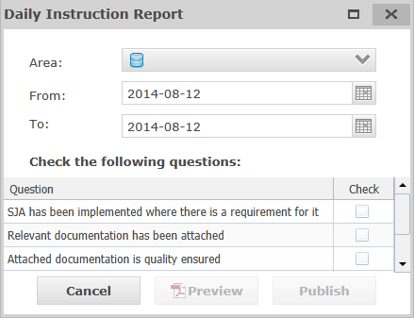

Select the SubArea(s) you want to publish daily instruction report(s) for.

Select the “From” and “To” date the daily instruction report(s) is for.

If more than one SubAreas has been selected the option of publishing one report for all or one per subarea becomes available; , if this is checked, all chosen SubAreas will be published as one .PDF and one Event in Ekho.

Go through the list of questions if any has been configured and check the ones that are true (list of questions is configurable in the “DIR Publish Questions” User Specification, for more information about this user spec see chapter 11.7.9. Note that all of the questions which has been configured as “Mandatory” in the user spec has to be checked before you are able to publish the report(s))

Press  to open a .pdf preview of the daily instruction report(s).

Press  to publish the report(s). The report(s) will be generated and a .pdf will be opened in a new window. The report(s) will be added to the list of published reports.

Press  to cancel the publishing.

### Republish

To republish a daily instruction report, select the published report that you want to republish in the event grid, then click  and select the “Republish” item.

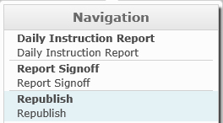

The “Republish” window appears

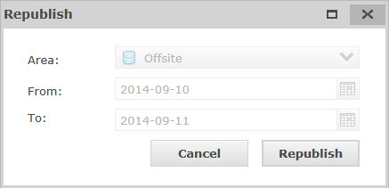

Area, From and To is set to the same values as when the report was published. Press  to republish the report or  to cancel the republish.

### Signoff

To sign off on a daily instruction report, select the published report that you want to sign off on from the grid then click  and select the “Report Signoff” item.

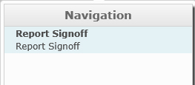

The “Report Signoff” window appears.

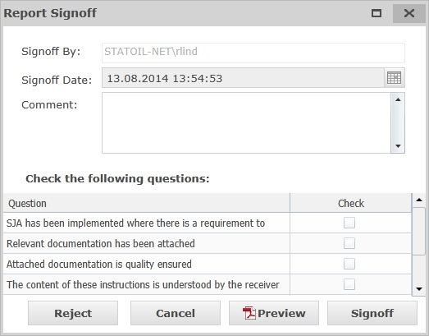

Go through the list of questions if any has been configured and check the ones that are true (list of questions is configurable in the “DIR Signoff Questions” User Specification, for more information about this user spec see chapter 11.7.10. Note that all of the questions which has been configured as “Mandatory” in the user spec has to be checked before you are able to sign off on the report). Enter a comment if there is a need to.

Press  to open a .pdf preview of the daily instruction report.

Press  to sign-off on the daily instruction report. Signoff by and signoff date is automatically set.

Press  to reject the daily instruction report.

Press  to cancel the signoff.

## Shift Reports

### Introduction

The shift report pages lets you filter out shift reports which consists of actual data values from the moment it was generated as well as operating instructions and log entries that has been flagged with “Shift report”. Shift reports will be automatically generated 30 minutes prior of a shift change, but can also be published manually and signed off on.

### Shift Reports Page

To view published and signed-off shift reports, click  and select the Shift Reports Page.

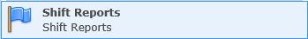

All manually or automatically published and signed-off shift reports matching your asset and date filtering will appear in the grid.

To open a .pdf version of a report, double-click the .pdf icon  in the cell for the shift report you want to open.

### Publish

To manually publish shift reports, click  and select the “Shift Report” item.

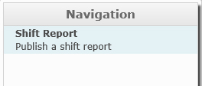

The “Publish Shift Report” window appears.

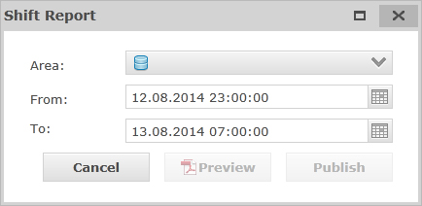

Select the Areas/SubAreas you want to publish shift report(s) for.

Select the “From” and “To” date the shift report(s) is for.

If more than one Area/SubArea has been selected the option of publishing one report for all or one per area/subarea becomes available; , if this is checked, all chosen Areas/SubAreas will be published as one .PDF and one Event in Ekho.

Press  to open a .pdf preview of the shift report(s).

Press  to publish the report(s). The report(s) will be generated and a .pdf will be opened in a new window. The report(s) will be added to the list of published reports.

Press  to cancel the publishing.

### Signoff

To sign off on shift reports, select the published report that you want to sign off on from the grid, click  and select the “Report Signoff” item.

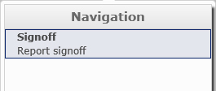

The “Signoff” window appears.

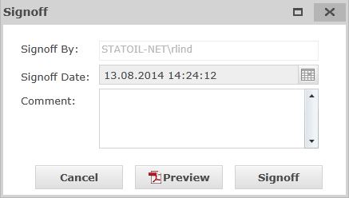

Enter a comment if there is a need to.

Press  to open a .pdf preview of the shift report.

Press  to sign-off on the shift report. Signoff by and signoff date is automatically set.

Press  to cancel the signoff

## Handover Reports

### Introduction

The handover report pages lets you filter out handover reports which consists of operating instructions and log events that has been flagged with “Handover Report” and manually publish new Handover Reports.

### Handover Reports Page

To view published handover reports, click  and select the Handover Reports Page.

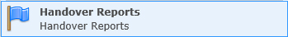

All published handover reports matching your asset and date filtering will appear in the grid.

To open a .pdf version of a report, double-click the .pdf icon  in the cell for the shift report you want to open.

### Publish

To manually publish handover reports, click  and select the “Handover Report” item.

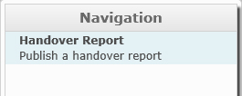

The “Publish Handover Report” window appears.

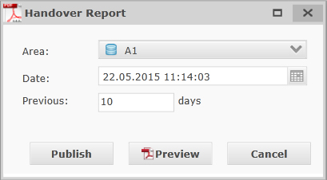

Select the SubArea(s) you want to publish handover report(s) for.

Select the Date (default “now” ) you want to publish until and the x number of previous days to include.

If more than one SubAreas has been selected the option of publishing one report for all or one per subarea becomes available; , if this is checked, all chosen SubAreas will be published as one .PDF and one Event in Ekho.

Press  to open a .pdf preview of the handover report(s).

Press  to publish the report(s). The report(s) will be generated and a .pdf will be opened in a new window. The report(s) will be added to the list of published reports.

The Report includes all Operator logs (and associated comments) associated with the chosen subarea(s) with an effective time that is within the duration of the published report, as well as all “Active” (Out of Service, Prepare for Service, Prepare for Maintenance, Under Observation, Active, Approved (if startdate is within duration of report)) Service Orders associated with the chosen subarea(s).

Press  to cancel the publishing.

# PPL Instructions App

## Introduction

The PPL Instructions App lists all of the “Active” Operating Instructions that are owned by “Planning” as well as any Order Comments that has been categorized with a category configured to be a part of the PPL Instructions App.

## General

When first entering the PPL Instructions app the grids are empty.

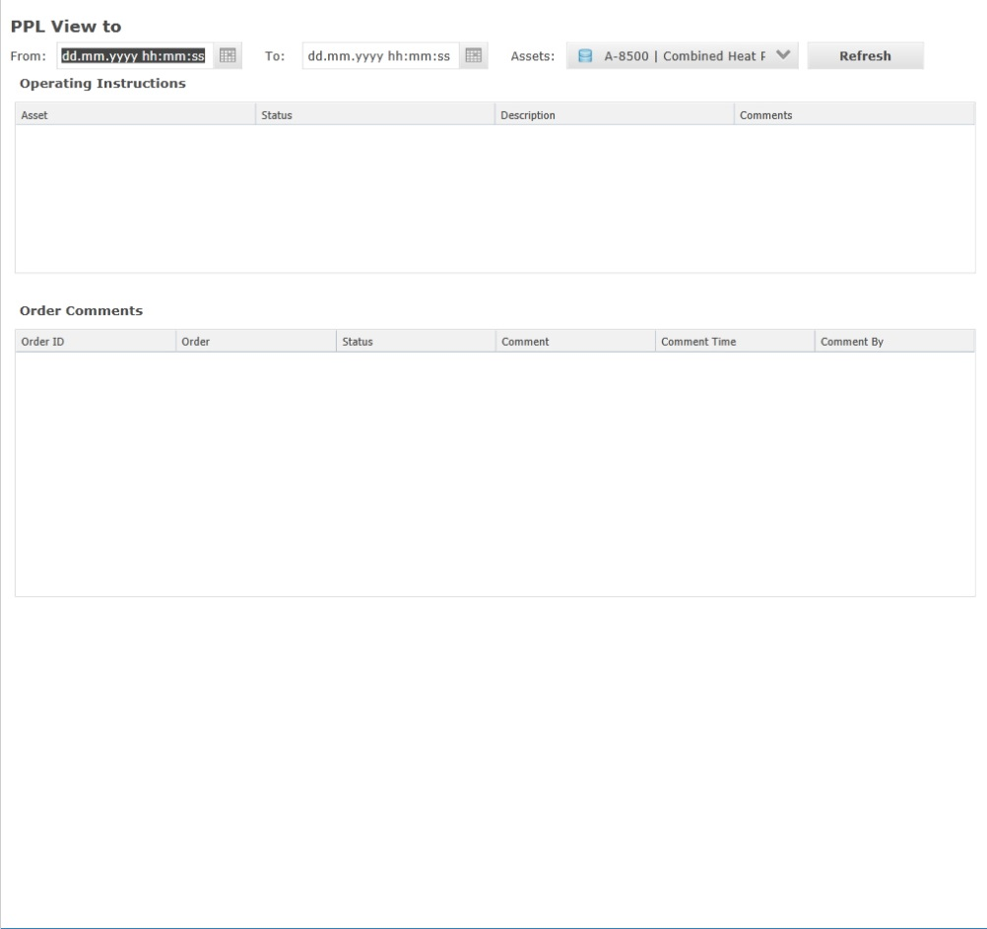

To fill the grids with data you must first select a from and to date as well as choose the assets whose associated operating instructions and order comments should appear.

The Operating Instructions grid displays all of the operating instructions with Owner = “Planning” that matches the asset filter and who are/where any of the following statuses during the filtered time-period: Active, Under Observation, Out of Service, Prepare for Operation, Prepare for Maintenance. Instructions with status “Approved” will also be included if the Start Time of the instructions is within the filtered time-period.

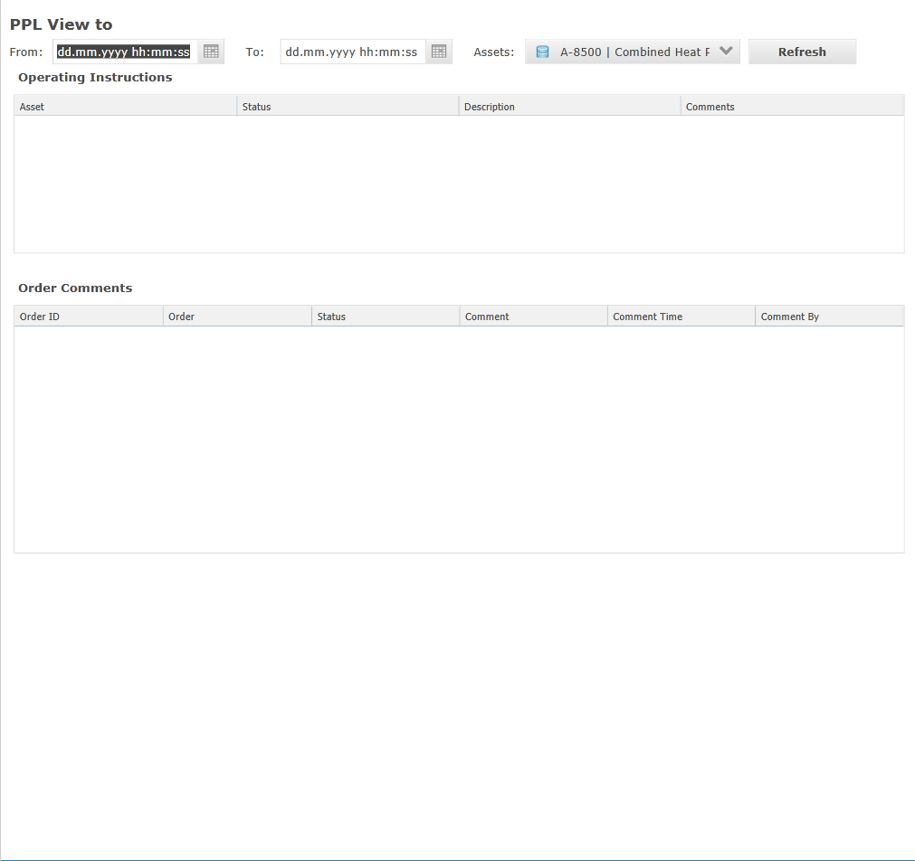

The Order Comments grid displays all of the order comments with a category that has been configured to be a part of the PPL Instructions app (This is configured in User Spec: “” for more information about this User Spec, see chapter “”), that stems from Orders with status: Approved, Ready, Initialized, Initilized Failed, Suspended or Active that matches the specified asset/timeperiod filter.



## Export to .PDF

The filtered PPL Instructions can be expoted to .PDF by…

# Tank Monitoring App

## Introduction

The Tank Monitoring app gives you an overview of the status of all the tanks related to your security group.

## General

When first opening the Tank Monitoring app, it will appear empty.

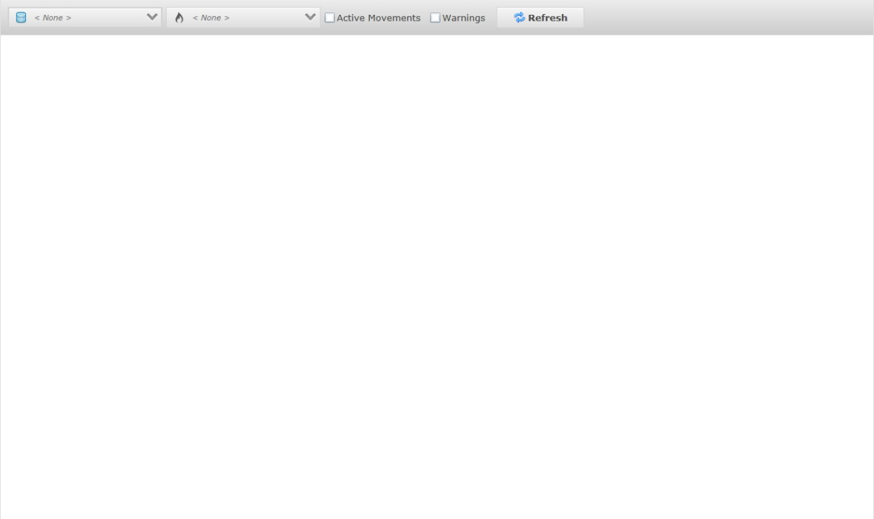

Before this app will display anything, you must first apply your filter selections.

|  |  |
| --- | --- |
| **Filter** | **Description** |
|  | Opens the asset tree-view where you can select the tanks you want to monitor. |
|  | Opens the material tree-view where you can select the materials that the displayed tanks should be related to. |
|  | Checking this option will only show tanks with an active movement. |
|  | Checking this option will only show tanks with a warning, for example tanks whose level is rising/falling without an active movement. |
|  | Clicking this button will refresh the data based on your filtering choices. |

### Filter Templates

It is possible to save the filter as a template and to load templates.

To Add or Load a template, press the 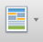 button.

A dropdown appears with all of the available filter templates.

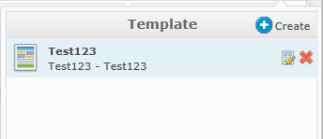

To load a filter template, simply select the template in the list, the filter meta data from the template will be applied.

#### Add Filter Template

To save your filter as a template, press the  button.

A new area will appear in the dropdown where you may enter some information about the template.

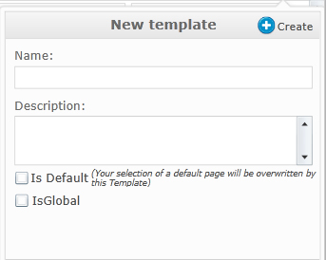

|  |  |
| --- | --- |
| **Field** | **Description** |
|  | The Name of the filter template |
|  | A short description of the filter template |
|  | If checked, this filter will be applied by default whenever you navigate to the Tank Monitoring application. |
|  | If checked, the filter template will be “global” meaning that every user with access to the Tank Monitoring app will be able to use this filter. Not every user will be able to check this flag, this is configurable in the User Spec called “Global Template Creation Group”, for more information about this user spec, see chapter: 11.7.13 |

When you have entered all necessary fields, press the  button to save the template or press the  to cancel the operation.

#### Edit Filter Template

To edit a filter template, hover the cursor over template you wish to edit and press the  button, from here you may edit the Name, Description, Is Default and possibly the Is Global flag of the template.

## Tanks

After making your filtering choices, all of the matching tanks will be displayed on the screen, the values will be automatically refreshed in the GUI when Ekho has fetched/calculated new values.

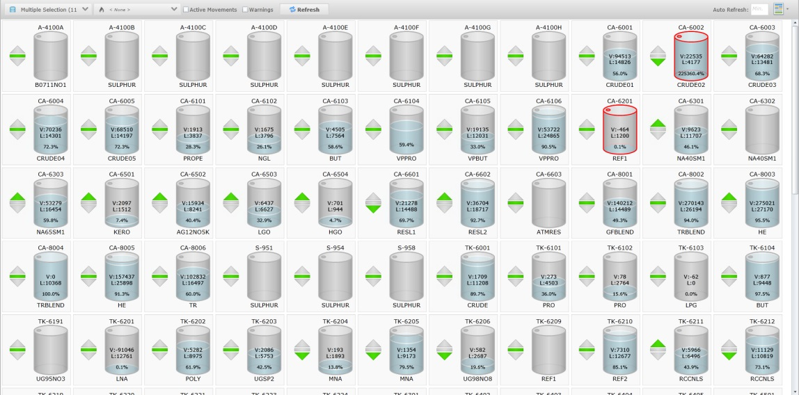

|  |  |
| --- | --- |
| **Visual** | **Description** |
|  | Shows the name of the tank. |
|  | Shows the current available volume in cubic meters |
|  | Shows the current level in mm. |
|  | Shows the current volume in percentage. |
|  | Shows the current material in the tank. |
|  | The red outline shows that the level in the tank is outside of the operational limits. |
|  | Shows that an input movement is filling the tank according to plan. |
|  | Shows that the level is static without active movements. |
|  | Shows that an output movement is draining the tank according to plan. |
|  | Shows that the level is rising without an active input movement. |
|  | Shows that the level is static with an active movement. |
|  | Shows that the level is decreasing without an active output movement. |
|  | Shows the time until empty/full when there is an active movement. |

## Tank Information

By clicking a tank, the Tank Information window appears with more information about the tank.

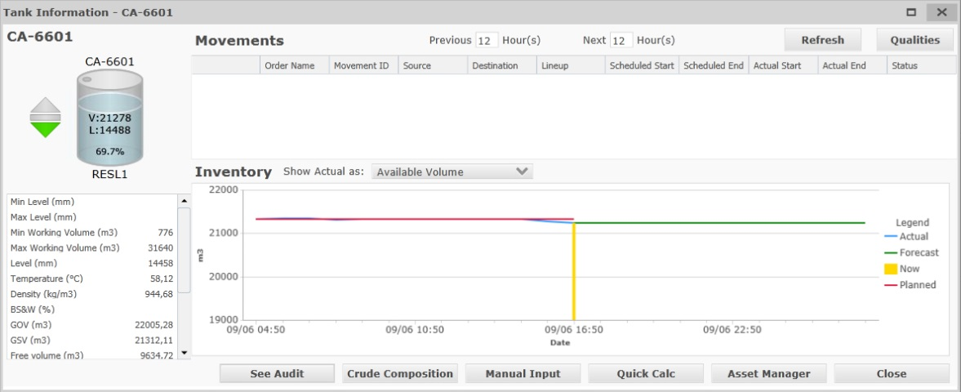

On the left side of the tank information window, you will find a set of properties that reads from the tags that has been setup on the tank in the Asset Profile app as well as some calculated values.

### Movements

The Movements section shows all of the movements using the tank for the time period you choose.

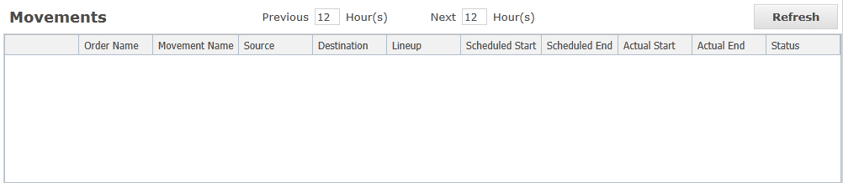

To change the time-period for the movements list and forecast chart, enter a new value in the  field and a new value in the  field.

click .

### Forecast

The forecast section shows you a chart of the planned and actual volume level change in the tank for the previous x hour(s).

It also shows you a forecast of the expected volume level change in the tank for the next x hour(s) based on approved, active and ready movements scheduled rate values.

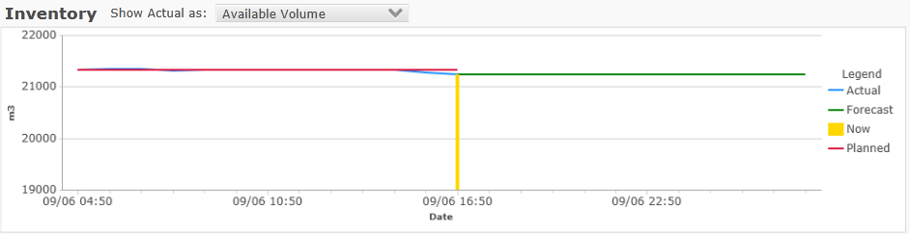

You have the option of chosing what the forecast displays



For liquids you have the option to view: Available Volume, GSV or GOV.

For solids you will only be able to see Mass.

### Manual Input

The Manual Input app lets users override certain values for a tank. The manual values will be use from “now” until the current mode is set to Automatic or the manual value is changed.

This app can be opened from the Tank Information window in the Tank Monitoring App by clicking , but also from the Inventory Report App.

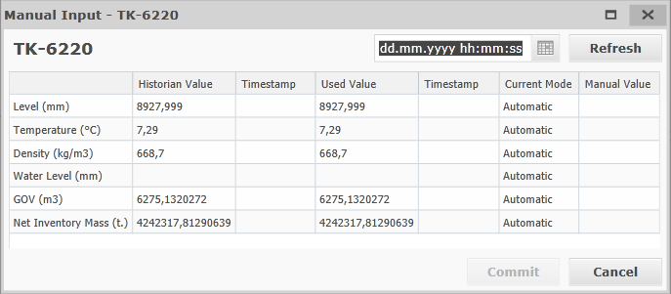

Click  to refresh the current values/quality for the tank properties based on your chosen date.

The grid shows you the Historian (IP21) Value with timestamp, Used Value with timestamp and Current Mode for Level, Temperature, Density, Water Level, GOV, GSV and Net Inventory Mass and gives you the ability to overwrite the current value by entering values in the “Manual Value” column.

The Datepicker allows you to specify a time in the past to overwrite the value(s) from.

Depending on the storage asset configuration, the overwritten value may be written to IP21 from the selected date until “now” and further until the Current Mode is set back to Manual.

To set the current mode back to Manual, simply remove the value from the Manual Value column.

After entering your new values, click  or click  to close the window without overriding.

### Quick Calc

The Quick Calc app lets you find changes in storage volumes over a given time and gives you the ability to calculate volume and mass quantities from level.

This app can be opened from both the Tank Information window in the Tank Monitoring App by clicking , but also from the Storage Inventory App.

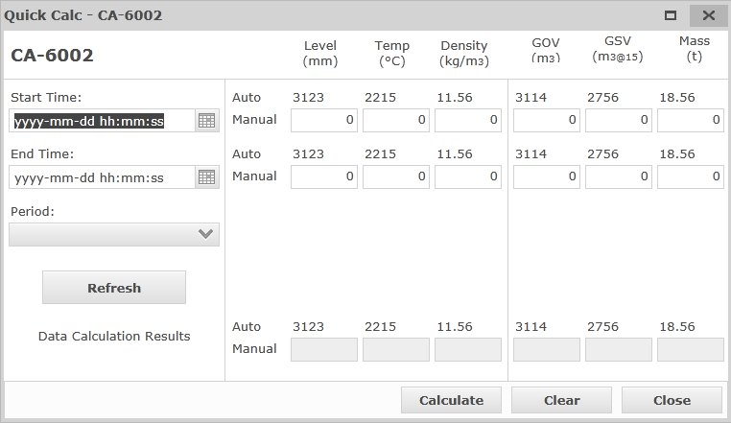

The app is split into three sections, period filtering, period values and data calculation results.

#### Period Filtering

|  |  |
| --- | --- |
| **Field** | **Description** |
|  | The first date for the quick calc. |
|  | The last date for the quick calc. |
|  | A list with pre-configured time periods to choose from.    Choosing one of these will automatically set the start time and end time based on your choice, end time will always be “now” when choosing one of these. |

#### Period Values



The system will show the actual values for Level, Temperature, Density, GOV, GSV and Mass for both the Start Time and the End Time. You also have the choice to enter manual values for them to use for calculating GOV, GSV and Mass, to calculate GOV you only need manual values for Level, to manually calculate GSV and Mass you also need manual values for Temperature and Density. Press  to see the results.

#### Data Calculation Results



When you have set your time period and optionally if you have entered som manual values, you can press  to calculate the delta change for the chosen time period.

To clear all calculation results and manual values, press .

### Asset Manager

Press to open the Asset Manager for the tank.

For more information about the Storage Asset Manager see chapter: [8.6](#_Storage)

### Material Composition

It is possible to open a read-only dialog of the storage assets Material Composition, for viewing purpose.

To open the Material Composition dialog, press the 

The Material Composition dialog appears, showing all of the material discs in the tank and their respective percentages.

### See Audit

To see the Audit trail for a tank, press the  button.

The Audit trail dialog for the storage asset appears, showing all of the modifications to the tanks storage profile or any Manual Input modifications that has been made on the Tank.

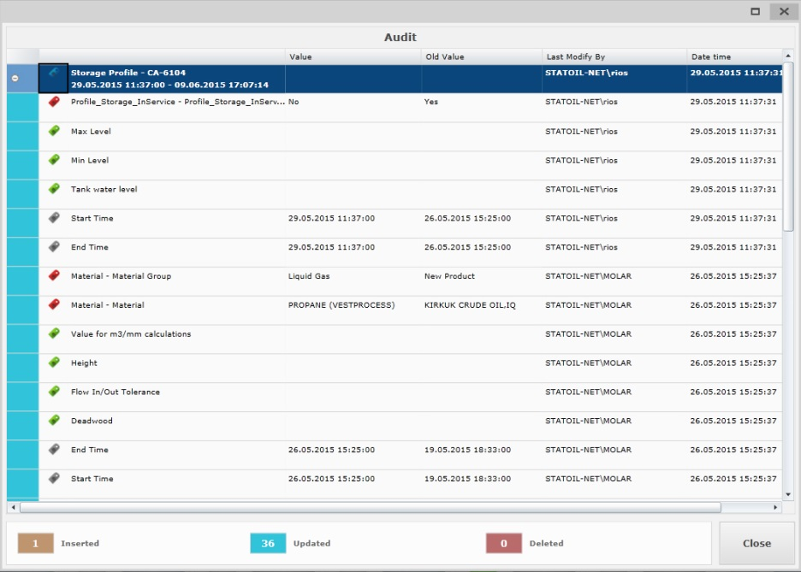

### Tank Qualities

It is possible to view the Tank qualities that has been configured for the Storage asset by pressing the  button.

This will open the tank qualities dialog.

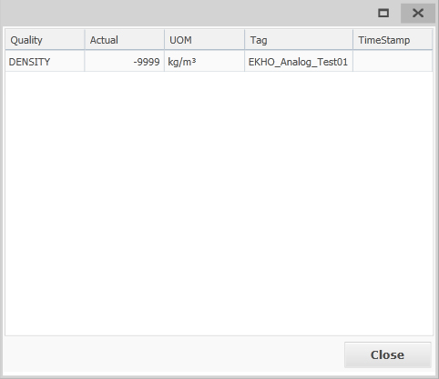

This dialog lists all of the tank qualities configured on the storage asset and the latest IP21 value for each tank quality tag as well as displaying the tag itself and the Timestamp of the latest value.

# Inventory Report App

## Introduction

The Inventory Report app lets you view past or present data related to the storage assets and export it as a report. The system will automatically generate Reports at 07:00 and send it to a configured printer, but this app allows the users to publish an Inventory Report on the fly.

## General

When entering the Inventory Report app the filter is by default set to “now”, but can be changed to a past date by using the Date control and pressing the Refresh button.

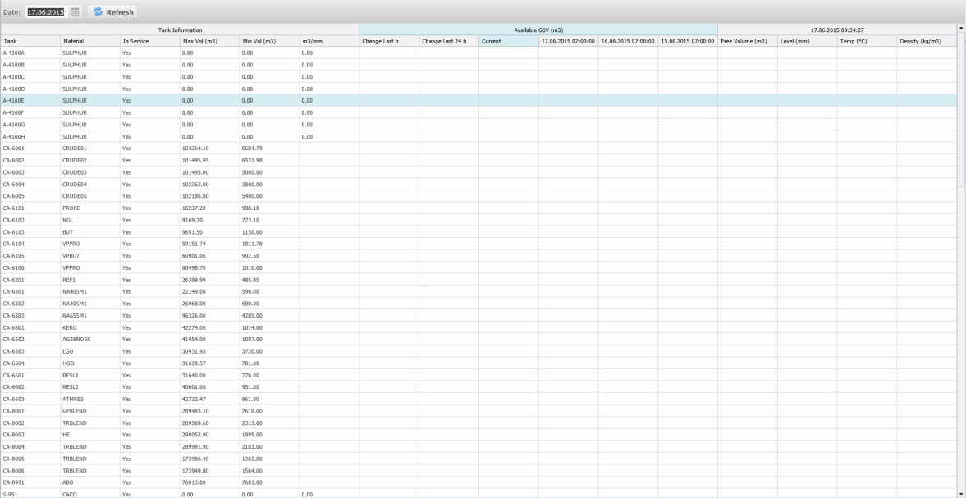

The following columns will be displayed:

|  |  |  |
| --- | --- | --- |
| **Section** | **Column** | **Description** |
| Tank Information (Values are taken from Storage Profile if today, else KPI) | Tank | Name of the storage asset |
| Material | Material in service on the storage asset |
| In Service | If the storage asset is In or Out of Service |
| Max Vol (m3) | The Max volume in m3 the Storage Asset can hold |
| Min Vol (m3) | The Min volume in m3 the Storage Asset can hold |
| m3/mm | The m3/mm value for the Storage Asset |
| Available GSV (m3) | Change Last h | The change in available volume (GSV) between “filtered date” and hour before. |
| Change Last 24 h | The change in available volume (GSV) between “filtered date” and 24 hours before. |
| Current | Current Available volume, this column is only visible when the report filter is not set to today at 07:00. |
| “today at 07:00” | Available volume (GSV) today at 07:00 |
| “yesterday at 07:00” | Available volume (GSV) yesterday at 07:00 |
| “day before yesterday at 07:00” | Available volume (GSV) day before yesterday at 07:00 |
| “Date Filtered” | Free Volume (m3) | Free Volume in m3 at the filtered date |
| Level (mm) | Level in mm at the filtered date |
| Temp (°C) | Temperature in deg-C at the filtered date. |
| Density (kg/m3) | Density in kg/m3 at the filtered date. |

## Export to .PDF

The filtered Inventory Report can be exported to .PDF by…

# Lineup

## Introduction

The Lineup app allows you to create and maintain lineups in the system used to define the route between source and destination assets.

## General

When entering the Lineup Manager a list of all the available lineups in the system will be shown to the left.

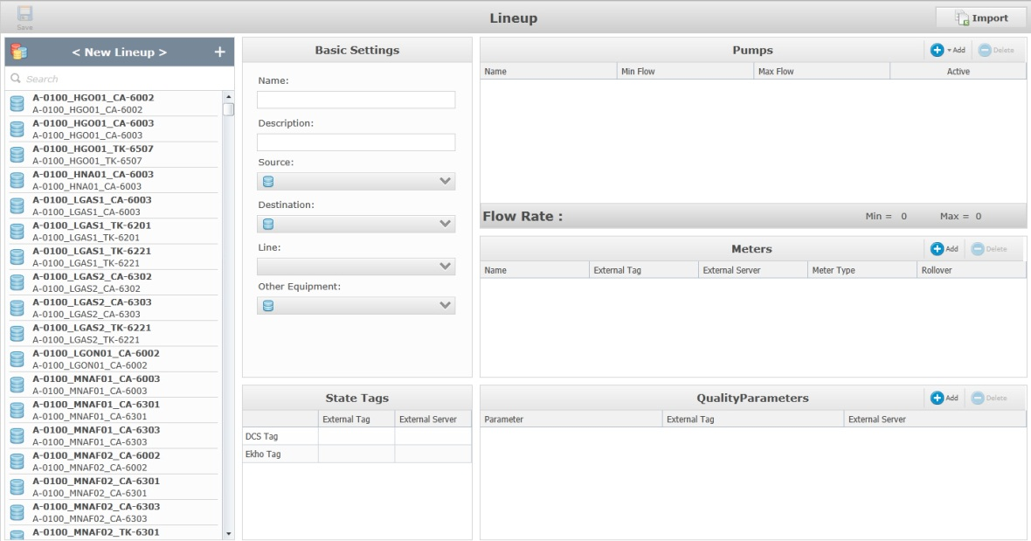

## Add a Lineup

To add a new lineup, click  over the list of lineups.

The lineup window consists of five sections; Basic Settings, State Tags, Pumps, Meters and QualityParameters.

### Basic Settings

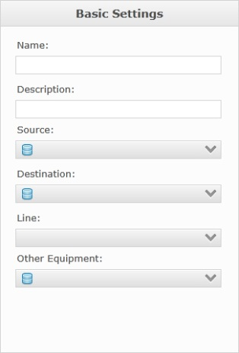

|  |  |
| --- | --- |
| **Field** | **Description** |
|  | This field assigns the name of the Lineup. |
|  | This field assigns a description of the lineup. |
|  | This field assigns the source asset that the lineup will use. |
|  | This field assigns the destination asset that the lineup will use. |
|  | This field assigns Line segments to the Lineup. |
|  | This field assigns any potential other equipment to be used in the lineup. |

### State Tags

Allows you to configure the tags to use for DCS and Ekho states.

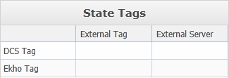

The External Tag column is for the tag to use for DCS / Ekho.

The External Server column is for the server the tag is associated with.

### Pumps

The pumps section lets you add the pump(s) (regular pumps, blend streams and additive streams may be chosen) that should be part of the lineup.

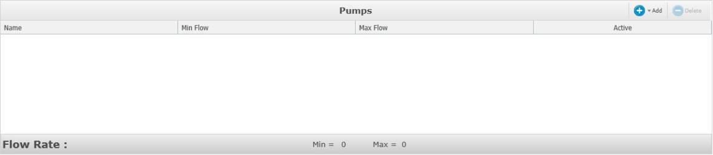

#### Add a Pump

To add a pump, blend stream or additive stream to the lineup, press the 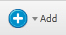 button and choose the pump you want to add from the dropdown.

The list of selected pumps will show the name, min flow, max flow of the pump(s) and if the pump is active or not.

When a lineup with multiple pumps is used by an order, Ekho will aggregate the values.

#### Delete a Pump

To remove a pump from the lineup, select the pump in the list of chosen pumps and press the  button.

### Meters

The meters section lets you add the meter(s) that should be part of the lineup.

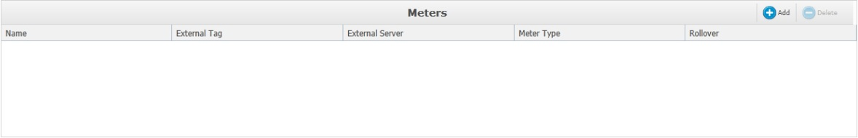

#### Add a Meter

To add a meter, press the  button. A new blank row will be added to the list of meters where you can input the meter information in certain cells.

|  |  |
| --- | --- |
| **Field** | **Description** |
| Name | The name of the meter. |
| External Tag | The meters External Tag. |
| External Server | The server the meters external tag is associated with. |
| Meter Type | Assigns the type of the meter, choices are: Flow, Totalizer (GOV), Totalizer (GSV) and Totalizer (NIM). |
| Rollover |  |

When a lineup with multiple meters of the same meter type is used by an order, Ekho will aggregate the values.

#### Delete a Meter

To remove a meter from the lineup, select the meter in the list of meters and press the  button.

### Quality Parameters

The Quality Parameters section lets you add the quality parameters that should be tracked for the lineup.

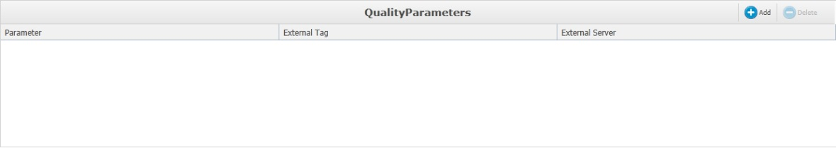

#### Add a Quality Parameter

To add a quality parameter, press the  button. A new blank row will be added to the list of quality parameters where you can input the parameter information in certain cells.

|  |  |
| --- | --- |
| **Field** | **Description** |
| Parameter | This lets you choose the parameter from a pre-configured list of quality parameters. |
| External Tag | The parameters External Tag. |
| External Server | The server the parameters external tag is associated with. |

#### Delete a Quality Parameter

To remove a quality parameter from the lineup, select the parameter in the list of parameters and press the  button.

When the lineup configuration is completed, press the  button in the top left corner to save the lineup.

## Edit a Lineup

To edit a lineup, select the lineup from the list of lineups. This will “open” the lineup for editing.

To save your modifications, press the  button in the top left corner.

## Delete a Lineup

To delete a lineup, hoover your mouse over the lineup you want to delete and press the  button.

# Asset Profile

## Introduction

The asset profile allows you to view/maintain blenders, lines, pumps, storages and streams.

## General

When first entering the Asset Profile app, it will appear empty. This is because no page has been selected.

|  |  |
| --- | --- |
| **Icon** | **Description** |
|  | Click to switch between the various pages. |
|  | Click to hide or display the assets pane where the assets can be filtered on. |
|  | Click to select a date for the search. The arrow on each side allows you to change the date incrementally. |
|  | Click to refresh the date or to apply new settings. |
|  | Click to view or edit selected asset profile. |
|  | Click to navigate between pre-configured order related pages (e.g. Profile Import) |
|  | Click to traverse the asset view, either by column or by row. |
|  | Click to save your filtered display as a template or to load a template. |
|  | Click to export the list to either Excel or PDF. |

The sub header row beneath the toolbar is designed to display the event filtering selections.







|  |  |
| --- | --- |
| **Icon** | **Description** |
| EEAssetsMultiIcon.png | Displays the asset that has been selected, if more than one asset is selected, “Multiple Assets” will be displayed. |
| EELastEventIcon.png | Displays the date selected (relative or specific). |
| EEPagesNumberIcon.png | Displays the name of the page that is selected. |
| EEFilterApplyIcon.png | Displays whether an advanced filter is “ON” or “OFF”. Click the icon to toggle between them if an advanced filter has been set. If no filter option is selected the icon will displayed with “NONE” beside. |

## Blender

To view the blenders in the system, click the  button and select the Blender Profile option from the dropdown.

To view the blender profile for a blender or to modify it, select it from the grid in the event editor and click .

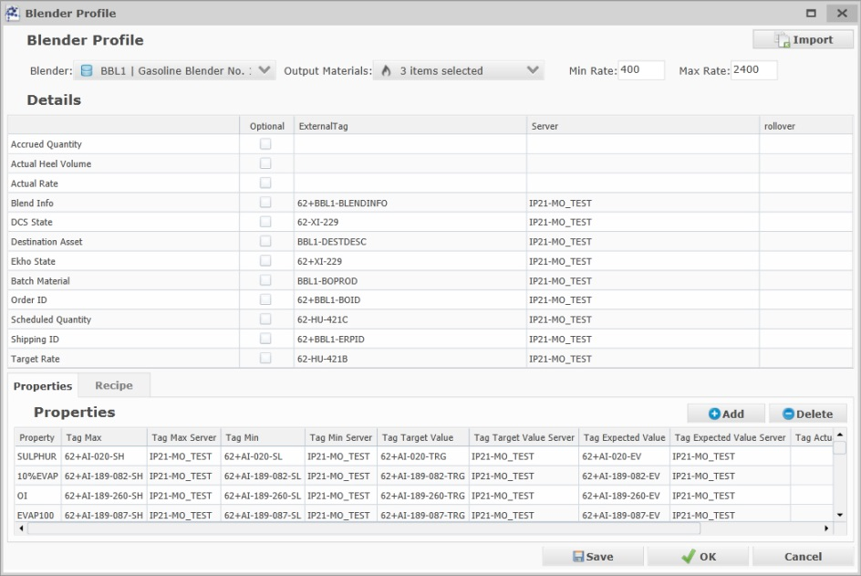

You can change the Blender you want to view/modify from here by selecting another blender here .

You may also select which material groups that should be valid options when creating a new blend order with the particular blender.

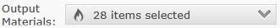

These fields lets you enter the Min and Max rate of the blender.

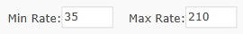

### Details

The detail section holds all of the blender details with their external tag and which server the tag exists on, it is also possible to set the blender detail tags to Optional, optional tags are not required for the blend setup to succeed.



### Properties

In the properties section you can add and remove properties on chosen blender. The properties selected here will determine which properties can be added to a blend order (for both manual and imported orders)

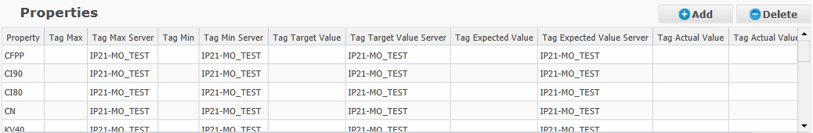

To add a new row in the properties list, click .

To delete a row in the properties list, select it in the list and click .

|  |  |
| --- | --- |
| **Column** | **Description** |
| Property | A list of pre-configured properties to choose from. |
| Tag Max | The tag for the Max value of the chosen property. |
| Tag Max Server | The server the tag for the Max value is associated with. |
| Tag Min | The tag for the Min value of the chosen property. |
| Tag Min Server | The server the tag for the Min value is associated with |
| Tag Target Value | The tag for the Target Value of the chosen property. |
| Tag Target Value Server | The server the tag for the Target Value is associated with |
| Tag Expected Value | The tag for the Expected Value of the chosen property. |
| Tag Expected Value Server | The server the tag for the Expected Value is associated with |
| Tag Actual Value | The tag for the Actual Value of the chosen property. |
| Tag Actual Value Server | The server the tag for the Actual Value is associated with. |

### Recipe

In the Recipe section you can add and remove Components/Additives that are valid for use with the blender, you can also associate them with Min/Max/Expected tags used for writing the scheduled order values during blend setup.

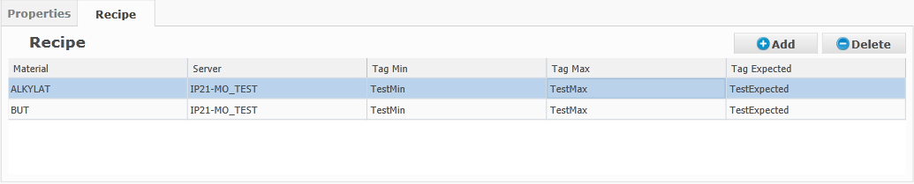

To add a new row in the recipe list, click .

To delete a row in the recipe list, select it in the list and click .

|  |  |
| --- | --- |
| **Column** | **Description** |
| Material | Component or Additive that should be available for Recipe with blender asset. |
| Server | The Server the external tags is associated with. |
| Tag Min | The external tag for scheduled min value |
| Tag Max | The external tag for scheduled max value |
| Tag Expected | The external tag for scheduled expected value |

To save modifications to the blender profile, click  or  to save and close the blender profile window.

## Line

To view the lines in the system, click the  button and select the Line Profile option from the dropdown.

To view the line profile for a line or to modify it, select it from the grid in the event editor and click .

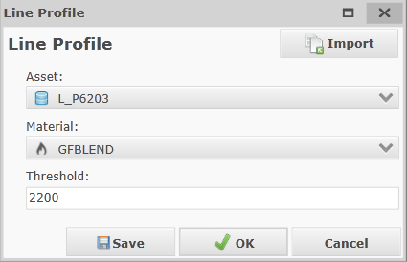

In the Line profile, you can override the latest material transported in the line asset.

You may also configure the Threshold used to determine when the Material on the line segment should be updated (When a movement is activated using the line segment and the accrued quantity becomes greater than this threshold value the line material will be updated with the movement material).

To save modifications to the line profile, click .

## Pump

To view the pumps in the system, click the  button and select the Pump Profile option from the dropdown.

To view the pump profile for a pump or to modify it, select it from the grid in the event editor and click .

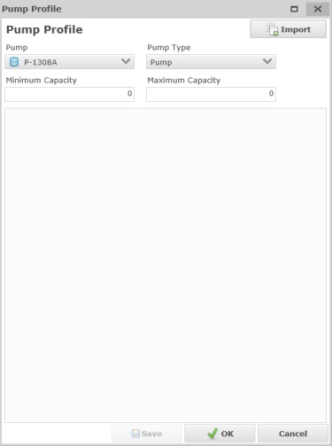

|  |  |
| --- | --- |
| **Field** | **Description** |
|  | This option determines the pump the profile is for. |
|  | This option determines which type of pump it is. Either an Additive Stream a Blend Stream or a regular Pump. |
|  | This field determines the Minimum Capacity. |
|  | This field determines the Maximum Capacity. |
|  | Specifies if the pump is in service and may be used or not. |

To save modifications to the pump profile, click .

## Blend Stream

To view the blend streams in the system, click the  button and select the Blender Profile option from the dropdown.

To view the blend stream profile for a blend stream or to modify it, select it from the grid in the event editor and click .

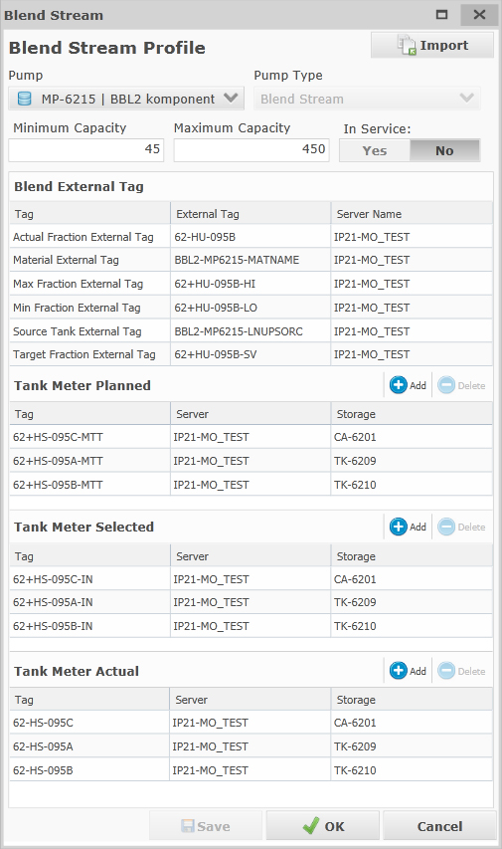

|  |  |
| --- | --- |
| **Field** | **Description** |
|  | This option determines the pump the profile is for. |
|  | This option determines which type of pump it is. Either an Additive Stream a Blend Stream or a regular Pump (Read-only) |
|  | This field determines the Minimum Capacity. |
|  | This field determines the Maximum Capacity. |
|  | Specifies if the pump is in service and may be used or not. |

### Blend External Tags

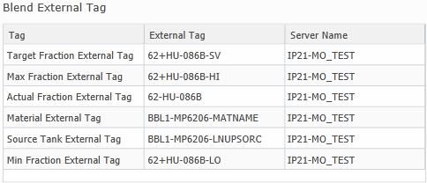

|  |  |
| --- | --- |
| **Column** | **Description** |
| Tag | A description of the tag. (Read-only)  Tags are available for: Target Fraction, Max Fraction, Actual Fraction, Material, Source Tank and Min Fraction. |
| External Tag | The external tag. |
| Server Name | The server the external tag is connected to. |

You also have the option to configure tags for Tank Meter Planned, Tank Meter Selected and Tank Meter Actual.

Tank Meter Planned tags are used to write to IP21 all lineups that are scheduled to be used during the blend order. Tank Meter Selected tags are used to write to IP21 only the lineups that are scheduled to be used at the start of the blend order. Tank Meter Actual tags are used to read the actual lineups from IP21.



To add a new tag for either Tank Meter Planned, Tank Meter Selected or Tank Meter Actual, press the  button over the respective list. A new row will be added where you may input Tag, Server the tag is associated with and Storage Asset.

To delete a tag, select it in the list and press the  button.

To save modifications to the blend stream profile, click .

## Additive Stream

To view the additive streams in the system, click the  button and select the Additive Stream Profile option from the dropdown.

To view the additive stream profile for an additive stream or to modify it, select it from the grid in the event editor and click .

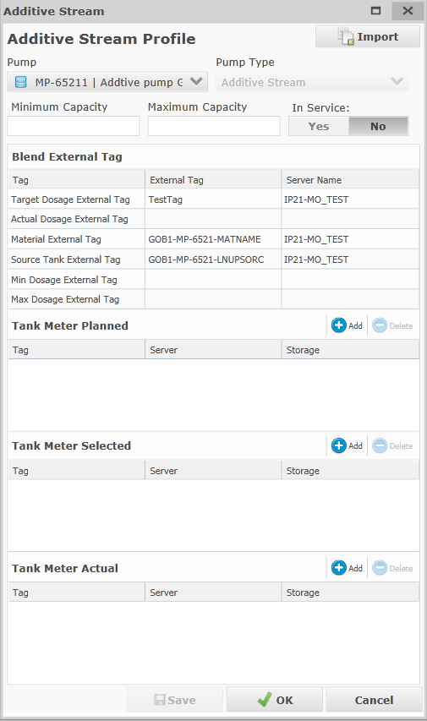

|  |  |
| --- | --- |
| **Field** | **Description** |
|  | This option determines the pump the profile is for. |
|  | This option determines which type of pump it is. Either an Additive Stream a Blend Stream or a regular Pump. |
|  | This field determines the Minimum Capacity. |
|  | This field determines the Maximum Capacity. |
|  | Specifies if the pump is in service and may be used or not. |

### Additive External Tags

For the Additive Stream type, a list of Additive External Tags is available.



|  |  |
| --- | --- |
| **Column** | **Description** |
| Tag | A description of the tag. (Read-only)  Tags are available for: Target Dosage, Actual Dosage, Material, Source Tank, Min Dosage and Max Dosage. |
| External Tag | The external tag. |
| Server Name | The server the external tag is associated with. |

You also have the option to configure tags for Tank Meter Planned, Tank Meter Selected and Tank Meter Actual.

Tank Meter Planned tags are used to write to IP21 all lineups that are scheduled to be used during the blend order. Tank Meter Selected tags are used to write to IP21 only the lineups that are scheduled to be used at the start of the blend order. Tank Meter Actual tags are used to read the actual lineups from IP21.



To add a new tag for either Tank Meter Planned, Tank Meter Selected or Tank Meter Actual, press the  button over the respective list. A new row will be added where you may input Tag, Server the tag is associated with and Storage Asset.

To delete a tag, select it in the list and press the  button.

To save modifications to the additive stream profile, click .

## Storage

To view the storage tanks in the system, click the  button and select the Storage Profile option from the dropdown.

To view the storage profile for a storage tank or to modify it, select it from the grid in the event editor and click .

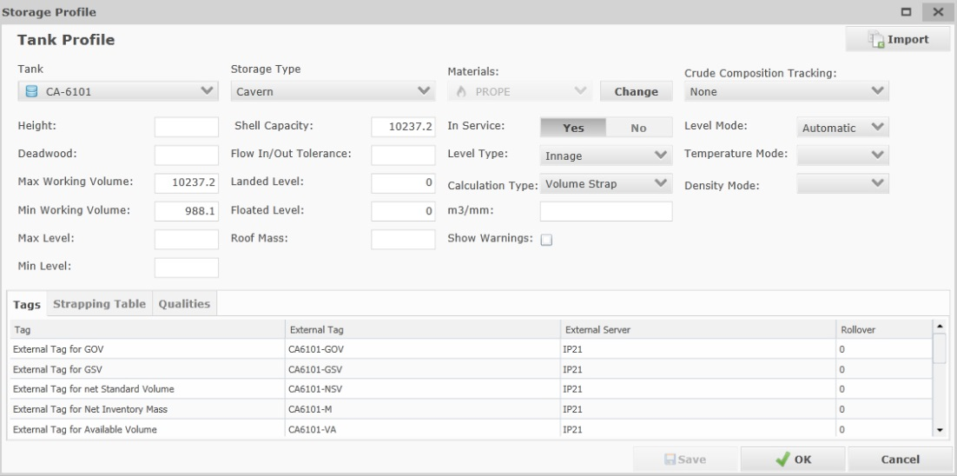

### Storage Information

|  |  |
| --- | --- |
| **Field** | **Description** |
|  | This option determines the Tank the profile is for. |
|  | This option determines the type of storage asset. |
|  | This option determines the Material that is in service on the storage asset. To change material press the  Button. A new dialog will appear.    The Date option which by default is “Now” lets you enter an effective date now or in the past from when the Material should have been in Service.  If the effective time is set to a past date, when commiting the change, all related KPI’s will be updated from the Effective time to “now”, Ekho will also update the IP21 trend with the new material including timestamp of the effective time, updating every value between now and the specified effective time with the new material. |
|  | This options determines if the tank should have Crude Composition Tracking and which type, options are:  FIFO (First in first out)  LIFO (Last in first out)  None (No tracking)  Perfect Blend |
|  | This field determines the Height of the storage asset. |
|  | This field determines the Deadwood of the storage asset. |
|  | This field determines the Max Working Volume of the storage asset. |
|  | This field determines the Min Working Volume of the storage asset. |
|  | This field determines the Max Level of the storage asset. |
|  | This field determines the Min Level of the storage asset. |
|  | This field determines the Shell Capacity of the storage asset. |
|  | This field determines the Flow In/Out Tolerance of the storage asset. |
|  | This field determines the Landed Level (Only available for Float Roof storage types) of the storage asset. |
|  | This field determines the Floated Level (Only available for Float Roof storage types) of the storage asset. |
|  | This field determines the Roof Mass (Only available for Float Roof storage types) of the storage asset. |
|  | This option determines if the storage tank is in service or not. |
|  | This option determines the type of Level on the tank (Innage or Ullage). |
|  | This option determines the calculation type (Mass Strap, Volume Strap, m3/mm or Manual). |
|  | If the calculation type is set to m3/mm, this option determines the m3/mm value for the storage asset used for calculating GOV. |
|  | If this is left unchecked, no warnings will be displayed for the tank in the Tank Monitoring application. |
|  | This option determines the Level Mode on the tank (Automatic or Manual). |

### Storage Tags

There are also different external tags that can be configured in the profile.

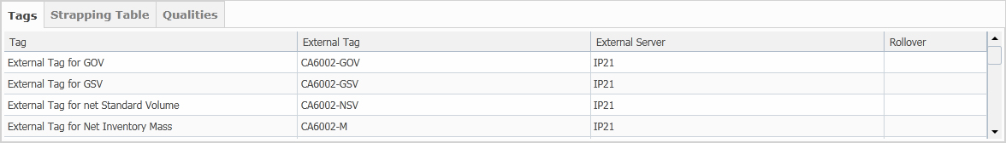

|  |  |
| --- | --- |
| **Column** | **Description** |
| Tag | A description of the external tag. (Read-only) Available placeholers for tags are:  GOV  GSV  Net Standard Volume Net Inventory Mass Available Volume Flow In/Out  Free Volume Material In Service  Temperature Level Gauge  Density BS&W Water Level |
| External Tag | The external tag. |
| Server Tag | The server the external tag is associated with. |
| Rollover |  |

### Strapping Table

The Strapping Table section displays the strapping table data that has been added for the storage asset in the User Specification table “Strapping Tables”.

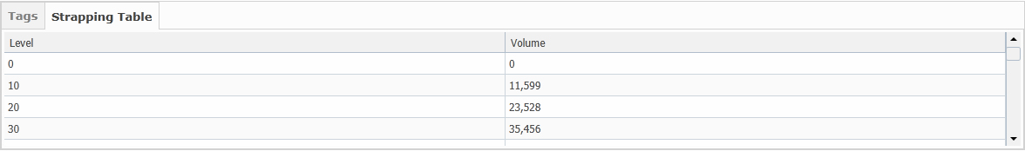

### Qualities

The Qualities section allows you to add quality properties and associate them with actual tags, the users will then be able to monitor the quality information in the Tank Monitoring application. These tags will also be used for reading the Actual Heel on Blend Orders.

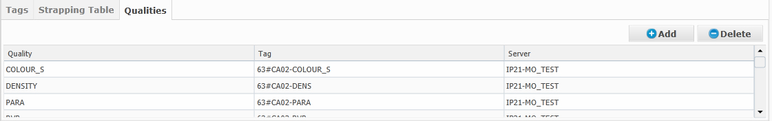

To add a new row press the  button.

|  |  |
| --- | --- |
| **Column** | **Description** |
| Quality | The Quality property |
| Tag | The external tag. |
| Server | The server the external tag is associated with. |

To delete a quality property press the  button.

### Composition

The Composition sections allows you to add Fraction Tags per material used for once a day writing the Tank Material Composition to IP21.

To add a new row press the  button.

|  |  |
| --- | --- |
| **Column** | **Description** |
| Material | The Material. |
| Tag | The external fraction tag. |
| Server | The server the external tag is associated with. |

To delete a quality property press the  button.

To save modifications to the storage profile, click  or  to save and close the storage profile window.

## Stream

To view the streams in the system, click the  button and select the Stream Profile option from the dropdown.

To view the stream profile for a stream or to modify it, select it from the grid in the event editor and click .

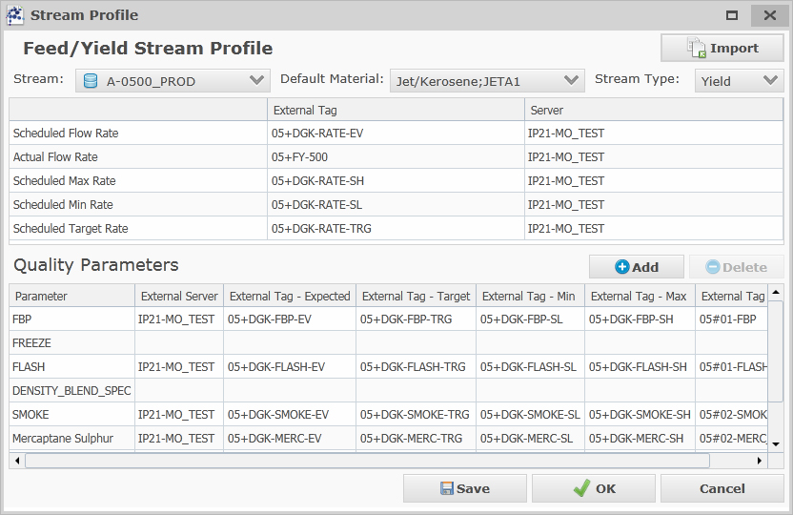

You can change the Stream you want to view/modify by selecting another stream from here

.

You can choose a default Material that is associated with the stream asset here:



This field lets you select the type of Stream (Feed or Yield)



The list of stream rate tags lets you configure the tags to use for the Rate.

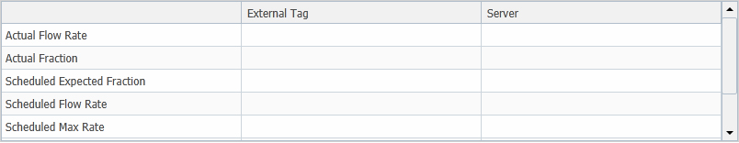

|  |  |
| --- | --- |
| **Column** | **Description** |
| Tag | A description of the tag. (Read-only)  Tags are available for: Scheduled Flow Rate, Actual Flow Rate, Scheduled Max Rate, Scheduled Min Rate, Scheduled Expected Fraction, Scheduled Target Rate and Actual Fraction. |
| External Tag | The external tag. |
| Server Name | The server the external tag is associated with. |

### Quality Parameters

In the Quality Parameters section you can add and remove properties on chosen stream asset.

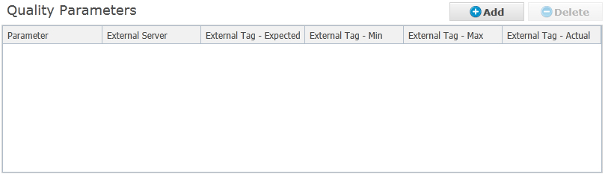

To add a new row in the quality parameters list, click .

To delete a row in the quality parameters list, select it in the list and click .

|  |  |
| --- | --- |
| **Column** | **Description** |
| Parameter | A list of pre-configured parameters to choose from. |
| External Server | The server the external tags for the parameter are associated with |
| External Tag - Expected | The external tag for the expected value of the parameter |
| External Tag - Min | The external tag for the min value of the parameter |
| External Tag - Max | The external tag for the max value of the parameter |
| External Tag - Actual | The external tag for the Actual value of the parameter |

To save modifications to the stream profile, click  or  to save and close the stream profile window.

## Additive Feed/Yield Stream

To view the addive feed/yield streams in the system, click the  button and select the Additive Stream Profile option from the dropdown.

To view the additive feed/yield stream profile for an additive stream or to modify it, select it from the grid in the event editor and click .

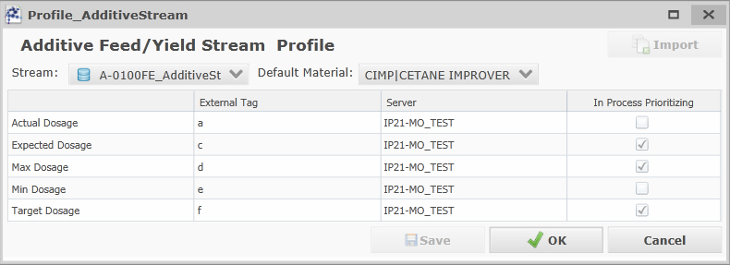

You can change the Additive Feed/Yield Stream you want to view/modify by selecting another additive stream from here

.

You can choose a default Additive Material that is associated with the additive stream asset here:



The list of tags lets you configure the dosage tags to use for additive feed/yield stream



|  |  |
| --- | --- |
| **Column** | **Description** |
| Tag | A description of the tag. (Read-only)  Tags are available for: Actual Dosage, Expected Dosage, Max Dosage, Min Dosage and Target Dosage. |
| External Tag | The external tag. |
| Server | The server the external tag is associated with. |
| In Process Prioritizing | If checked the tag value will be available in the process prioritizing reports. |

## Process Unit

To view the process units in the system, click the  button and select the Process Unit Profile option from the dropdown.

To view the process unit profile for a unit or to modify it, select it from the grid in the event editor and click .

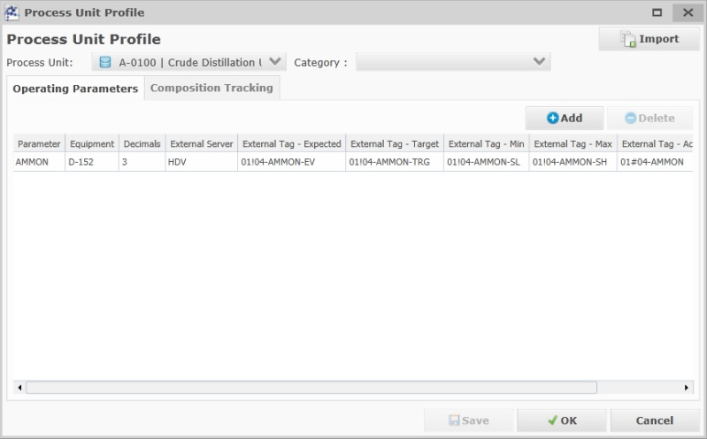

The field allows you to select the comment categories for process order comments that should be visible in the process prioritizing reports for the Process Unit.

### Operating Parameters

When editing a Process Unit profile, the Operating Parameters tab is selected by default.

Operating Parameters can be associated to the process units, these parameters will then be selectable when creating a process order for the process unit in question, it will also act as a filter for which operating parameters to import when importing process unit orders from Orion.

To associate an operating parameter to the process unit press the  button.

A new row is added to the operating parameters list.

|  |  |
| --- | --- |
| **Field** | **Description** |
| Parameter | This option lets you select which operating parameter to configure for the process unit. |
| Equipment | This option determines which equipment the parameter is associated with. |
| Decimals | Determines the number of decimals to limit the operating parameter values to in the GUI. |
| External Server | This option determines which external server the tags are associated with. |
| External Tag – Expected | This option determines which tag to write the expected value to. |
| External Tag – Target | This option determines which tag to write the target value to. |
| External Tag – Min | This option determines which tag to write the min value to. |
| External Tag - Max | This option determines which tag to write the max value to. |
| External Tag – Actual | This option determines which tag to read the actual value from. |
| In Process Prioritizing | Determines if the Operating Parameter values should be included in process prioritizing reports for the process unit. |
| Unit of Measure | Determines the UoM for the operating parameter. |

To remove an operating parameter from the process unit profile, select it in the list and press the  button.

### Composition Tracking

It is possible to configure a set of material composition tags per process unit in order for Ekho to calculate the composition going in to the units when any FEED movement(s) are active and feeding to the process unit and write the composition fraction per material to IP21.

(Only tanks with mixing model “Perfect Blend or “None” are subjects for fraction calculation)

To view/alter the Composition Tracking tags for the process unit, select the Composition Tracking tab. 

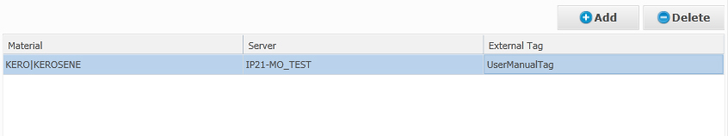

To add a material for composition tracking press the  button.

|  |  |
| --- | --- |
| **Field** | **Description** |
| Material | The Material to track |
| Server | The server the composition tag is associated with |
| External Tag | The external tag for the material fraction |

To remove a material from the composition tracking grid, select it in the list and press the  button.

To save modifications to the process unit profile, click  or  to save and close the stream profile window.

## Scheduling Area

To view the scheduling areas in the system, click the  button and select the Scheduling Area Profile option from the dropdown.

### Add Scheduling Area

To add a new scheduling area, press the  button.

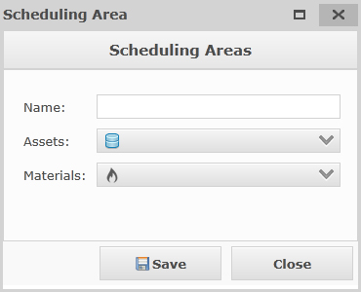

The “Name” field allows you to name the scheduling area (Name should be equal to the associated scheduling group in Orion if one exists)

The “Assets“ options determines which assets should be associated with the scheduling area.

The “Materials” options determines which material groups that should be associated with the scheduling area.

### Edit Scheduling Area

To view the scheduling area profile for a scheduling area or to modify it, select it from the grid in the event editor and click .

To save modifications to the process unit profile, click  .

## Import

It is possible to import profiles from excel files for any type of profile.

To import an excel file, either click  in the event editor and choose ”Profile Import”, or click the 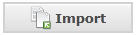button from within any of the profile windows.

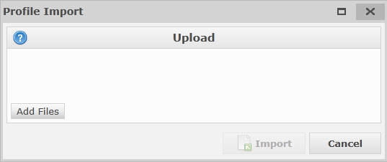

Click the  and choose the file you want to import from. The file you import from has to be either .XLS or .XLSX.

Depending on which type of profile you are importing the excel file should look different.

### Blender Profiles

For blender profiles, there should be four sheets in your excel file called; Assets, Tags, Properties and PropertyTags.

#### Assets

Example:

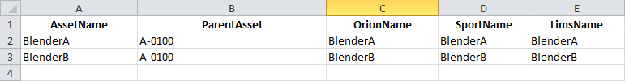

#### Tags

Example:

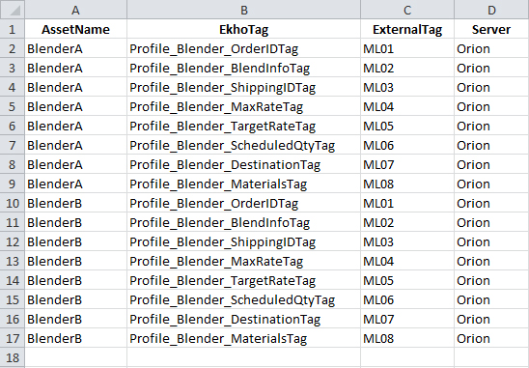

#### Properties

Example:

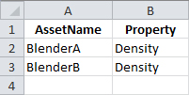

#### PropertyTags

Example:

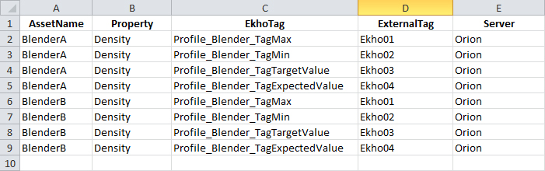

### Line Profiles

For line profiles, there should be one sheet in your excel file called Line.

Example:

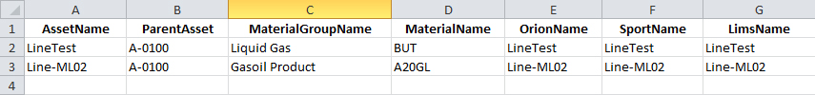

### Pump Profiles

For pump profiles, there should be two sheets in your excel file called Assets and Tags.

#### Assets

Example:

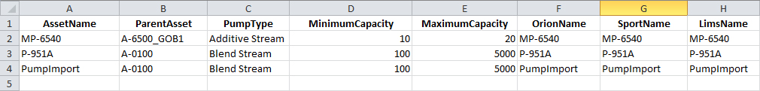

#### Tags

Example:

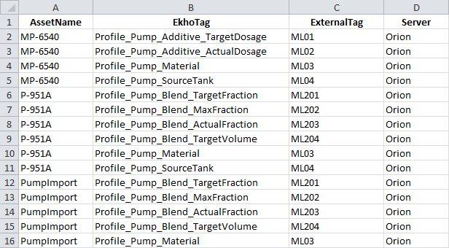

### Storage Profiles

For storage profiles, there should be two sheets in your excel file called Assets and Tags.

#### Assets

Example:



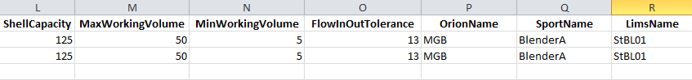

#### Tags

Example:

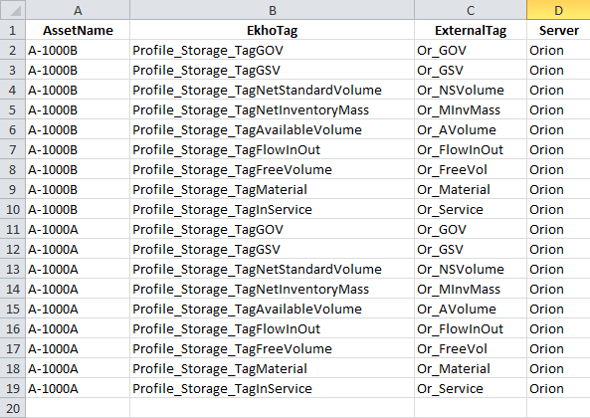

### Stream Profiles

For stream profiles, there should be two sheets in your excel file called Assets and Tags.

#### Assets

Example:

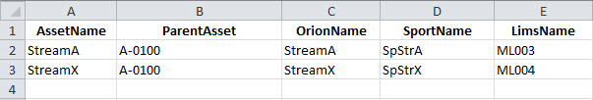

#### Tags

Example:

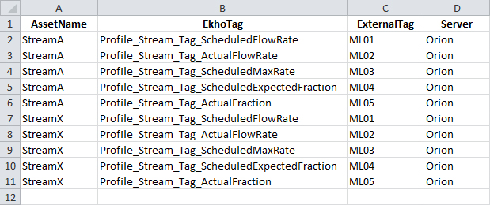

# Material Manager

## Introduction

The Material Manager lets you manage the materials in the system and gives you functions to view/edit and add materials.

## General

When entering the Material Manager, a list of all the material groups and materials will be shown.

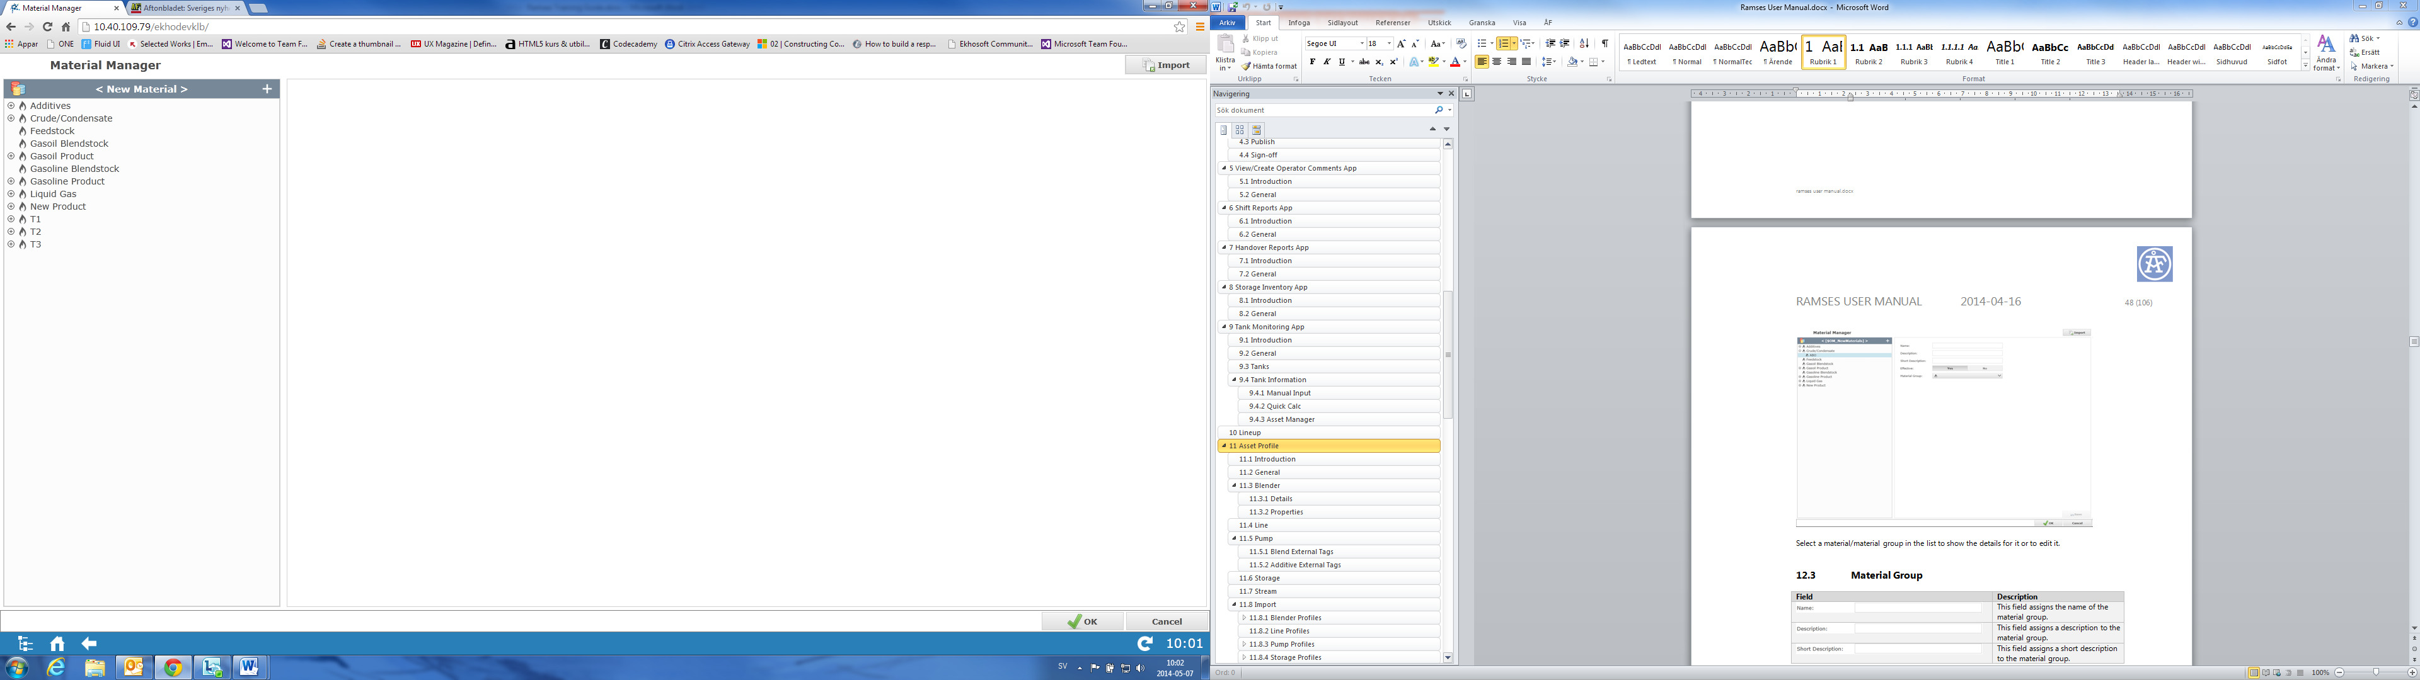

Select a material/material group in the list to show the details for it or to edit it.

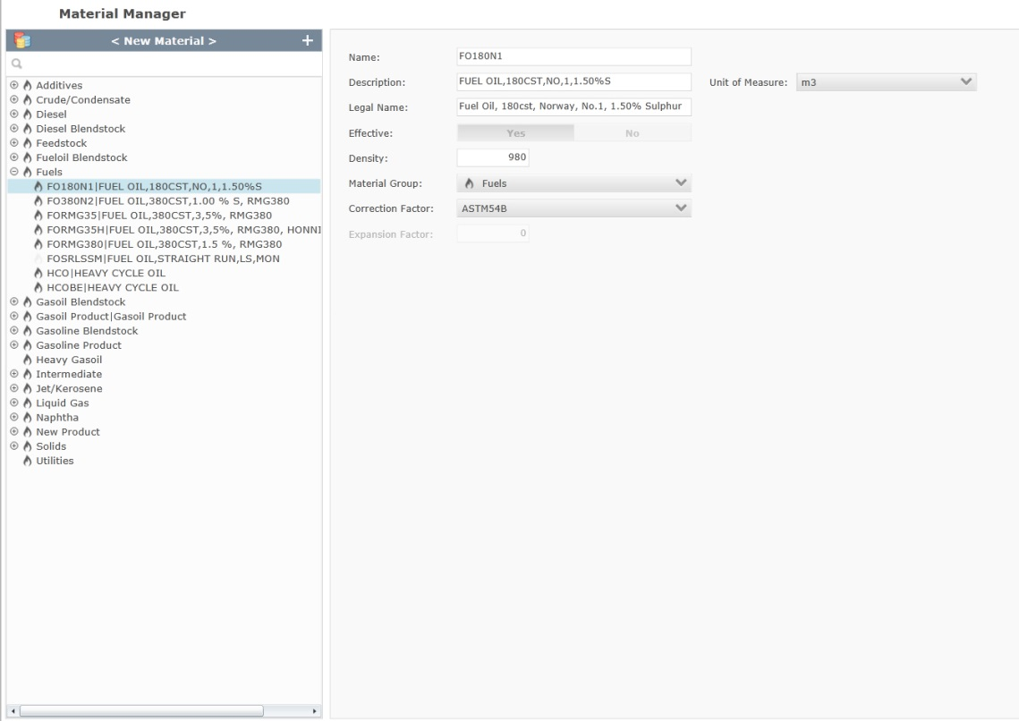

After doing any modification to a material/material group you must save it by clicking .

## Material Group

|  |  |
| --- | --- |
| **Field** | **Description** |
|  | This field assigns the name of the material group. |
|  | This field assigns a description to the material group. |
|  | This field assigns a a legal name to the material group. |
|  | This option tells the system if the material group should be available or not. |
|  | This option lets you assign the material type of the material group for reporting purposes, available options are:  Charge  Yield(Finished)  Yield(Intermediate)  Yield(Other) |
|  | This option lets you select which Material groups the materials in this material group should be valid input components for.  Example:  *If editing the Gasoil Product material group, checking the Gasoil Feedstock option here would allow you to select materials from the Gasoil Feedstock group as recipe components when blending a product in the Gasoil Product group.* |
|  | This option lets you select which Additive materials the materials in this material group should be valid additives for.  Example: *if editing the Gasoil Product material group, checking the CIMP option here would allow you to select CIMP as an additive when blending a product in the Gasoil Product group.* |

## Material

|  |  |
| --- | --- |
| **Field** | **Description** |
|  | This field assigns the name of the material. |
|  | This field assigns a description to the material. |
|  | This field assigns a legal name to the material. |
|  | This option tells the system if the material should be available for use with orders or not. If a material exists both in Sport and Ekho, this will be read-only. |
|  | The density of the material |
|  | This option lets you chose a material group that the material should be assigned to. |
|  | Lets you choose which ASTM table to take the correction factor from, available options are:  ASTM54A  ASTM54B  ASTM54C  ASTM54X |
|  | Assigns the Expansion Factor value (only available to edit if the Correction Factor has been set to “ASTM54C”). |
|  | Assigns a UoM for the Material (m3 or t) |

## Add

Click  and select if you want to add a new material group or a new material.

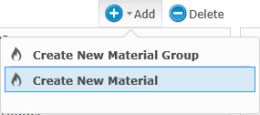

When you have entered all of the fields for your new material group or material, click  to save it.

## Sport Import

The system checks periodically for material updates in sport, when an update is detected, the materials will be automatically imported into the Material Manager in Ramses.

If the material already exists in Ramses, it will be overwritten (Unless “Ignore Sport” has been checked on a specific material). If the material is new, it will be saved in the material group called New Product.

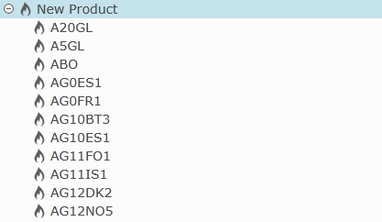

You are free to change the group for each new material.

## Manual Import

It is possible to manually import materials/material groups from an excel file by clicking in the top right corner of the screen.

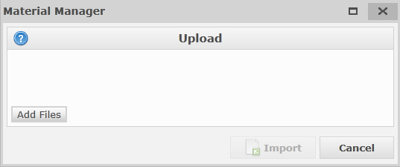

Click the  button and locate the excel file you want to import from then click the Import button.

If you want to import materials and material groups at the same time, the excel file should have two sheets, one called MaterialGroups and one called Materials.

### MaterialGroups

Example:

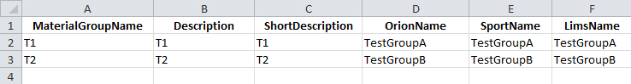

### Materials

Example:

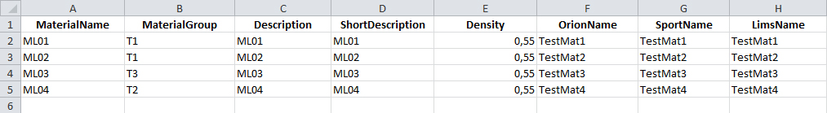

# User Settings

## General

The user Settings application allows the users to select the default comment category that should be pre-selected for them whenever they are adding a comment to an event (Order, Log, Instruction)

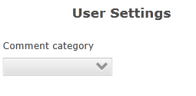

# Asset Security

## Introduction

The Asset Security app lets you manage user groups and asset security for said groups.

## General

The first time you open Asset Security it will look something like this.

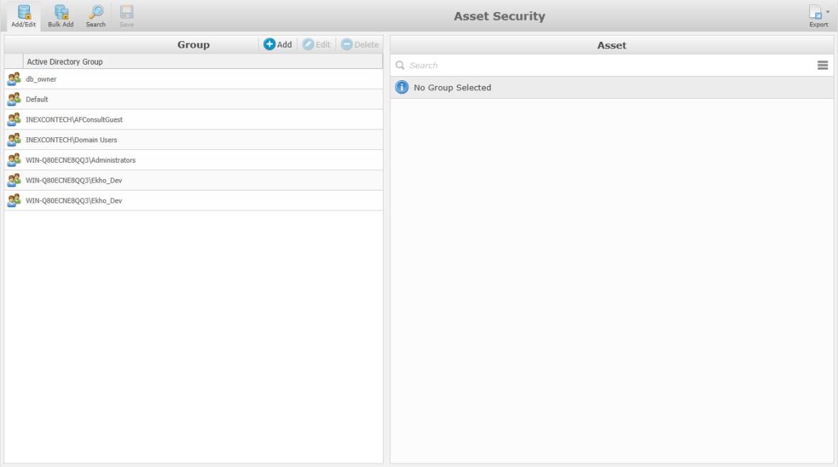

By default, the left section of the screen will contain the entire list of existing groups.

On the right section of the screen, you will see the actual existing asset tree view.

|  |  |
| --- | --- |
| **Icon** | **Description** |
|  | This option will give you the ability to create new or edit groups and their asset security. |
|  | This option works similar to add/edit but here you can apply asset security to groups in bulk. |
|  | This option lets you find groups by searching through assets. |
|  | This option lets you save your changes. |
|  | This option lets you export your asset security list to an .XLSX format for excel. |

## Add/Edit

When you click 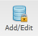 the Add/Edit page will be displayed.

In the group Add/Edit page you have three possible options.

### Add

To add a new security group you need to click , this will open the Security Group Management form which will let you add a new group.

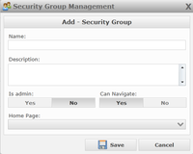

|  |  |
| --- | --- |
| **Field** | **Description** |
|  | The name of the group. |
|  | A description to help you describe the group. |
|  | This option tells the system if the group should have administrator privileges. |
|  | This option tells the system if the group should be able to |
|  | This option determines the default page that will open when a user of that group opens the application. |

After the information is completed, click  to save your new group or  to quit without saving.

You will now see the new group in the list.

To associate the related assets, click on the group and select the assets in the right section of the screen.

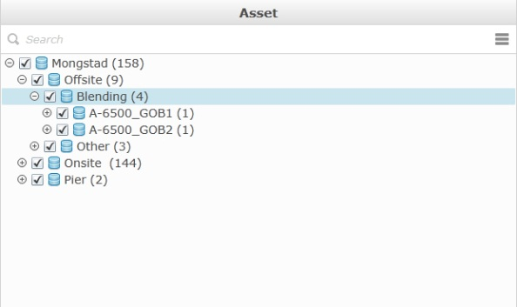

After choosing the assets that should be available for the group, you must click  for your changes to take effect.

### Edit

To edit a security group, select it in the list and then click .

The Security Group Management form will open and let you modify the group.

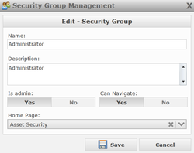

After doing modifications, click  to save your changes or  to quit without saving.

You don’t need to click on the edit button change the assets selection, this can be done simply by clicking the name of the security group in the left section and select new assets from the list.

To save your asset selection changes, click .

### Delete

To delete a security group, select it in the list and then click .

A confirmation message will appear.

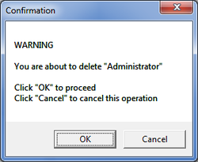

## Bulk Add

In the Bulk Add option, you have the same three possible options as in Add/Edit, but they can be applied to multiple groups instead of only one.

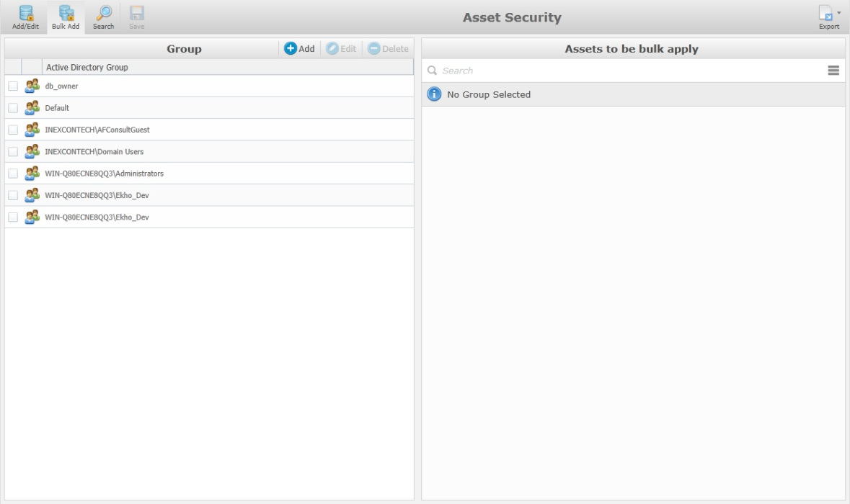

Check all the groups that you want to modify in bulk and then select the assets in the right screen. When all of your selections are complete, click  to save your changes.

## Search

When you click on the search option 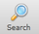 the window will change to show the search related option. The purpose of this page is to find the groups related to an asset.

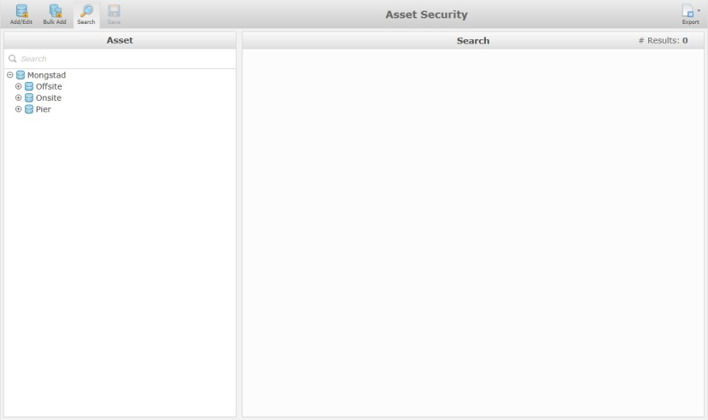

To find the group related to an asset, open the tree view and click on the asset name or type the name of the asset in the search bar and press enter.

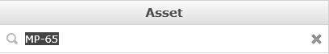

The groups that are configured to access the selected asset will be displayed in the right section of the screen.

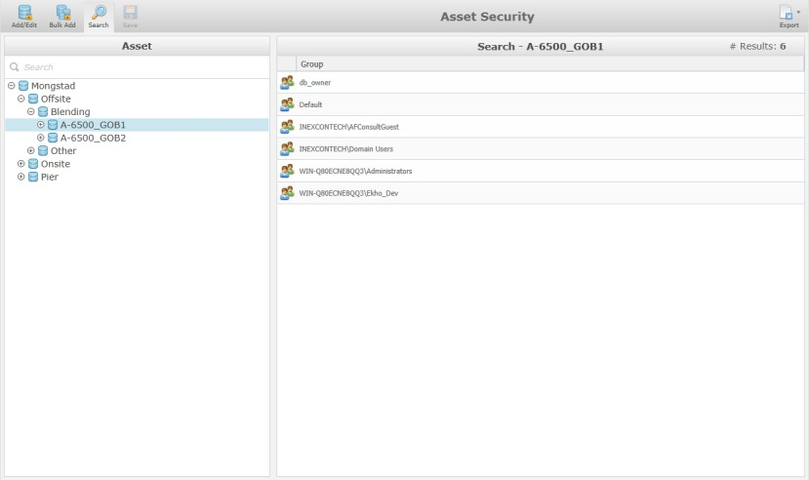

# User Specification

## Introduction

The purpose of the User Specifications app is to allow you to configure specifications that can be used when there is a need to store reference information that is not stored by default in the system.

An example of a user specification is the tank strappings.

## General

When first accessing the User Specifications app, the main display pane will appear blank.

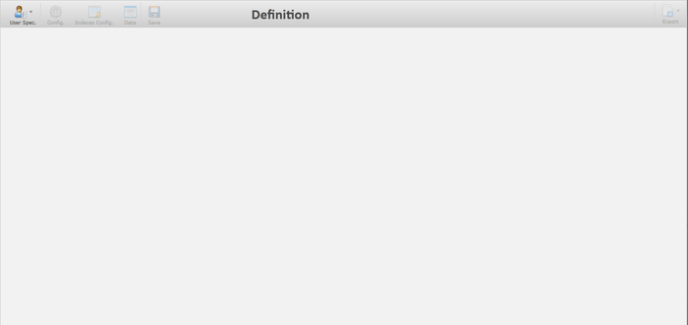

Before this page will display any information, you have to either create a new or load an existing user specification.

To create a brand new user spec, click on the 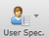 icon, this opens the dropdown containing all of the available user specifications in the system, but you can also create new user spec templates from here by clicking on the Create User Spec Template icon  this will open the main display page, without any information.

You also have the ability to create a new extraction from an existing extraction by clicking the icon beside the name of an existing extraction template 

When this option is used, all of the information from the selected user spec will be displayed and you only have to complete the User Spec Properties section.

If you want to create a user spec with the same basic information and data, select the Import Template and Data option 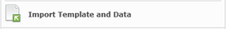, a new window will then be available to let you chose the file to import.

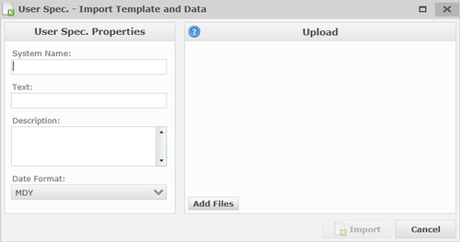

To create a user spec from a .csv file, you need to provide some basic information to create the user spec (refer below for a detailed explanation). Select the  icon to get more information on the .CSV file format. To upload the file click  and the name of the file that you import will be shown in the Upload part of the screen.

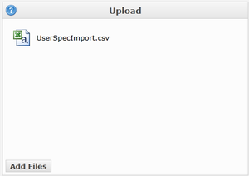

To complete the process, click , or  to cancel the import.

Once the user spec columns are configured, more options will be available on the top tool bar.

The purpose of the top tool bar is to help assist in the configuration of the user spec.



|  |  |
| --- | --- |
| **Icon** | **Description** |
| USMainUserSpecIcon.png | This option will give you the ability to create a new user spec or to open an existing one. |
| USMainConfigIcon.png | This option will give you the ability to access the configuration of the current selection. |
| USMainIndexIcon.png | This option will give you the ability to add, edit or delete indexes. |
| USMainDataIcon.png | This option will give you the ability to import, add or delete data. |
| USMainSaveIcon.png | This option will give you the ability to save the current selection. |
| USMainExportIcon.png | This option will give you the ability to export the data in a .PDF and .XLX / .CSV file. |

## Configuration

To create a new user spec click  and then 

The user spec main display page contains properties that need to be populated with the appropriate information.

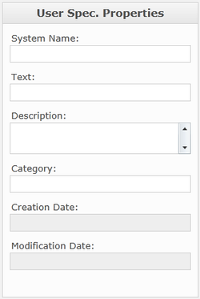

|  |  |
| --- | --- |
| **Field** | **Description** |
|  | This name will be used to create the associated table in the system. It will also be used as a reference to retrieve your information. The system name must be unique. |
|  | This is what will be displayed in the user spec list. |
|  | This is where you can enter information to help describe the purpose and/or usage of the user spec. |
|  | This is not used for the moment, but will be used in future versions of the application. |
|  | This will be automatically populated by the system. |
|  | This will be automatically populated by the system. |

### Columns

In this section you have the ability to Add, Edit or Delete columns of the current user spec.

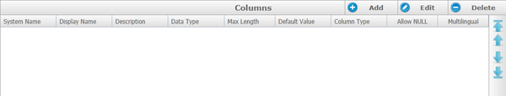

|  |  |
| --- | --- |
| **Icon** | **Description** |
| USAddColumn.png | This option gives you the ability to configure new columns. |
| USEditColumn.png | This option gives you the ability to modify the selected column. When this button is clicked, a window will open with the column information to let you modify. |
| USDeleteColumn.png | This option gives you the ability to delete a column by selecting one and then clicking the delete button. |
| KMFormulaAllUp.png | This option gives you the ability to move the column that is currently selected to the top, click this up arrow icon and the column will be moved to the first position of the list. |
| KMFormulaUp.png | This option gives you the ability to move the column that is currently selected to the top, click this up arrow icon and the column will be moved one row up in the list. |
| KMFormulaDown.png | This option gives you the ability to move the column that is currently selected to the bottom, click this down arrow icon and the column will be moved one row down in the list. |
| KMFormulaAllDown.png | This option gives you the ability to move the column that is currently selected to the bottom, click this down arrow icon and the column will be moved to the last position of the list. |

When a new column is added, a new window will be displayed.

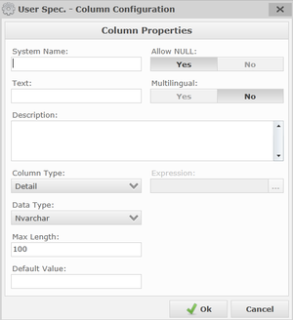

|  |  |
| --- | --- |
| **Field** | **Description** |
| USColumnConfigSName.png | This field is used to create the corresponding column in the user specification table. Note that no space or special characters are permitted in this field. |
| USColumnConfigDName.png | This field will be the display name used by the system. |
| USColumnConfigDescr.png | This field will be used to hold a description of the column. |
|  | This field is used to define the column type. A pre-defined list of choices is available to choose which type of column you would like to configure.  USColumnConfigTypeChoice.png |
|  | This field is used to configure the data type of the column. If the column type is set to Detail you may change the Data Type for something more suitable.  USColumnConfigDataTypeChoice.png  If something other than Detail is selected for the Column Type, then the Data Type will be automatically selected. |
| USColumnConfigMaxL.png | This field is used to fix the maximum length entry of the text value. This setting will only be available for an Nvarchar Data Type. |
| USColumnConfigDefVal.png | This field is used to pre-fill the value when you add some data to that column. |
| USColumnConfigNULL.png | This field is used to determine if the column allows a null value. If there is no value in the column when you save, you will be prompted to put one in. |
| USColumnConfigMulti.png | This field is used only with an Nvarchar column and will give you the ability to have some text in different languages according to the setting of the computer. |
| USColumnConfigExpr.png | The Expression field is disabled by default and will become enabled when you selected <Expression> in the column type. See below for more information on the expression. |

When all field selections are completed, press  or  to quit without saving.

All the configuration information will now be displayed on the main page.

Once the column is created, click  in order to save your changes.

#### Expression

If a column type is expression, when you click on the edit expression button  and new window will appear.

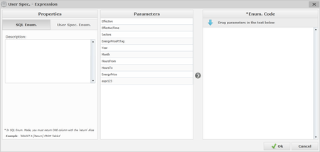

There are two options to define an expression: SQL Enum. (Enumeration) and User Spec Enum.

In both modes there is some basic information that needs to be entered.

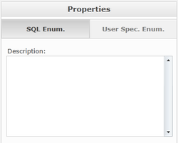

The Description is to help you describe the usage of the expression.

The SQL Enum mode is when you want to execute an action directly related to an existing field in the current User Spec. The User Spec Enum mode is when you want to use values from another user spec. Based on this selection, other sections will need to be adjusted.

**SQL Enum**

In the parameters section, you can see the list of all the columns defined in the current user spec. They can be moved in the \*Enum. Code section by using the drag and drop method or by using the right arrow button .

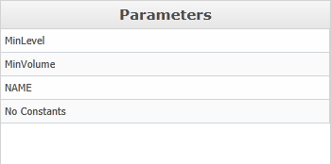

The \*Enum. Code section is where the SQL code of the expression is created. Any syntax that is allowed by SQL will be allowed here.

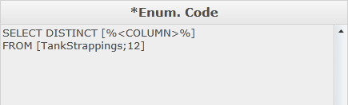

**User Spec. Enum**

In the parameters section, you can see two selection boxes.

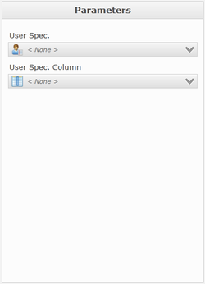

In the User Spec. option, you will see a list of all the available User Specs. In the User Spec. Column option, you will see a list of columns available from the User Spec you select.

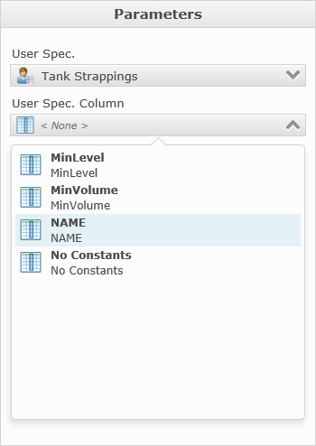

In the \*Enum. Code section the SQL code of the expression is automatically created according to the selection in the parameters section.

When all of the information has been completed, press  or  to quit without saving.

All the configuration information will now be displayed on the main page.

## Indexes Configuration

The User Spec. is saved as a real data table in the system. You also have the ability to add some indexes on the user spec. columns. This is done via the Indexes Config. Page.

To open the Indexes Config. Entry page, click .

An index can be created on a table to query data more quickly and efficiently.

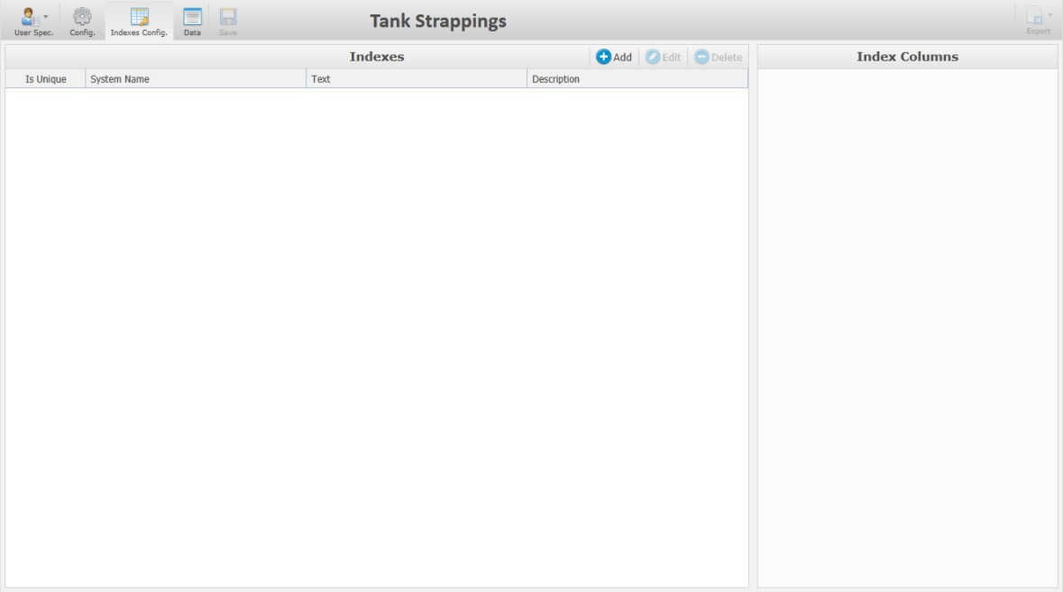

|  |  |
| --- | --- |
| **Icon** | **Description** |
| USAddColumn.png | This option gives you the ability to configure new indexes. |
| USEditColumn.png | This option gives you the ability to modify the selected column. When this button is clicked, a window will open with the column information to let you modify. |
| USDeleteColumn.png | This option gives you the ability to delete a column by selecting the column and clicking the delete button. |

When you Add or Edit an index, a new window appears.

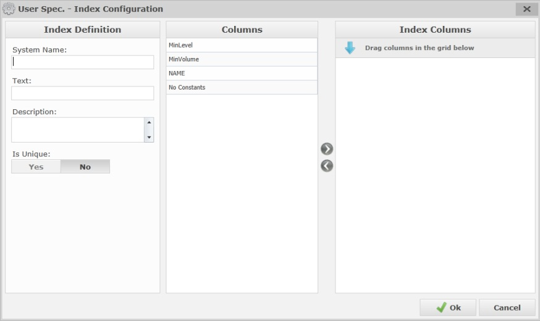

|  |  |
| --- | --- |
| **Field** | **Description** |
|  | This name will be used to create the index for the table. The system name must be unique. |
|  | This is what will be displayed in the user spec list. |
|  | This is where you can enter information to help describe the usage of the index. |
|  | The Is Unique option will determine if the data in that field allows duplicate data or not. |

In the columns section, a list of all the available columns from the User Spec. is displayed for selection.

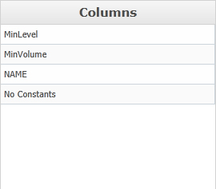

To create an index on a specific column, select the column name and drag it in the Index Columns section. You can also use the right and left arrows  to move columns back and forth.

When all required information has been entered, press  or  to quit without saving.

All the configurations will now be displayed on the main page.

When an index is selected, the column(s) name(s) related to that index will be displayed in the Index Column section.

Once the Index is created, click  to save your changes.

## Data

To access the data entry page, click on  and the main data entry page will appear.

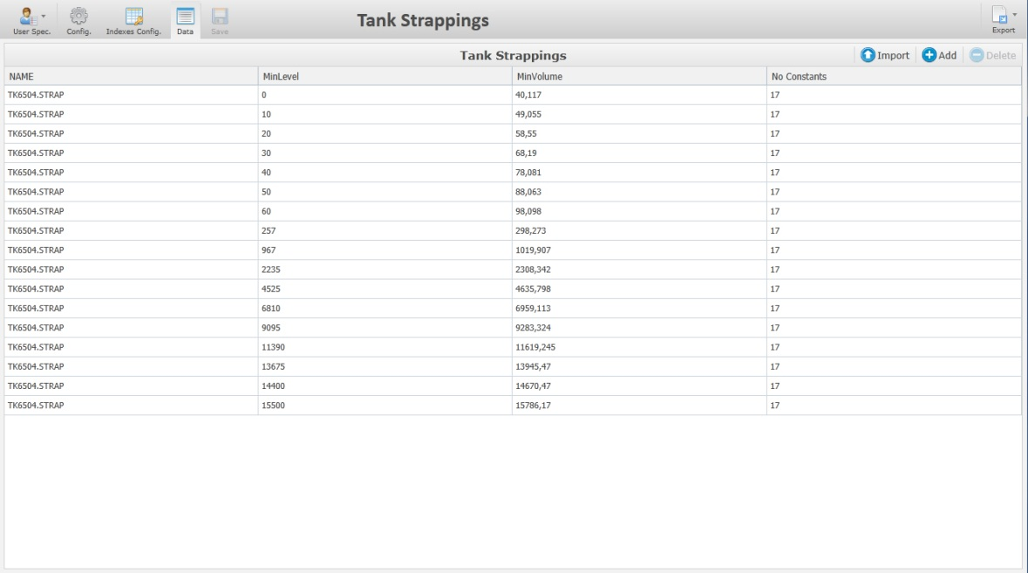

Each column defined in the configuration screen is represented here. To add some data click 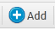

A new, empty row will appear where you can enter data. Each column may have different behavior according to the column type selected in the configuration screen.

You can also import User Spec. data from a .CSV file. The file should contain the same number of columns defined in the User Spec.

To import, click  and a new window will appear.

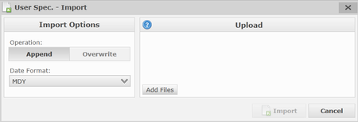

In the import window, you have the choice to Append or Overwrite the data. When a date field is contained within the imported file, there is a field (Date Format) to specify the date format of the file. It is important to specify a valid date format in order to ensure that the import is successful.

Next, in the Upload section of the window, click  and a new window will appear to give you the ability to select the location of the file you would like to import.

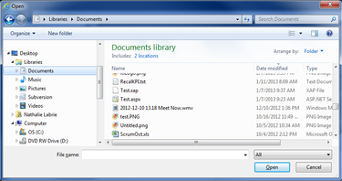

Once the upload is complete, you will see the file name in the Upload section. If the type of file you are trying to import is not in a valid format, a message will appear at the bottom of the screen.



To get additional information regarding the upload, click  and an information popup will appear.

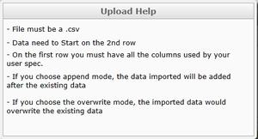

The date that was uploaded should now appear on the page.

To delete a line of data, select the desired line and click .

Click  in order to save your changes.

## Export

Click  to export the User Spec. data. You have the ability to export to .XLSX or .PDF

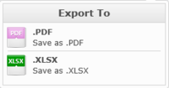

## Important User Specifications

Listed below are some of the important user specifications that might need maintenance from time to time.

### Mapping Asset

This user specification is used to map asset names from Orion, Sport and Lims to the assets in Ekho.

|  |  |
| --- | --- |
| **Column** | **Description** |
| Asset | Determines the Ekho asset the mapping is for. |
| Orion | The name used to describe the Asset in Orion. |
| Sport | The name used to describe the Asset in Sport. |
| Lims | The name used to describe the Asset in Lims. |
| IP21 | The name used to describe the Asset in IP21. |

### Mapping Material

This user specification is used to map material names from Orion, Sport and Lims to the materials in Ekho.

|  |  |
| --- | --- |
| **Column** | **Description** |
| Material | Determines the Ekho Material the mapping is for. |
| Orion | The name used to describe the Material in Orion. |
| Sport | The name used to describe the Material in Sport. |
| Lims | The name used to describe the Material in Lims. |
| IP21 | The name used to describe the Material in IP21. |

### Mapping Quality Property

This user specification is used to map Quality Property names from Orion, Sport and Lims to the Quality Properties in Ekho.

|  |  |
| --- | --- |
| **Column** | **Description** |
| Property | Determines the Ekho Quality Property the mapping is for. |
| Orion | The name used to describe the Property in Orion. |
| Sport | The name used to describe the Property in Sport. |
| Lims | The name used to describe the Property in Lims. |
| Is Density | A flag to determine if the property is density |
| Is BSW | A flag to determine if the property is BS&W |
| Unit of Measure | Determines which Unit of measure that should be set for all places in Ekho where the quality property is used. |
| Data Type | Determines if the propertys values are Numeric or Text |
| Tolerance Type | Determines if the Expected vs Target Tolerance should be Relative or Absolute |
| Tolerance | Determines the Tolerance for Expected vs Target (If Expected value = Min or Max with respect of tolerance, value becomes Target) |
| Decimals | Default number of decimals to use for the quality property if the v\_property\_decimals view from LIMS does not supply this. |

### Mapping Operating Parameter

This user specification is used to map the operating parameters in the Orion output to Ekho.

|  |  |
| --- | --- |
| **Column** | **Description** |
| Operating Parameter | Determines the Ekho Operating Parameter marker the mapping is for. |
| Equipment | The Equipment associated with the operating parameter on the process unit profile. |
| ORION | The Orion name for the operating parameter. |

### Mapping Movement Type

### Mapping Lineup

This user specification is used to determine if a stream asset should be mapped to a lineup.

If an order is imported from Orion and has a stream that has been associated with a lineup here, a cold stream transfer order would be generated.

|  |  |
| --- | --- |
| **Column** | **Description** |
| Lineup | Displays the lineups |
| ORION Stream ID | Lets you associate a stream with the lineup (The ORION stream ID should be entered) |

### Mapping Stream

This user specification is used to determine the Mapping of Feed/Yield streams to Sample points in LIMS.

|  |  |
| --- | --- |
| **Column** | **Description** |
| Stream | The Feed/Yield Stream in Ekho that should be mapped. |
| Sample Point | The Sample Point in LIMS, a Feed/Yield Stream can be mapped to multiple Sample Points. |

### Material Rules

This user specification is used for rules to determine blend and flush generation on order import, default source/destination and flow rates.

|  |  |
| --- | --- |
| **Column** | **Description** |
| Material | Determines the Material all the rules are associated with. |
| Blend Limit | If the quantity of an order in SPORT is greater than this value, the order will by default be imported to Ekho as a Blend order (Possible to override when importing). |
| Low Qty Limit | If the quantity of an order in SPORT is lower than or equal to this value, the default flow rate of the order in Ekho would be taken from the “Low Flow Rate” column in this user specification. |
| High Qty Limit | If the quantity of an order in SPORT is greater than or equal to this value, the default flow rate of the order in Ekho would be taken from the “High Flow Rate” column in this user specification. |
| Low Flow Rate | This default value for Flow Rate would be used for the order in Ekho if the Quantity of the order in SPORT is lower than or equal to the “Low Qty Limit” column in this user specification. |
| Mid Flow Rate | This default value for Flow Rate would be used for the order in Ekho if the Quantity of the order in SPORT is greater than the “Low Qty Limit” column but lesser than the “High Qty Limit” column in this user specification. |
| High Flow Rate | This default value for Flow Rate would be used for the order in Ekho if the Quantity of the order in SPORT is greater than or equal to the “High Qty Limit” column in this user specification. |
| Default Jetty | If a Jetty has not been set on an order in SPORT, this default value would be used for Source/Destination on the order in Ekho depending on if it is an import or export. |
| Default Blender | This field determines a default blender to be used for the order in Ekho if the order imported from SPORT generated a blend order. It will also be used when importing from Orion, if left blank the blender in the Orion output will be used. |
| Default Storage | This field determines a default storage equipment to use as Source/Destination depending on if it is an import or export if the order imported from SPORT was generated as a Transfer Order in Ekho. |
| Comment | This field assigns a default comment to the order in Ekho. |
| Ship Cubic on Transfer | Determines if a ship cubic sample should be taken for transfer orders with the material this rule is for. |
| Flush Before Volume | If this column has a value, any order with the Material this rule is for would generate a flush order that will be scheduled before the main order when imported from Sport/Orion. |
| Flush Before Source | Determines the default source for the generated flush before order (Only used by Ekho if the flush order is for a transfer order) |
| Flush Before Destination | Determines the default destination for the generated flush before order. (If destination is a jetty the flush order will be part of the nomination, e.g have the same ERP\_ID as the main order if the main order has an ERP\_ID.) |
| Flush Before Type | Choice between:   * NULL (Blend quantity limit and order quantity determines if flush order should be transfer or blend. * Transfer Order (Flush order will be generated as a transfer order regardless of if the main order is blend order or transfer order) |
| Flush Before Comment | This field assigns a default comment to the flush before order in Ekho. |
| Flush After Volume | If this column has a value, any order with the Material this rule is for would generate a flush order that will be scheduled after the main order when imported from Sport/Orion. |
| Flush After Source | Determines the default source for the generated flush after order (Only used by Ekho if the flush order is for a transfer order) |
| Flush After Destination | Determines the default destination for the generated flush after order. (If destination is a jetty the flush order will be part of the nomination, e.g have the same ERP\_ID as the main order if the main order has an ERP\_ID.) |
| Flush After Type | Choice between:   * NULL (Blend quantity limit and order quantity determines if flush order should be transfer or blend. * Transfer Order (Flush order will be generated as a transfer order regardless of if the main order is blend order or transfer order) |
| Flush After Comment | This field assigns a default comment to the flush after order in Ekho. |

### Default Order Comment

This user specification is used to determine if any default comments should be generated on the order when imported from Orion and/or Sport. Note that any comment generated on the order due to the Material Rules user spec will override any potential comment that would be generated due to this “Default Order Comment” user spec.

|  |  |
| --- | --- |
| **Column** | **Description** |
| OrderType | Which type of order/transfer type the rule applies to. |
| On Import From | Determines which external system(s) the rule applies to on import, Orion, Sport or Orion & Sport. |
| DefaultComment | The comment that will be generated. |

### Status Security

This user specification is used to determine which user groups that should be able to edit (fully or partial) or delete orders/movements by status.

|  |  |
| --- | --- |
| **Column** | **Description** |
| User Group | Determines the security group (AD group) the rule is for. |
| Page | Describes the EventType the rule is for. Blend Order  Transfer Order  Process Order |
| Status | Defines the order status the rule is valid for. |
| Can User Change Status | Determines if the selected security group should be able to edit the status of the order when it has the selected status. |
| Can User Edit Final Figures | Determines if the selected security group should be able to edit the final figures on the movement when it has the selected status. |
| Can User Edit Header | Determines if the selected security group should be able to edit the Header information on the order when it has the selected status. |
| Can Delete | Determines if the selected security group should be able to delete the order/movement when it has the selected status. |

### Status Change

This user specification is used to determine which statuses that will be visible in the status dropdown when an order/movement has a certain status. By default the current status will always be visible in the status dropdown.

|  |  |
| --- | --- |
| **Column** | **Description** |
| Current Status | The order/movement status the rule is applicable for. |
| New Status | The order/movement status it should be possible to select in the status dropdown on the order/movement(s) when they have the selected “Current Status”. |
| Applicable to Transfer Order | Determines if the rule is applicable for Transfer Order movements. |
| Applicable to Blend Order | Determines if the rule is applicable for Blend Orders |
| Applicable to Process Order | Determines if the rule is applicable for Process Orders. |

### OrderType ResponsibleAsset

This user specification is used to determine the default responsible asset and which text label to show for the responsible asset option on the transfer order envelope per Order Type. This user spec is used in conjunction with the MovementType-AssetType cfg user spec, any Default Responsible Asset set here must have its Asset Type configured as a valid Asset Type in the MovementType-AssetType cfg user spec.

|  |  |
| --- | --- |
| **Column** | **Description** |
| Order Type | The transfer type the rule is for |
| Default Responsible Asset | This option determines which asset should be selected by default as responsible asset when this specific Order Type is selected on a Transfer Order. |
| Responsible Asset Label | This option determines what the Text Label describing the Responsible Asset option in the Transfer Order dialog should read like when this specific Order Type is selected on a Transfer Order. |
| Movement | Either Source or Destination, determines if the Responsible asset is the source or destination of the order. |

### MovementType-AssetType cfg

This user specification is used to determine which types of assets that should be visible and selectable in the dropdowns when selecting a source/destination for a movement per movement type, as a rule the parents of the valid assets will be visible but not selectable unless they have been configured to be selectable here.

|  |  |
| --- | --- |
| **Column** | **Description** |
| Movement Type | The types of movements the rule applies to (TKTOTK, IMPORT, EXPORT, PUMPBACK, TRUCKEXP, TRUCKIMP, FEED, RUNDOWN, OWNCONSUMPTION, PIPEIMP, FLUSH, CRTRANS, BLENDIN, BLENDOUT) |
| Source or Destination | Determines if the rule applies to the Source selection list or Destination selection list |
| Asset Type | Determines the Type of Assets (Storage, Blender, Loading Arm etc.) that should be visible in the source/destination dropdown for the movement type. |

### Template Creation Security

This user specification is used to determine which user groups that are allowed to create and edit Order/Log/Instruction Templates in the system.

|  |  |
| --- | --- |
| **Column** | **Description** |
| EventType | The type of event the rule is for.  OM\_BlendOrder (for blend orders)  OM\_TransferOrder (for transfer orders)  OM\_ProcessOrder (for process orders)  Log\_Operator (for operator logs)  Log\_OperatingInstruction (for operating instructions) |
| SecurityGroup | The security group the rule is for. |
| CanCreateTemplate | If the chosen security group is allowed to create/edit templates for the chosen event type. |

### DIR Publish Questions

This user specification is used to determine any check-list questions to display when publishing a daily instruction report and if the user should be forced to check any of them before being able to publish.

|  |  |
| --- | --- |
| **Column** | **Description** |
| Question | The check-list question / statement. |
| Order | The order of which the question / statement will appear in the list. |
| Is Mandatory | This option determines if the question / statement needs to be checked before being able to publish the report. |

### DIR Signoff Questions

This user specification is used to determine any check-list questions to display when signing off on a daily instruction report and if the user should be forced to check any of them before being able to signoff.

|  |  |
| --- | --- |
| **Column** | **Description** |
| Question | The check-list question / statement. |
| Order | The order of which the question / statement will appear in the list. |
| Is Mandatory | This option determines if the question / statement needs to be checked before being able to sign-off on the report. |

### Global Template Creation Group

This user specification is used to determine which user groups that are able to create global Tank Monitoring filter templates, meaning filter templates that every user can use.

|  |  |
| --- | --- |
| **Column** | **Description** |
| AD\_Group | The name of the AD group |
| CanCreateGlobalTemplate | True or False, if True every user belonging to the user group will be able to create global tank monitoring filter templates. |

### Automatic Operators Log Config

This user specification is used to determine if operator logs should be automatically created when an order goes from one status to another, it also determines which category the log will have and if it should be included in Shift Reports and/or Handover Reports,

The Log Description will be the following: Order “<OrderName>” with ID <OrderId> went from <From Status> to <To Status>

|  |  |
| --- | --- |
| **Column** | **Description** |
| Order Type | The Order Type (OM\_ProcessOrder, OM\_BlendOrder, OM\_TransferOrder) the rule is applicable for. |
| From Status | The log will be created when an order of the chosen Order Type goes from this status to the “To Status” |
| To Status | The log will be created when an order of the chosen Order Type goes from “From Status” to this status. |
| Category | Determines the Category of the Operator Log. |
| Include in Shift Report | Determines if the operator log should be included in Shift Reports |
| Include in Handover Report | Determines if the operator log should be included in Handover Reports. |

### PPL-View

This user spec determines which comment categories that should be included in the PPL Instruction Reports, only one column is available in this user spec: Comment Category.

### Form Security

This user spec determines which Ekho Forms that should be completely read-only for certain user groups.

|  |  |
| --- | --- |
| **Column** | **Description** |
| User Group | The AD group the rule is applicable for. |
| Ekho Form | The Ekho form the rule is applicable for:   * Operator Log * Operating Instruction * Profile Line * Profile Pump * Material Manager * Profile Blender * Line-up Manager * Profile Process Unit * Scheduling Area * Profile Storage * Profile Stream * ERP Adjustment * Manual Input * Material Composition Tracking * Transfer Order * Blend Order * Process Order. |
| Is Read Only | Determines if the ekho form should be read-only for the selected user-group. |

### FIFO\_OrderTypes

This user specification determines which ordertypes that should be included in the v\_transfer\_orders & v\_movements views that are supplied to the FIFO application. This user spec only has one column: Order Type (CRTRANS, PIPEIMP, IMPORT etc)

### FIFO\_TankInventory

This user specification determines which storage assets that should be included in the v\_tank\_inventory, v\_transfer\_orders & v\_movements views that are supplied to the FIFO application. This user spec only has one column: Asset.

### OrderCommentsConfiguration

This user specification determines if any default comments should be added to an order of the specified order type when manually creating the order based ont Responsible Asset and Material combination.

|  |  |
| --- | --- |
| **Column** | **Description** |
| Order Type | The Order Type (OM\_ProcessOrder, OM\_BlendOrder, OM\_TransferOrder) the rule is applicable for. |
| Asset | The Responsible Asset the rule is for. |
| Material | The Material the rule is for. |
| Comment | The comment that will be automatically added to any manually created order with the chosen Asset/Material combination. |

### Stream UoM

This user specification determines the Unit of Measure to use for the rates of the Hot/Cold Streams.

|  |  |
| --- | --- |
| **Column** | **Description** |
| Stream Type | Cold Stream or Hot Stream. |
| Unit of Measure | The unit of measure to use for the Cold/Hot stream (m3/h or t/h) |

# Event Editor – Template Wizard

## Introduction

The Event Editor – Template Wizard is a tool that allows for the addition, edition and deletion of templates that will be used within the event editor application as pages. This tool contains multiple sections such as basic setting, advanced setting, default values and security.

## General

When you first access the Template Wizard, the page will appear like this. Select the Template selection option, in this option you can choose to create a new template from scratch, create a template from an existing one or open an existing template in order to do some validation or modification.

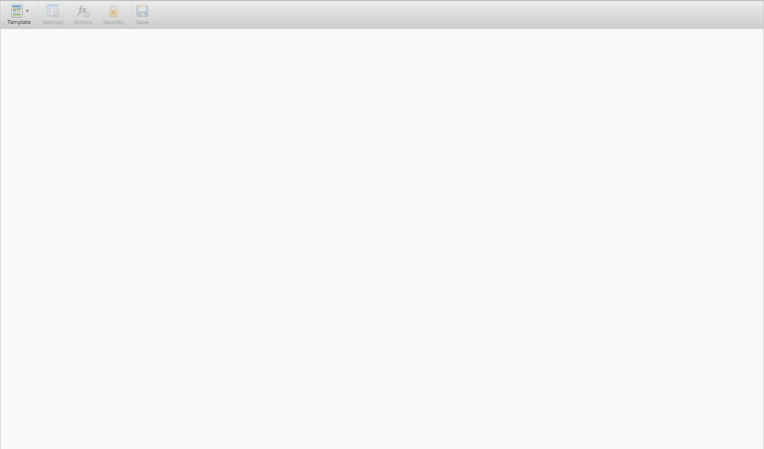

The Template Wizard top tool bar will help navigate within the tool.

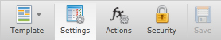

|  |  |
| --- | --- |
| **Icon** | **Description** |
| TWTemplateIcon.png | Click to hide or display the Template pane. |
|  | Click to hide or display the Settings pane. |
|  | Click to hide or display the Actions pane. |
|  | Click to hide or display the Security pane. |
| TWSaveIcon.png | Click to save after editing. |

## Template

Click 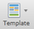 to Create a new template, open an existing one or create a new template from an existing one.

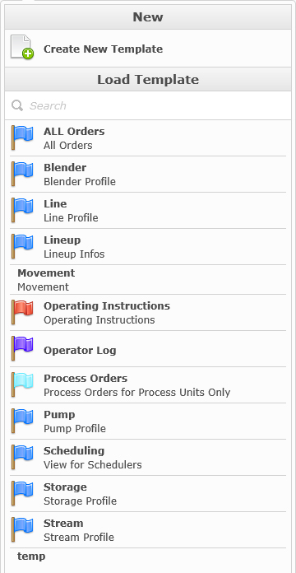

To create a new template, click . You also have the ability to create a new template from an existing template by hovering your mouse over the one you want to create from and clicking .

Another option is to open an existing template, by selecting one under the Load Template section.



## Settings

When creating a new template or selecting an existing template, you will automatically be transferred to the Settings pane.

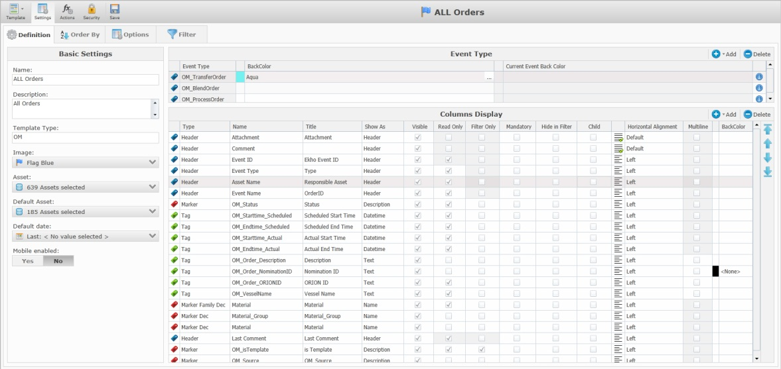

### Definition

The Definition section will be automatically selected when navigating to the Settings pane.

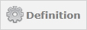

#### Basic Settings

The basic settings section is where you can give your template some settings like name, description etc.

|  |  |
| --- | --- |
| **Field** | **Description** |
|  | This field assigns a name to the template. |
|  | This field assigns a description to the template. |
|  | This field connects the template page to a specific app.  To have a page show up in View/Create Execute Order app, enter OM in this field.  To have it show up in View/Create Operator Comments app, enter Log in this field. |
|  | This option lets you select an image to help you identify the template. |
|  | This option lets you select the assets or asset types that that the template relates to. If asset type and asset is not selected, all asset types and assets will be available. |
|  | This option allows you to select the assets that should be selected by default in the Asset filter when the page template is loaded in an App. |
|  | This option lets you choose the default filter for the date period.  **Quick Period:**  Current Event  Yesterday  Current Shift  Current Week  Current Month  **Last/Next**  Last or Next number of  Event(s)  Hour(s)  Shift(s)  Day(s)  Week(s)  Month(s) |

#### Event Type

This section allows you to add the event types that are associated with the template page.

Only attributes that are associated with the selected eventtypes will be available in the page.

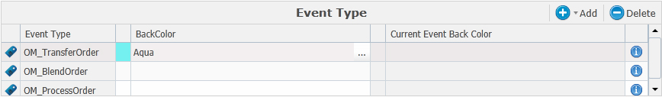

|  |  |
| --- | --- |
| **Column** | **Description** |
| Event Type | The name of the event type |
| BackColor | Allows you to choose a background color for all of the rows that are associated with this event type. |
| Current Event Back Color | Allows you to choose a background color for all of the “current event” rows that are associated with this event type. |

Press the  button to add a new eventtype to the page.

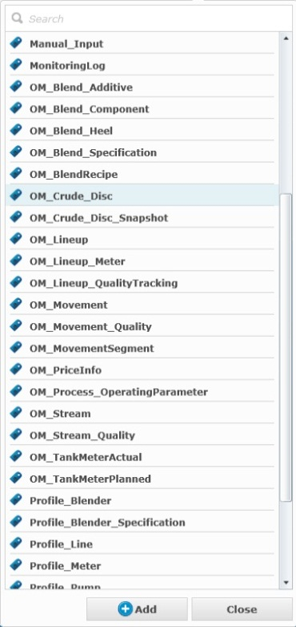

Select the eventtype you want to add and press the  button in the bottom of the dropdown.

To remove an Event Type, select it in the list and press the  button.

#### Columns Display

The columns display section, shows all of the selected columns that the template should show.

|  |  |
| --- | --- |
| **Name** | **Description** |
|  | Icon that represents the type of the column, TWBlue.png for Headers TWGreen.png for tags and TWRed.png for markers. |
| Type | Represents the type of the column. |
| Name | Name that can be found in the column selection list. |
| Title | This text can be changed and replaced with a customized text that will be displayed in the column header when that template is loaded in an Event Editor. |
| Shown As | With this column we can have more precision on the displayed element. For a header type there is only one possibility, but for the tag type you can select; Value, Text, Enumeration, Image, Checkbox, UCT (Server), UCT (Sector), Datetime, Date or Formula according to the format of the tag that was selected. For a marker type you can select; Description Short, Description, Description Long or Name. |
| Visible | Determines if the column should be visible in the page. |
| Read Only | Determines if the column should be read-only |
| Filter Only | Determines if the column should only be accessible through the advanced filter (meaning you could filter on data in this column but not see the actual column) |
| Mandatory | This determines if the column is mandatory to hold data or not. |
| Hide in Filter | Determines if the column should only be visible in the page but not in the advanced filter (meaning it is possible to view the data in this column but no filter on the data with the advanced filter) |
| Child | Determines if the column is a child. |
| Horizontal Alignment | Allows you to selected the horizontal alignment of the text in the cells for each column. Default, Left, Center or Right. |
| Multiline | Determines if the column should allow multilines. |
| BackColor | Lets you choose a background color for all of the cells under respective columns. |

Column items can be removed from the list by selecting one and clicking .

To change the items position in the list, you can use the available arrows on the right of the screen.

|  |  |
| --- | --- |
| **Icon** | **Description** |
| KMFormulaAllUp.png | To move the column item that is currently selected to the top, click this up arrow icon and the column item will be moved to the first position of the list. |
| KMFormulaUp.png | To move the column item that is currently selected to the top, click this up arrow icon and the column item will be moved one row up in the list. |
| KMFormulaDown.png | To move the column item that is currently selected to the bottom, click this down arrow icon and the column item will be moved one row down in the list. |
| KMFormulaAllDown.png | To move the column item that is currently selected to the bottom, click this down arrow icon and the column item will be moved to the last position in the list. |

To add a new column click  which will open the Columns Selection drop down.

**Columns Selection**

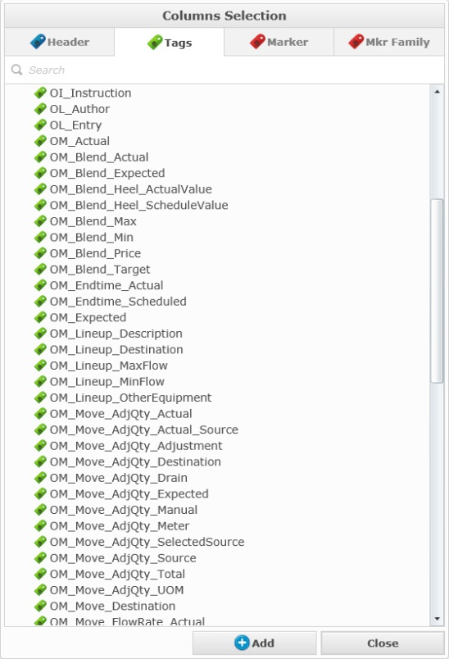

In the columns selection section, there are four column types that you can select from.

Each item selected in those sections will represent a column in an Event Editor display.

***Header***

In the column selection type you will find items that represents information directly related to the event such as name, start time, end time and duration. To select values that are related to that event, go in the Tags tabs.

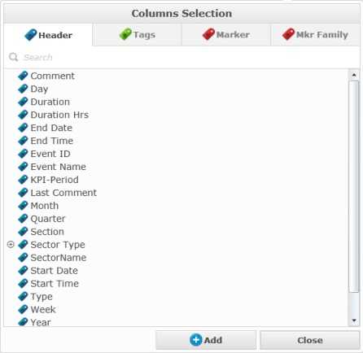

***Tags***

The tags column type is directly related with the event type that you have selected in the left part of the screen. All the tags that hold a value related to the selected event will be displayed in that list.

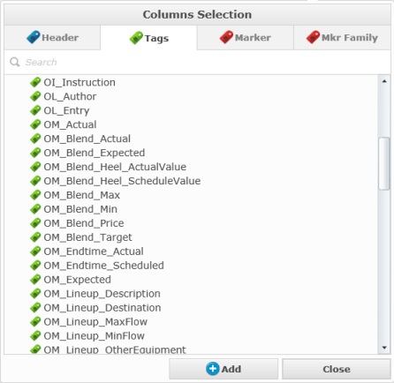

***Marker***

In the marker type you will have the possibility to select the marker directly related with the event. The list represents the entire marker lists that have a group defined. In that list you can also find ”Sector Specific Marker” if this item is selected the marker that is related to the specific selected sector will be displayed.

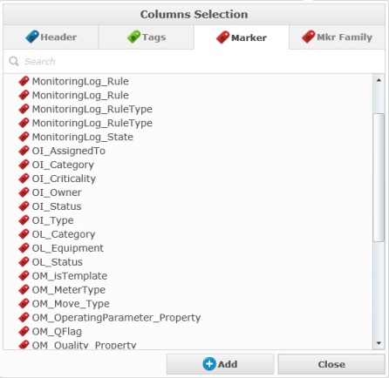

***Marker Family***

In the Marker family type you will have the possibility to select a marker family and the hierarchy that belongs to it.

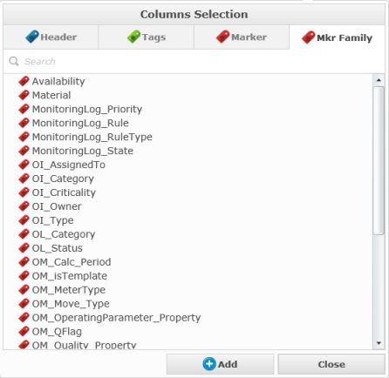

For all those types, to transfer the items to the ”Columns Display” section you can select the items and click .

### Order By

To navigate to the Order By section, press 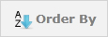

The Order By section allows you to select which attributes and in which order to sort the rows in the page.

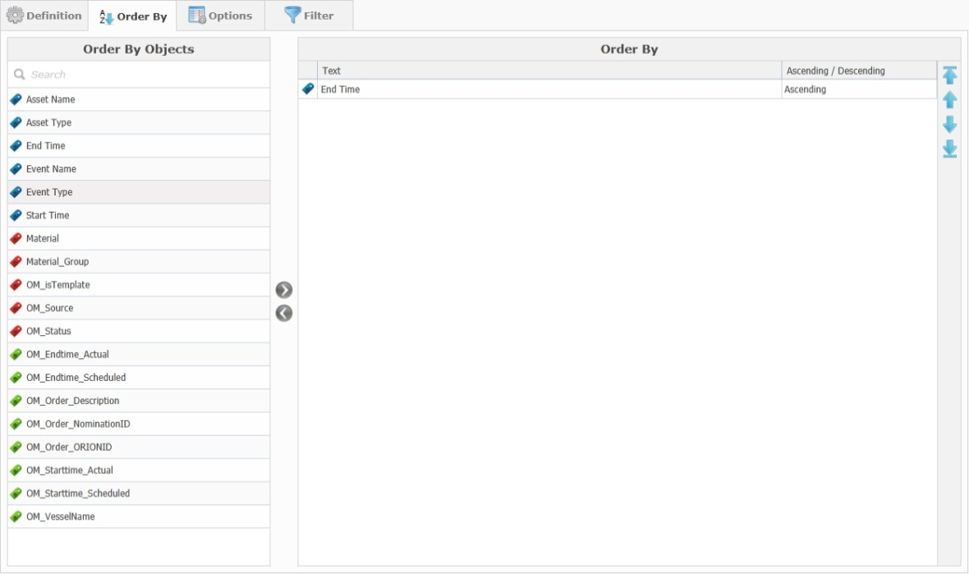

#### Order By Objects

This list displays all of the columns that where added to the Column Display section.

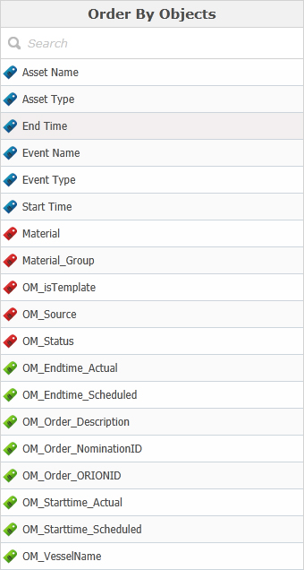

#### Order By

This list displays all of the selected columns to sort on in sort order.

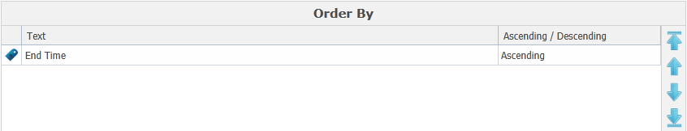

|  |  |
| --- | --- |
| **Column** | **Description** |
| Text | Shows the name of the selected column |
| Ascending/Descending | Determines if the sorting should be ascending or descending for each selected column. |

To add a new column to order by, select the column in the “Order By Objects” list and either drag and drop it into the “Order By” grid or use the arrow buttons to move the column.

 

To determine the sort order of the columns, you can use the available arrows on the right of the screen.

|  |  |
| --- | --- |
| **Icon** | **Description** |
| KMFormulaAllUp.png | To move the column item that is currently selected to the top, click this up arrow icon and the column item will be moved to the first position of the list. |
| KMFormulaUp.png | To move the column item that is currently selected to the top, click this up arrow icon and the column item will be moved one row up in the list. |
| KMFormulaDown.png | To move the column item that is currently selected to the bottom, click this down arrow icon and the column item will be moved one row down in the list. |
| KMFormulaAllDown.png | To move the column item that is currently selected to the bottom, click this down arrow icon and the column item will be moved to the last position in the list. |

### Options

To navigate to the Options section, press 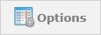

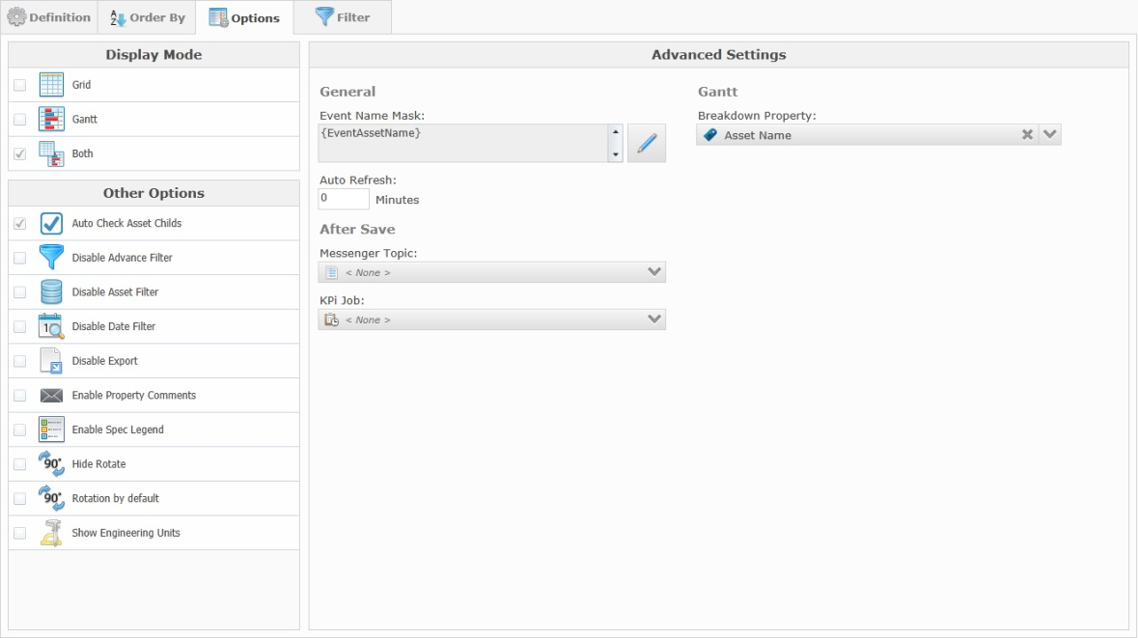

#### Display Mode

|  |  |
| --- | --- |
| **Setting** | **Description** |
|  | When this option is checked only the event editor grid is available, no gantt chart. |
|  | When this option is checked only the event editor gantt chart is availabe, no grid. |
|  | When this option is checked, both the event editor grid and gantt chart available for the page. |

#### Other Options

|  |  |
| --- | --- |
| **Setting** | **Description** |
|  | When this option is checked, all the children under the selected parent assets will also be selected. When this option is not checked, each asset will have to be selected individually. |
|  | When this option is checked, the Advance Filter window will not be available, but the button will still be visible. |
|  | When this option is checked, the Asset Filter panel will not be available, but the button will still be visible. |
|  | When this option is checked, the Date Filter window will not be available, but the button will still be visible. |
|  | When this option is checked, the Export possibility will not be available, but the button will still be visible. |
|  | When this option is checked, a new icon will be added in the display screen of the Event Editor to let you put some comment on a particular property. |
|  | When this option is checked, the Specifications icon will be available. By default this icon is not available. |
|  | When this option is checked, the grid will always be displayed horizontally and there will be no way to rotate it. |
|  | When this option is checked, the grid will be rotated and displayed vertically by default. |
|  | When this option is checked, a new row will be added in the display screen of the Event Editor. |

#### Advanced Settings

|  |  |
| --- | --- |
| **Setting** | **Description** |
|  | This option is used for display purpose only. So when you open a popup page this mask will be used as the header of the page. To change the mask selection click on the Edit button and a new window with different options will be displayed. |
|  | Will give you the possibility to have the Event Editor page refresh by itself each x minutes. |
|  | Gives you the ability to select an existing topic that will be automatically triggered after the save. |
|  | Gives you the ability to select an existing KPI job to be automatically triggered after the save. |
|  | This option is only available if the Gantt or Both option has been selected under “Display Mode” and lets you choose which attribute the Gantt chart should display. |

### Filter

To navigate to the Filter section, press 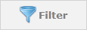

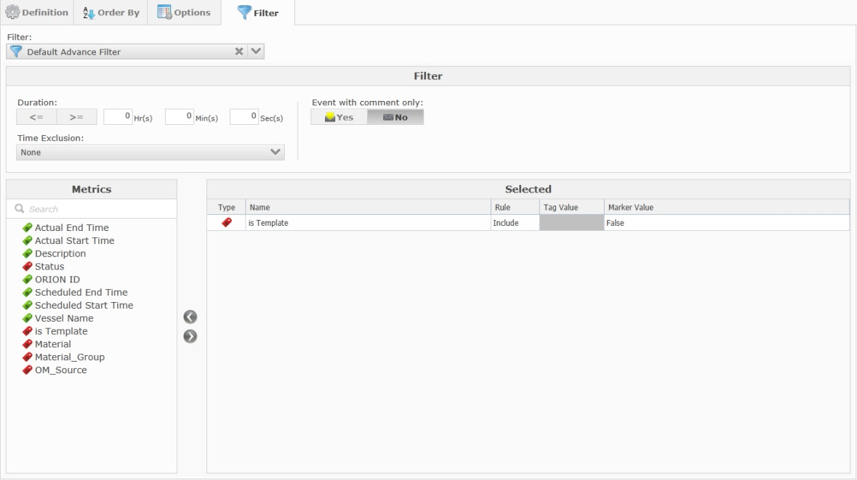

In this section you can pre-define some filter options, like the duration and time exclusion.

|  |  |  |
| --- | --- | --- |
| Action | Icon | Description |
| Filter duration | EEFilterDuration.png | Filter the duration of the order(s). |
| Time Exclusion | EEFiltersTimeExcl.png | Filter by excluding certain time periods. |
| Event with Comment only | EEFilterCommentExcl.png | Filter by excluding order with or without comment. |

The “Metrics” filter option allows for the filtering of events based on certain metric tags or marker values.



To select (or remove) a metric, you can use the drag and drop method or you can use the arrows  .

Once in the “Selected” list you can apply a rule value to filter for. If the selected item is a marker (status, material group etc.) you can enter a marker value. Markers are noticeable by their red icon.



Once the configurations for the page are completed, you need to save your settings by clicking .

If you try and navigate away from the Settings page with unsaved changes, you will be prompted with a warning message.

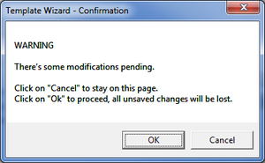

## Actions

To navigate to the Actions Pane, press the 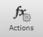 button.

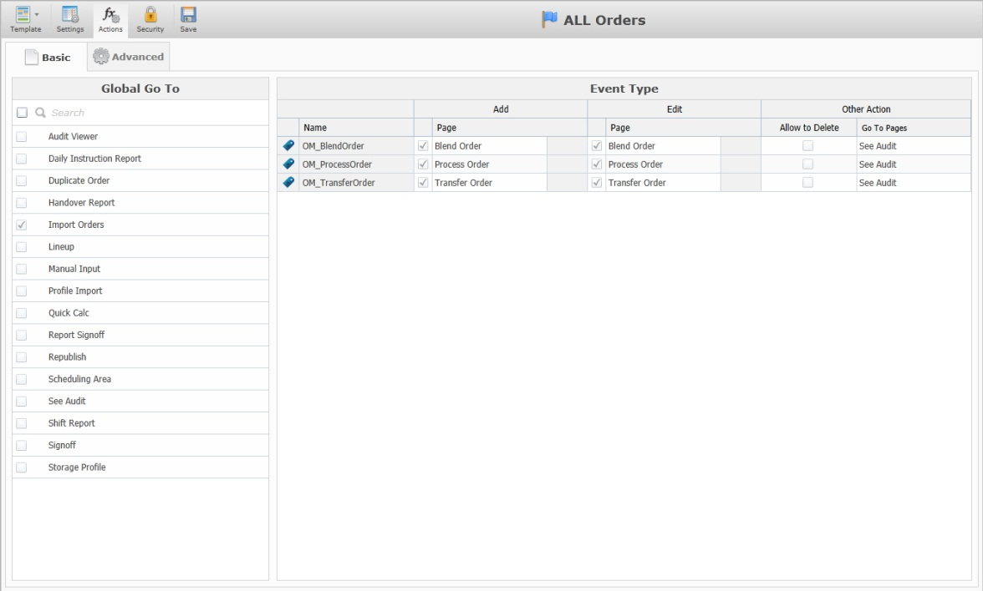

### Basic

Whenever you navigate to the Actions pane, the Basic section will be automatically selected.

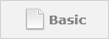

#### Global Go To

The Global Go To section allows you to select some pre-defined forms that should always be openable from the “Go To” button in the Event Editor.

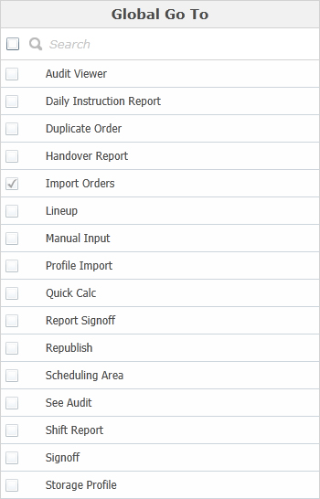

#### Event Type

The Event Type section displays all of the selected Event Types and gives you the option to select a pre-defined form per event type that should be opened or selectable whenever the Add, Edit (with an event selected) or Go To (with an event selected) buttons are clicked.

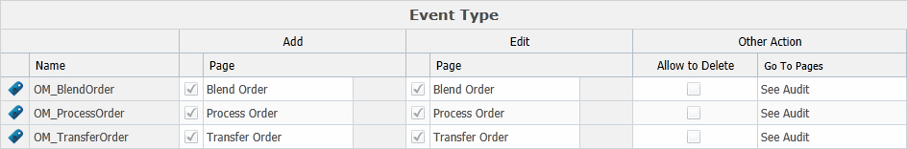

### Advanced

To navigate to the Advanced section, press the 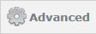 button.

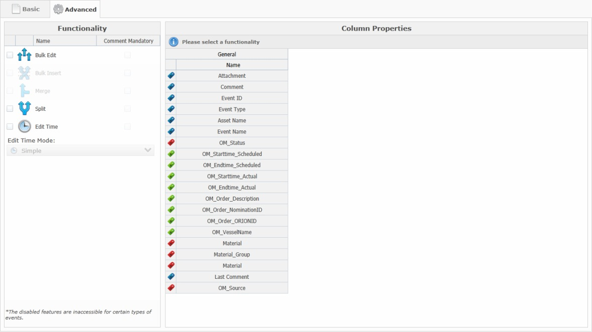

#### Functionality

The Functionality section allows you to check certain functions that should be available from the Event Editor and if a comment should be mandatory whenever these functions are used.

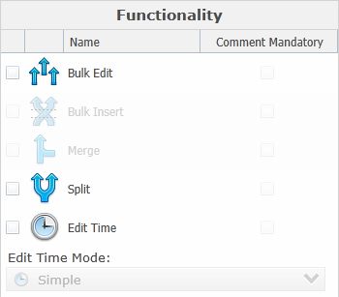

These are the functions that may be applied to the event editor, note that some of the functionalities might be inaccessible for certain types of events.

|  |  |
| --- | --- |
| **Icon** | **Description** |
|  | When this option is checked, the Bulk Edit icon will be displayed on the top toolbar of the Event Editor. |
|  | When this option is checked, the Bulk Insert icon will be displayed on the top toolbar of the Event Editor. |
|  | When this option is checked, the Merge icon will be displayed on the top toolbar of the Event Editor. |
|  | When this option is checked, the Split icon will be displayed on the top toolbar of the Event Editor. |
|  | When this option is checked, the Edit Time icon will be displayed on the top toolbar of the Event Editor. |
|  | This combobox lets you select which mode to use for the Edit Time function. |